

A DATABASE DESIGN FOR LEBANESE AIRPORTS

by

YEHYA ALAMEH

RAYAN MOUSTAFA

MOHAMAD CHEBLI

AYA ALAYLI

MONA YAHFOUFI

OMAR HASSOUN

A REPORT

Submitted to DR. RAMZI HARATY in fulfillment of the requirements

for the course Database Management Systems in Computer Science

DATA PILOTS

November 28, 2020

*This page was left blank intentionally*

1. **Table of Contents**
2. Table of Contents
3. Introduction
4. Copyright Notice
5. System Description and Constraints
6. ER diagram for airport
7. Entities
8. Airport
9. Airline
10. Hangar
11. Employee
12. Gates
13. Flight
14. Security equipment
15. Passengers
16. Flight schedule
17. Airport operation
18. Maintenance
19. Airplane test
20. Ticket
21. Airplane
22. Relationships
23. ER Relational Mapping Algorithms

Step 1: Mapping of Regular Entity Types

1. Airport
2. Hangar
3. Flight_Schedule
4. Airline
5. Airplane
6. Airplane_Test
7. Flight
8. Employee
9. Passenger
10. Ticket
11. Security_Equipment
12. Maintenance
13. Airport_Ops

Step 2:

1. Gate

Step 3:

1. Ticket
2. Security_Equipment

Step 4:

1. Hangar
2. Employee
3. Passenger
4. Airplane

Step 5:

1. Provides
2. Lands
3. Serves

Step 6:

1. Time
2. Location

Step 7:

1. Works_On
2. Table Structure
3. Table Descriptions
4. Inserting Data
5. Final Table State
6. Queries
7. Normalization
8. Conclusion
9. Phase I Report Checklist
10. Instructor’s comment and evaluation

**II. Introduction**

We, the **DATA PILOTS,** take the pleasure to submit our report. This work-project provided us the opportunity to experience database design like creating ER diagrams, writing documentation and like working on a project in a team.

This report summarizes the work process. Our group was assigned to design a database for **Lebanese airports**. Overall, the project gave us an understanding of ER Diagrams for a database. We used draw.io and other tools to facilitate the process. This report will explore the different aspects of what we have done when designing the database for Lebanese airports, as they were preparing to launch their new airports.

III. Copyright Notice

Copyright © 2020-2021. This design and report is a copyright of Data Pilots. All rights reserved. This work is protected by Copyright, and permission should be obtained from the publisher prior to any prohibited reproduction, storage in a retrieval system, or transmission in any form or by any means, electronic, mechanical, photocopying, recording, or likewise. To obtain permission(s) to use material from this work, please submit a written request to one of the authors of this work: [omardavid.hassounharmouch@lau.edu](mailto:omardavid.hassounharmouch@lau.edu), [mohamed.chebli@lau.edu](mailto:mohamed.chebli@lau.edu), [rayan.moustafa@lau.edu](mailto:Rayan.moustafa@lau.edu), [yehya.alameh@lau.edu](mailto:yehya.alameh@lau.edu), [aya.alayli@lau.edu](mailto:aya.alayli@lau.edu) and [mona.alyahfoufi@lau.edu](mailto:mona.alyahfoufi@lau.edu).

IV. System Description and Constraints

In Lebanon, there are multiple airports being built. These airports are owned by different airlines that provide a flight schedule for flights in and out of the country. Each of these airports have hangars where airplanes are stored and managed and may be maintained. In these airports we also have employees divided according to their tasks. Some of them work on airport operations, others on maintenance, they also use security equipment to monitor activity and check luggage for potential threats or anything that may not be allowed inside the planes or airport. An airplane contains passengers that had purchased their tickets from various airlines. An airplane is tested every six months to ensure it meets the design and safety requirements.

V. ER diagram for Lebanese Airports

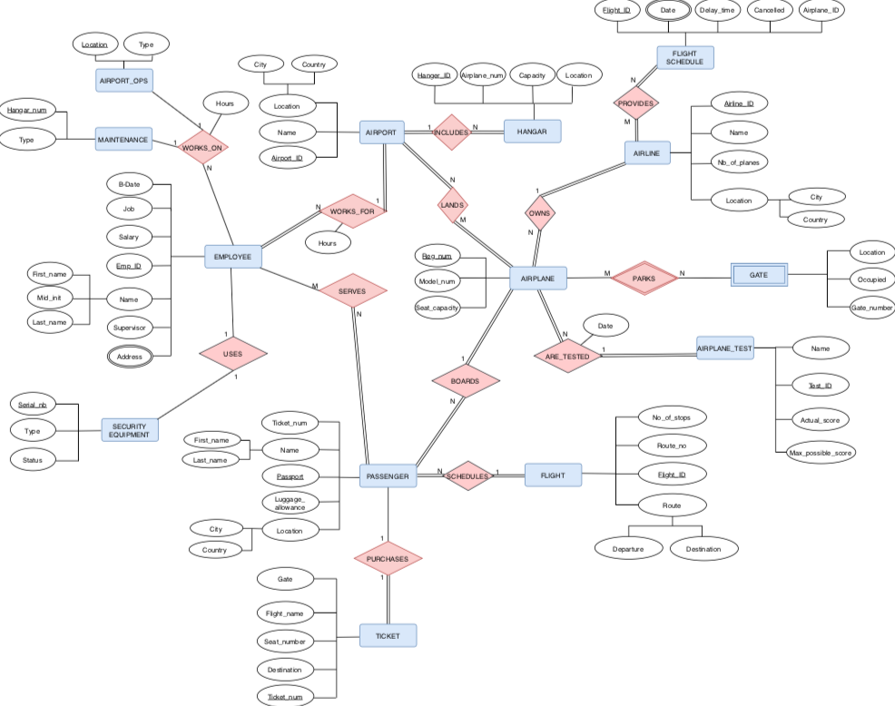

VI. Entities

1. Airport

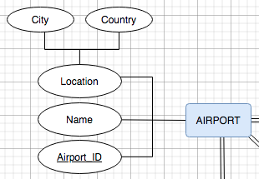

This entity holds the data of the airports in Lebanon such as the major airport in Beirut, known as Haraty Fly By, Tripoli, and the southern airport in Tyre. It consists of the attributes **name**, **location** (composite attribute), and **Airport_ID** (primary key). These airports host the arrival of millions of passengers every year, offering extensive safety and care to the arrivals and their luggage.

1. Airline

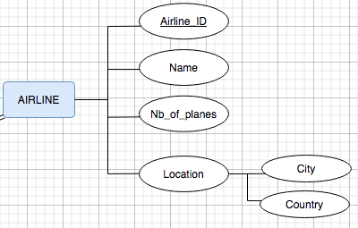

Airlines all over the world provide air transport services for traveling passengers and freight. The airline entity is associated with a key attribute named **Airline_ID** (primary key). The entity also contains the attributes name (of the airline), “Nb_of_planes” for the number of airplanes stored by the airline and location of the airline (composite attribute).

1. Hangar

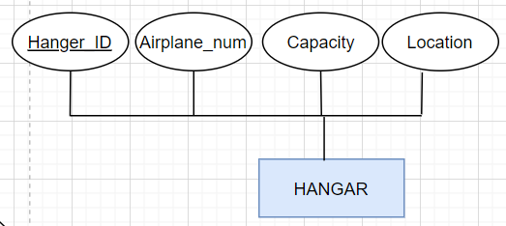

Haraty Fly By along with the other airports in Lebanon own hangers to store airplanes which have a primary key attribute of **Hanger_ID** and keep track of how many airplanes are parked there, in addition to their number. The hangar also has a location name in the airport vicinity and controls the capacity of planes inside the hangar.

1. Employee

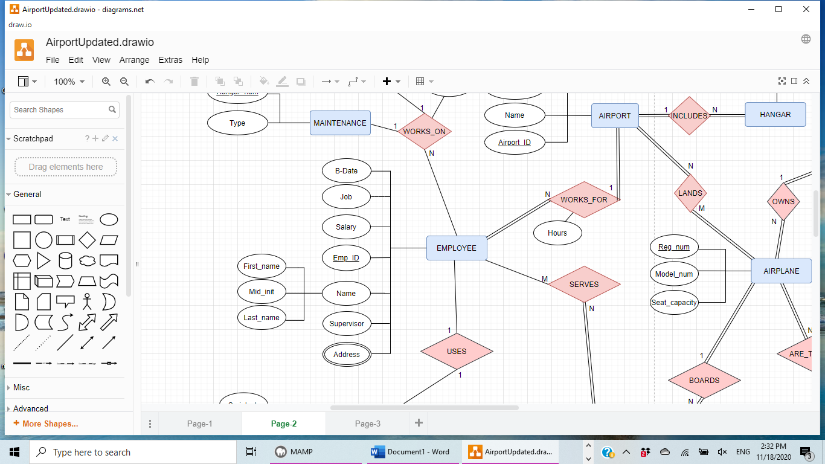

The employee entity consists of attributes and one key attribute. Job is an attribute that represents the work assigned for each employee. The salary attribute is found to show the monthly paid money for each employee working at the airport. The id of each employee working in the airport is represented as a primary key attribute (Emp_ID), the employee entity also contains one composite attribute, which is the name that is composed of first (First_name), middle initial (Mid_init), and last name (Last_name). As well as the birthdate of each employee in order to know his age. Additionally, this entity has a multivalued attribute which is the address of the employee. It’s multivalued because an employee can have several addresses (his parents’ address, his own address..). It is important to keep track of the work done in the airport, this is done by supervision of the supervisor.

1. Gate

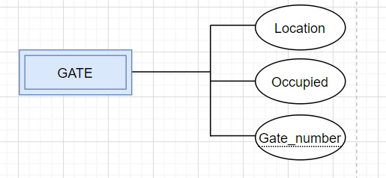

Gate is one of the most important entities that each airport should have, yet this entity is a weak one that does not contain a primary key attribute. Gate entity is made up of three attributes, location of each gate in the airport, the number of the gate the passenger should head to catch his/her flight which is a partial key. Occupied is the attribute that keeps track if there is a plane parked in this gate or not.

1. Flight

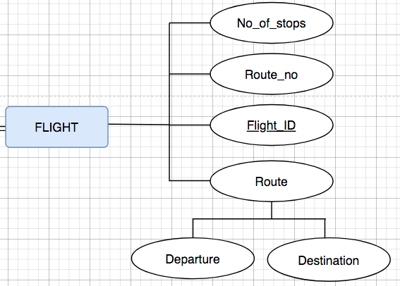

The flight entity is essential in every airport; it consists of several attributes that help in keeping track of flights. The number of stops (No_of_stops) represents the stops that the flight will make. For example, from Beirut to Paris and then to New York. Flight id **(Flight_ID)** represents the id of each flight, as for route number (Route_no) it is a key attribute that shows the id of each route. There is a composite attribute, the route. The route attribute which its main function is to show the way a flight is going is composed of destination which means where the flight is heading to (NewYork) and departure which represents the city this flight came from (Beirut).

1. Security Equipment

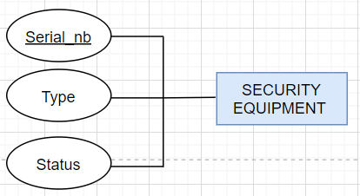

In a public place like the airport, security is a must in order for the protection and public safety to prevail. In our database we created an entity called security equipment to describe the security system at our airport. Security equipment is identified by their **serial number**, which is considered a primary key for this entity. Additionally, security equipment has many types, which is also an attribute here, since security at the airport can take several forms and can be achieved through different equipment. This entity has also status as an attribute.

1. Passenger

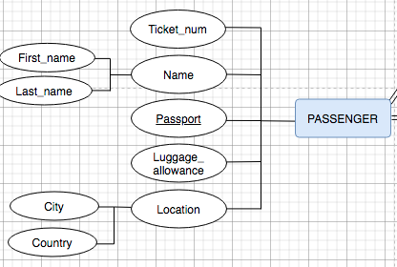

Of course, an airport is meaningless without the passengers that actually go to it, which is why this entity is important in our database. Passengers reserve their flights and they are differentiated by their **social security number (SSN)**, which is the primary key for this entity. A passenger surely has a name and here it is fully provided, since it is divided into first name, last name, and middle initial, so it is a composite attribute. A passenger also has other attributes like ticket number, passport, luggage allowance that specifies how much weight is allowed for every passenger, and location. Here location is a composite attribute as well, which is branched into state, city and country which tell us where this passenger is from specifically.

1. Flight Schedule

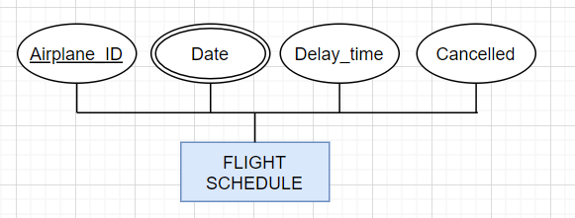

Passengers, and even their relatives, cannot track their flights without a flight schedule. A flight schedule contains an **airplane ID** that specialize it, this is why this attribute is considered as a primary key, because 2 planes cannot have the same flight schedule. Additionally, a flight schedule provides the date at which this certain flight occurs, and so date is a multivalued attribute. There is also a delay time that tells if a flight will end later than specified, to provide the waiting people at the airport when their relatives will arrive. At last, a cancellation attribute is there to specify if a flight is cancelled due to certain circumstances.

1. Airport Operation

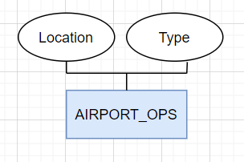

The airport operation entity is very important in an airport because it manages many attributes that are essential for running any airport. The airport operation entity contains the tower control, which supervises over all the departing/arriving planes, also the air traffic control and the ground control, there are also other operations such as the lighting, weather observations and the safety management.

1. Maintenance

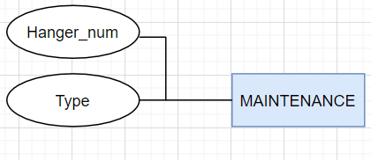

In every airport we have a maintenance section which is responsible to make sure that everything works perfectly as intended in an airport. This section should take care of refueling airplanes, doing the usual airplane maintenance, visual aid maintenance, making sure that all the electrical systems work, ventilation is working fine, and information technology systems are all in check.

1. Airplane Test

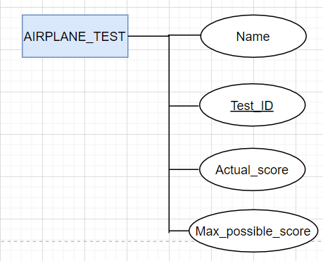

Airplanes need to be tested before being used to transport civilians across airports and nations. Each airplane has a name, and **test id**. Each test will be composed of the max possible score, and the actual score of the airplane.

1. Ticket

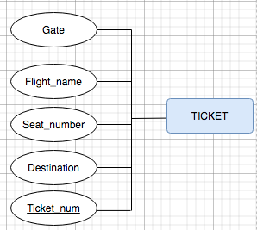

In the airport each scheduled flight has seats which are resembled by tickets that the passengers purchase in order to reserve a seat in a particular plane to a specific destination .

1. Airplane

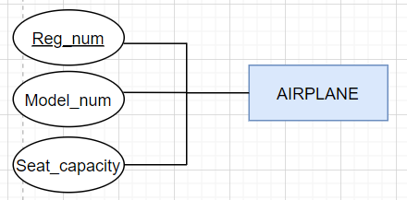

In each airport many airplanes park on specific gates and are owned by different airlines that undergo different tests on specific dates in order to insure the safety of the boarding passengers.

VII. Relationships

1. Works_For

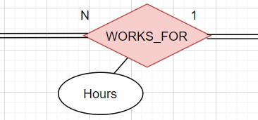

**Employees** work for one **airport**. Thus, a WORK_FOR relationship should be created between the EMPLOYEE and AIRPORT entity. There is total participation on both sides since an employee must work for exactly one airport and each airport must have at least one employee. The relationship is one to many because multiple employees work for an airport.

1. Serves

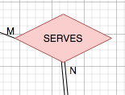

Employees serve passengers. Hence, the SERVES relationship. There is total participation on the Passenger side and partial participation on the Employee side. The relationship is many to many since multiple employees can serve a passenger and an employee can serve multiple passengers.

1. Uses

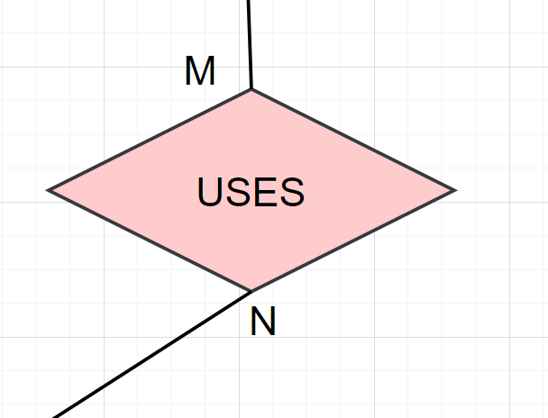\

Some employees use security equipment to their work, so we added a USES relationship. They are both partial relationships since an employee can use a lot of security equipment or none and security equipment can not be used by an employee. It’s also many to many because the same security equipment can be used by multiple employees (two employees can use a patrolling car) and one employee can use multiple security equipment (an employee can carry a gun and an anti-bullet vest).

1. Purchases

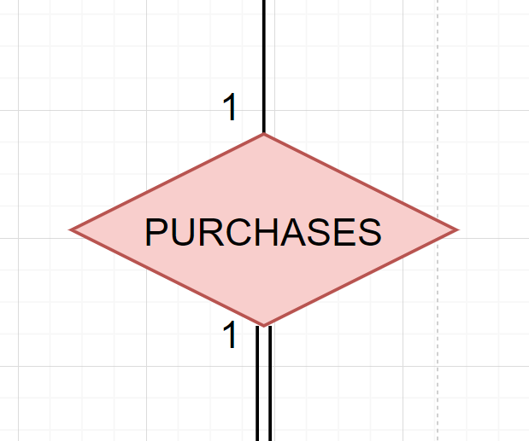

Passengers need to purchase a ticket. Therefore, we created the PURCHASES relationship. In our diagram, there is partial participation from the side of the Passenger since a passenger may not purchase a ticket, but it’s total from the ticket side since a ticket must be purchased by a passenger in order to exist. The relationship is one to one since the passenger can just purchase one ticket.

1. Boards

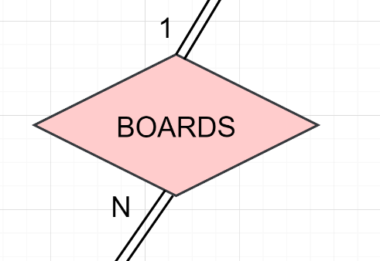

A passenger boards an airplane, therefore the BOARDS relationship was created. Participation is total on both sides since an airplane doesn’t fly unless there are passengers in it and a passenger has to board an airplane to be considered a passenger. The relationship is one to many since a passenger is just assigned one airplane (a passenger can’t be on multiple planes at the same time) and an airplane may contain multiple passengers.

1. Are_Tested

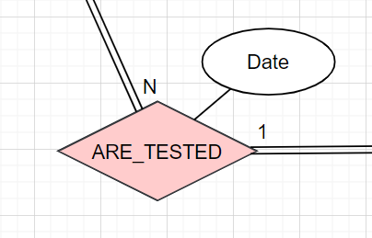

An airplane has to be tested in order to fly so we created the ARE_TESTED relationship between the entities Airplane and Airplane_test. The relationship is total on both sides since an airplane cannot fly unless it’s tested. The relationship is one to many since multiple airplanes can be tested but they can just take one test. The relationship has the attribute “Date”, it states the date the airplane was tested.

1. Works_On

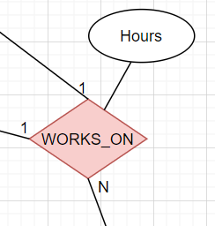

An employee can either work on maintenance or airport operations, therefore we created the ternary relationship WORKS_ON between the entities EMPLOYEE, MAINTENANCE and AIRPORT_OPS making this a ternary relationship. There is partial participation from all three since an employee because not all employees have to work on either of those fields. The relationship is one to many since an employee can be either maintenance or airport operations. The relationship also has the attribute Hours for the amount of hours an employee works.

1. Schedules

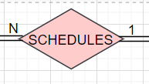

The passengers schedule their flight. Hence, we created the SCHEDULES relationship between the passenger entity and the flight entity. There is total participation on both sides since a passenger has to be scheduled at least a flight and a flight has to have at least a passenger. The relationship is one to many because a passenger can just schedule a flight but can have multiple passengers.

VII. ER to Relational Mapping Algorithm

After designing the ER schema and having displayed the database for Lebanese Airports as entities, attributes, and relationships, this design is translated into a relational database design. The seven-step algorithm is followed and applied to the ER design in order to convert it into a relational database design.

**Step 1: Mapping of Regular Entity Types**

Step 1 is where all strong entities are mapped along with their simple attributes and a single primary key which is underlined.

1. AIRPORT

|  |  |  |  |
| --- | --- | --- | --- |
| Airport_ID | Name | City | Country |

The AIRPORT entity consists of a name, city, and country as simple attributes and a primary key attribute Airport_ID.

2. HANGAR

|  |  |  |  |
| --- | --- | --- | --- |
| Hangar_ID | Airplane_Num | Capacity | Location |

HANGAR has a primary key of Hangar_ID, and three simple attributes Airplane_Num, Capacity, and Location.

3. FLIGHT_SCHEDULE

|  |  |  |  |
| --- | --- | --- | --- |
| Flight_ID | Delay_Time | Cancelled | Airplane_ID |

FLIGHT_SCHEDULE also has a primary key Flight_ID and three simple attributes Delay_Time, Cancelled, and Airplane_ID. It also has a multivalued attribute called Date but is not included in this step.

4. AIRLINE

|  |  |  |  |  |
| --- | --- | --- | --- | --- |
| Airline_ID | Name | Nb_of_Planes | City | Country |

The AIRLINE entity has a primary key Airline_ID and two simple attributes Name and Nb_of_planes.

It also has a composite attribute Location, but only the simple attributes City and Country are included.

5. AIRPLANE

|  |  |  |
| --- | --- | --- |
| Reg_num | Model_num | Seat_capacity |

The AIRPLANE entity has a primary key attribute Reg_Num. The simple attribute Model_num may also be a candidate key in this case. And Seat_Capacity is the last simple attribute.

6. AIRPLANE_TEST

|  |  |  |  |
| --- | --- | --- | --- |
| Test_ID | Name | Actual_score | Max_possible_score |

AIRPLANE_TEST contains a primary key named Test_ID and three simple attributes Name, Actual_score, and Max_possible_score.

7. FLIGHT

|  |  |  |  |  |
| --- | --- | --- | --- | --- |
| Flight_ID | Route_num | No_of_stops | Destination | Departure |

The FLIGHT entity has a primary key attribute named Flight_ID and two simple attributes: Route_num and No_of_stops. It also has a composite attribute: Route: We include the simple attributes of Route as Destination and Departure.

8. EMPLOYEE

|  |  |  |  |
| --- | --- | --- | --- |
| Emp_ID | Salary | Job | First_name |
| Mid_init | Last_name | Supervisor |  |

EMPLOYEE consists of four simple attributes: Job, Salary, Supervisor and B-Date. It’s primary key is Emp_ID. The multivalued attribute Address is not included in the step. The Employee also has a composite attribute called Name in which we only included the simple attributes First_name, Mid_init, and Last_name.

9. PASSENGER

|  |  |  |  |
| --- | --- | --- | --- |
| Passport | First_name | Last_name | Ticket_num |
| Luggage_Allowance | City | Country |  |

Here we have a primary key Passport in addition to simple attributes Luggage_allowance and Ticket_num. Two composite attributes Location and Name have the simple attributes City, Country, and First_name, and Last_name respectively.

10. TICKET

|  |  |  |  |  |
| --- | --- | --- | --- | --- |
| Ticket_num | Gate | Flight_name | Seat_num | Destination |

The TICKET entity has a primary key Ticket_num and 4 simple attributes which are Gate, Flight_name, Seat_Num, and Destination.

11. SECURITY_EQUIPMENT

|  |  |  |
| --- | --- | --- |
| Serial_no | Type | Status |

Here in SECURITY_EQUIPMENT the primary key is Serial_no and the simple attributes are Type and Status.

12. MAINTENANCE

|  |  |
| --- | --- |
| Hangar_num | Type |

MAINTENANCE only has a primary key attribute Hanagar_num and a simple attribute Type.

13. AIRPORT_OPS

|  |  |
| --- | --- |
| Location | Type |

AIRPORT_OPS also only contains Location as a primary key and a Type as a simple attribute.

**Step 2: Mapping of Weak Entity Types**

In step 2 a new relation is created for each weak entity including its simple attributes. A foreign key from the owner entity is set to be one of the candidate keys in GATE.

1. GATE

|  |  |  |  |
| --- | --- | --- | --- |
| Reg_num | Gate_number | Occupied | Location |

GATE is a weak entity where Gate_number is a partial key of this entity. Reg_num is the primary key of the owner entity AIRPLANE. Together they form the primary key of this relation. It contains Location and Occupied as simple attributes.

**Step 3: Mapping of Binary 1:1 Relation Types**

In this step, we map the binary one-to-one relationships. To do this we follow the first approach, called foreign key approach. We choose the entity on the total participation side of the relation and add it as a foreign key, the primary key of the other entity participating in this relation.

1. TICKET

|  |  |  |  |  |
| --- | --- | --- | --- | --- |
| Ticket_num | Gate | Flight_name | Seat_num | Destination |
| Pass_port |  | | | |

Every passenger has a ticket. The “Purchases'' relationship links the TICKET and PASSENGER entities together. We only have total participation on the TICKET side therefore we set Passport as a foriegn key and renamed it Pass_port.

2. SECURITY_EQUIPMENT

|  |  |  |  |
| --- | --- | --- | --- |
| Serial_no | Type | Status | E_ID |

The “Uses” relationship links SECURITY_EQUIPMENT and EMPLOYEE together and we have partial participation on both ends, thus it doesn't matter where we add the foriegn key. We chose Emp_ID as a foriegn key here and renamed it E_ID.

**Step 4: Mapping of Binary 1: N Relationship Types**

In this step we map 1: N relationship types. We take a foreign key in the entity type at the N side of the relationship. This foreign key is the primary key of the other entity type participating in this relationship. We also include any other simple attribute of the 1: N relationship. For example, HANGAR takes Airport_ID as a foreign key.

1. HANGAR

|  |  |  |  |  |
| --- | --- | --- | --- | --- |
| Hangar_ID | Airplane_Num | Capacity | Location | Air_ID |

The “Includes” relationship links the HANGAR and AIRPORT entities together. Each airport includes many hangars. We took the primary key from AIRPORT which is Airport_ID and set it as a foreign key in HANGAR. We renamed Airport_ID to Air_ID

EMPLOYEE

|  |  |  |  |  |
| --- | --- | --- | --- | --- |
| Emp_ID | Salary | Job | First_name | Air_ID |
| Mid_init | Last_name | Supervisor | Hours | B_Date |

The “Works_For'' relationship links EMPLOYEE and AIRPORT together. We took the primary key from AIRPORT and took it took the N side (EMPLOYEE) along with the relationship's simple attribute called Hours. Airport_ID is renamed to Air_ID and now the foriegn key of EMPLOYEE.

3. PASSENGER

|  |  |  |  |
| --- | --- | --- | --- |
| Passport | First_name | Last_name | R_num |
| Luggage | City | Country | Fl_ID |

There are two 1: N relationships here. Many passengers BOARDS 1 airplane. Many passengers SCHEDULES 1 Flight. PASSENGER takes Reg_num renamed to R_num as a foriegn key from AIRPLANE.

PASSENGER also takes Flight_ID renamed Fl_ID as a foriegn key from FLIGHT.

4. AIRPLANE

|  |  |  |  |  |  |
| --- | --- | --- | --- | --- | --- |
| Reg_num | Model_num | Seat_capacity | Test_ID | Test_Date | A_ID |

The first 1: N relationship here is: One airline OWNS many airplanes. The second is many airplanes ARE_TESTED 1 time periodically. Therefore Airline_ID is taken as a foriegn key and renamed to A_ID and Test_ID is also taken as a foreign key to AIRPLANE.

**Step 5: Mapping of Binary M: N Relationship Types**

In the 5th step of this algorithm, for each M: N relationship a new relation is created that takes all primary keys of the entities related and also takes any simple attributes on the relationship.

1. PROVIDES

|  |  |
| --- | --- |
| Flight_ID | Airline_ID |

PROVIDES is a M: N relationship between AIRLINE and FLIGHT_SCHEDULE therefore a primary key from each entity is taken as a foreign key to the new entity PROVIDES.

2. LANDS

|  |  |
| --- | --- |
| Airport_ID | Reg_num |

LANDS is a M: N relationship between AIRPORT and AIRPLANE therefore a primary key from each entity is taken as a foreign key to the new entity LANDS.

3. SERVES

|  |  |
| --- | --- |
| Emp_ID | Passport |

SERVES is a M: N relationship between EMPLOYEE and PASSENGER therefore a primary key from each entity is taken as a foreign key to the new entity SERVES.

**Step 6: Mapping of Multivalued attributes**

Mapping multivalued attributes involves creating a new relation R and including the primary key of the owner entity.

1. TIME

|  |  |
| --- | --- |
| Date | Flight_ID |

TIME is a new entity created for the multivalued attribute in FLIGHT_SCHEDULE. Date and Flight_ID represent the primary key of this entity.

2. LOCATION

|  |  |
| --- | --- |
| Emp_ID | Address |

LOCATION is a new entity created for the multivalued attribute in EMPLOYEE. Emp_ID and Address represent the primary key of this entity.

**Step 7: Mapping of N-ary Relationship Types**

This final step maps the N-ary relationship types, therefore a new relation is created including every primary key of the related entities, in addition to any simple attributes.

1. WORKS_ON

|  |  |  |  |
| --- | --- | --- | --- |
| Emp_ID | Hangar_num | Location | Hours |

We only have one ternary relationship between EMPLOYEE, MAINTENANCE, and AIRPORT_OPS. The primary keys from each entity are taken as foreign keys to make up the primary key of the new entity WORKS_ON. Hours is the simple attribute of this entity.

VIII. Final Step: Final Display

1. AIRPORT

|  |  |  |  |
| --- | --- | --- | --- |
| Airport_ID | Name | City | Country |

2. HANGAR

|  |  |  |  |  |
| --- | --- | --- | --- | --- |
| Hangar_ID | Airplane_Num | Capacity | Location | Air_ID |

3. FLIGHT_SCHEDULE

|  |  |  |  |
| --- | --- | --- | --- |
| Flight_ID | Delay_Time | Cancelled | Airplane_ID |

4. AIRLINE

|  |  |  |  |  |
| --- | --- | --- | --- | --- |
| Airline_ID | Name | Nb_of_Planes | City | Country |

5. AIRPLANE

|  |  |  |  |  |  |
| --- | --- | --- | --- | --- | --- |
| Reg_num | Model_num | Seat_capacity | Test_ID | Test_Date | A_ID |

6. AIRPLANE_TEST

|  |  |  |  |
| --- | --- | --- | --- |
| Test_ID | Name | Actual_score | Max_possible_score |

7. FLIGHT

|  |  |  |  |  |
| --- | --- | --- | --- | --- |
| Flight_ID | Route_num | No_of_stops | Destination | Departure |

8. EMPLOYEE

|  |  |  |  |  |
| --- | --- | --- | --- | --- |
| Emp_ID | Salary | Job | First_name | Air_ID |
| Mid_init | Last_name | Supervisor | Hours | B-Date |

9. PASSENGER

|  |  |  |  |
| --- | --- | --- | --- |
| Passport | First_name | Last_name | R_num |
| Luggage | City | Country | Fl_ID |
| Ticket_num |  | | |

10. TICKET

|  |  |  |  |  |
| --- | --- | --- | --- | --- |
| Ticket_num | Gate | Flight_name | Seat_num | Destination |
| Pass_port |  | | | |

11. SECURITY_EQUIPMENT

|  |  |  |  |
| --- | --- | --- | --- |
| Serial_no | Type | Status | E_ID |

12. MAINTENANCE

|  |  |
| --- | --- |
| Hangar_num | Type |

13. AIRPORT_OPS

|  |  |
| --- | --- |
| Location | Type |

14. GATE

|  |  |  |  |
| --- | --- | --- | --- |
| Reg num | Gate_number | Occupied | Location |

15. PROVIDES

|  |  |
| --- | --- |
| Flight_ID | Airline_ID |

16. LANDS

|  |  |
| --- | --- |
| Airport_ID | Reg_num |

17. USES

|  |  |
| --- | --- |
| Emp_ID | Serial_no |

18. SERVES

|  |  |
| --- | --- |
| Emp_ID | Passport |

19. TIME

|  |  |
| --- | --- |
| Date | Flight_ID |

20. LOCATION

|  |  |
| --- | --- |
| Emp_ID | Address |

21. WORKS_ON

|  |  |  |  |
| --- | --- | --- | --- |
| Emp_ID | Hangar_num | Location | Hours |

IX. Table Structure for the Airport:

After designing the ER diagram for the Lebanese airports and mapping this diagram into a relational database design. The next step is to create the actual tables for our database on the Oracle Database Server. First we create the tables, insert data, and then execute some queries to display the significance of this database for Lebanese airports.

1. Airport:

[CREATE](http://localhost:8888/phpMyAdmin/url.php?url=https://dev.mysql.com/doc/refman/5.5/en/create-table.html) [TABLE](http://localhost:8888/phpMyAdmin/url.php?url=https://dev.mysql.com/doc/refman/5.5/en/create-table.html) AIRPORT (

Airport_ID [INT](http://localhost:8888/phpMyAdmin/url.php?url=https://dev.mysql.com/doc/refman/5.5/en/numeric-types.html)(9) PRIMARY KEY,

Name [VARCHAR](http://localhost:8888/phpMyAdmin/url.php?url=https://dev.mysql.com/doc/refman/5.5/en/string-types.html)(15) [NOT](http://localhost:8888/phpMyAdmin/url.php?url=https://dev.mysql.com/doc/refman/5.5/en/logical-operators.html#operator_not) NULL,

City [VARCHAR](http://localhost:8888/phpMyAdmin/url.php?url=https://dev.mysql.com/doc/refman/5.5/en/string-types.html)(15) [NOT](http://localhost:8888/phpMyAdmin/url.php?url=https://dev.mysql.com/doc/refman/5.5/en/logical-operators.html#operator_not) NULL,

Country [VARCHAR](http://localhost:8888/phpMyAdmin/url.php?url=https://dev.mysql.com/doc/refman/5.5/en/string-types.html)(15) );

1. Hangar:

[CREATE](http://localhost:8888/phpMyAdmin/url.php?url=https://dev.mysql.com/doc/refman/5.5/en/create-table.html) [TABLE](http://localhost:8888/phpMyAdmin/url.php?url=https://dev.mysql.com/doc/refman/5.5/en/create-table.html) HANGAR (

Hangar_ID [INT](http://localhost:8888/phpMyAdmin/url.php?url=https://dev.mysql.com/doc/refman/5.5/en/numeric-types.html)(4) PRIMARY KEY,

Airplane_num [INT](http://localhost:8888/phpMyAdmin/url.php?url=https://dev.mysql.com/doc/refman/5.5/en/numeric-types.html)(4) [NOT](http://localhost:8888/phpMyAdmin/url.php?url=https://dev.mysql.com/doc/refman/5.5/en/logical-operators.html#operator_not) NULL,

Capacity [INT](http://localhost:8888/phpMyAdmin/url.php?url=https://dev.mysql.com/doc/refman/5.5/en/numeric-types.html) [NOT](http://localhost:8888/phpMyAdmin/url.php?url=https://dev.mysql.com/doc/refman/5.5/en/logical-operators.html#operator_not) NULL,

Location [VARCHAR](http://localhost:8888/phpMyAdmin/url.php?url=https://dev.mysql.com/doc/refman/5.5/en/string-types.html)(15) [NOT](http://localhost:8888/phpMyAdmin/url.php?url=https://dev.mysql.com/doc/refman/5.5/en/logical-operators.html#operator_not) NULL,

Air_ID [INT](http://localhost:8888/phpMyAdmin/url.php?url=https://dev.mysql.com/doc/refman/5.5/en/numeric-types.html)(9) [NOT](http://localhost:8888/phpMyAdmin/url.php?url=https://dev.mysql.com/doc/refman/5.5/en/logical-operators.html#operator_not) NULL,

FOREIGN KEY (Air_ID) REFERENCES AIRPORT(Airport_ID));

1. Flight_Schedule:

[CREATE](http://localhost:8888/phpMyAdmin/url.php?url=https://dev.mysql.com/doc/refman/5.5/en/create-table.html) [TABLE](http://localhost:8888/phpMyAdmin/url.php?url=https://dev.mysql.com/doc/refman/5.5/en/create-table.html) FLIGHT_SCHEDULE (

Flight_ID [INT](http://localhost:8888/phpMyAdmin/url.php?url=https://dev.mysql.com/doc/refman/5.5/en/numeric-types.html)(9) PRIMARY KEY,

Delay_time [TIME](http://localhost:8888/phpMyAdmin/url.php?url=https://dev.mysql.com/doc/refman/5.5/en/date-and-time-types.html)(0),

Cancelled [VARCHAR](http://localhost:8888/phpMyAdmin/url.php?url=https://dev.mysql.com/doc/refman/5.5/en/string-types.html)(9) CHECK(Cancelled [IN](http://localhost:8888/phpMyAdmin/url.php?url=https://dev.mysql.com/doc/refman/5.5/en/comparison-operators.html#function_in)('TRUE', 'FALSE')),

Air_ID [INT](http://localhost:8888/phpMyAdmin/url.php?url=https://dev.mysql.com/doc/refman/5.5/en/numeric-types.html)(9) [NOT](http://localhost:8888/phpMyAdmin/url.php?url=https://dev.mysql.com/doc/refman/5.5/en/logical-operators.html#operator_not) NULL,

FOREIGN KEY (Air_ID) REFERENCES AIRPORT(Airport_ID) );

1. Airline:

[CREATE](http://localhost:8888/phpMyAdmin/url.php?url=https://dev.mysql.com/doc/refman/5.5/en/create-table.html) [TABLE](http://localhost:8888/phpMyAdmin/url.php?url=https://dev.mysql.com/doc/refman/5.5/en/create-table.html) AIRLINE (

Airline_ID [INT](http://localhost:8888/phpMyAdmin/url.php?url=https://dev.mysql.com/doc/refman/5.5/en/numeric-types.html)(9) PRIMARY KEY,

Name [VARCHAR](http://localhost:8888/phpMyAdmin/url.php?url=https://dev.mysql.com/doc/refman/5.5/en/string-types.html)(15) [NOT](http://localhost:8888/phpMyAdmin/url.php?url=https://dev.mysql.com/doc/refman/5.5/en/logical-operators.html#operator_not) NULL,

Nb_of_planes [INT](http://localhost:8888/phpMyAdmin/url.php?url=https://dev.mysql.com/doc/refman/5.5/en/numeric-types.html),

City [VARCHAR](http://localhost:8888/phpMyAdmin/url.php?url=https://dev.mysql.com/doc/refman/5.5/en/string-types.html)(15) CHECK(City [IN](http://localhost:8888/phpMyAdmin/url.php?url=https://dev.mysql.com/doc/refman/5.5/en/comparison-operators.html#function_in)('Beirut','Tyre','Tripoli')),

Country [VARCHAR](http://localhost:8888/phpMyAdmin/url.php?url=https://dev.mysql.com/doc/refman/5.5/en/string-types.html)(15));

1. Airplane:

[CREATE](http://localhost:8888/phpMyAdmin/url.php?url=https://dev.mysql.com/doc/refman/5.5/en/create-table.html) [TABLE](http://localhost:8888/phpMyAdmin/url.php?url=https://dev.mysql.com/doc/refman/5.5/en/create-table.html) AIRPLANE (

Reg_num [INT](http://localhost:8888/phpMyAdmin/url.php?url=https://dev.mysql.com/doc/refman/5.5/en/numeric-types.html)(9) PRIMARY KEY,

Model_num [INT](http://localhost:8888/phpMyAdmin/url.php?url=https://dev.mysql.com/doc/refman/5.5/en/numeric-types.html)(9) [NOT](http://localhost:8888/phpMyAdmin/url.php?url=https://dev.mysql.com/doc/refman/5.5/en/logical-operators.html#operator_not) NULL UNIQUE,

Seat_capacity [INT](http://localhost:8888/phpMyAdmin/url.php?url=https://dev.mysql.com/doc/refman/5.5/en/numeric-types.html),

Test_ID [VARCHAR](http://localhost:8888/phpMyAdmin/url.php?url=https://dev.mysql.com/doc/refman/5.5/en/string-types.html)(3) [NOT](http://localhost:8888/phpMyAdmin/url.php?url=https://dev.mysql.com/doc/refman/5.5/en/logical-operators.html#operator_not) NULL,

FOREIGN KEY(Test_ID) REFERENCES AIRPLANE_TEST(Test_ID),

Test_Date [DATE](http://localhost:8888/phpMyAdmin/url.php?url=https://dev.mysql.com/doc/refman/5.5/en/date-and-time-types.html),

A_ID [INT](http://localhost:8888/phpMyAdmin/url.php?url=https://dev.mysql.com/doc/refman/5.5/en/numeric-types.html)(9),

FOREIGN KEY (A_ID) REFERENCES AIRLINE(Airline_ID));

1. Airplane Test:

[CREATE](http://localhost/phpMyAdmin/url.php?url=https://dev.mysql.com/doc/refman/5.5/en/create-table.html) [TABLE](http://localhost/phpMyAdmin/url.php?url=https://dev.mysql.com/doc/refman/5.5/en/create-table.html) AIRPLANE_TEST(

Test_ID [VARCHAR](http://localhost/phpMyAdmin/url.php?url=https://dev.mysql.com/doc/refman/5.5/en/string-types.html)(3) PRIMARY KEY,

Name [VARCHAR](http://localhost/phpMyAdmin/url.php?url=https://dev.mysql.com/doc/refman/5.5/en/string-types.html)(15) [NOT](http://localhost/phpMyAdmin/url.php?url=https://dev.mysql.com/doc/refman/5.5/en/logical-operators.html#operator_not) NULL,

Actual_score [FLOAT](http://localhost/phpMyAdmin/url.php?url=https://dev.mysql.com/doc/refman/5.5/en/numeric-types.html) [NOT](http://localhost/phpMyAdmin/url.php?url=https://dev.mysql.com/doc/refman/5.5/en/logical-operators.html#operator_not) NULL,

Max_possible_score [FLOAT](http://localhost/phpMyAdmin/url.php?url=https://dev.mysql.com/doc/refman/5.5/en/numeric-types.html) CHECK(Max_possible_score [IN](http://localhost/phpMyAdmin/url.php?url=https://dev.mysql.com/doc/refman/5.5/en/comparison-operators.html#function_in) (0.0,10.0)) );

1. Flight:

[CREATE](http://localhost/phpMyAdmin/url.php?url=https://dev.mysql.com/doc/refman/5.5/en/create-table.html) [TABLE](http://localhost/phpMyAdmin/url.php?url=https://dev.mysql.com/doc/refman/5.5/en/create-table.html) FLIGHT(

Flight_ID VARCHAR(9) PRIMARY KEY,

Route_num [int](http://localhost/phpMyAdmin/url.php?url=https://dev.mysql.com/doc/refman/5.5/en/numeric-types.html) (3)NOT NULL,

No_of_stops [int](http://localhost/phpMyAdmin/url.php?url=https://dev.mysql.com/doc/refman/5.5/en/numeric-types.html) (4) [NOT](http://localhost/phpMyAdmin/url.php?url=https://dev.mysql.com/doc/refman/5.5/en/logical-operators.html#operator_not) NULL,

Destination [VARCHAR](http://localhost/phpMyAdmin/url.php?url=https://dev.mysql.com/doc/refman/5.5/en/string-types.html)(30),

Departure [TIME](http://localhost/phpMyAdmin/url.php?url=https://dev.mysql.com/doc/refman/5.5/en/date-and-time-types.html)(0));

1. Employee:

[CREATE](http://localhost/phpMyAdmin/url.php?url=https://dev.mysql.com/doc/refman/5.5/en/create-table.html) [TABLE](http://localhost/phpMyAdmin/url.php?url=https://dev.mysql.com/doc/refman/5.5/en/create-table.html) EMPLOYEE(

Emp_ID [INT](http://localhost/phpMyAdmin/url.php?url=https://dev.mysql.com/doc/refman/5.5/en/numeric-types.html)(9) PRIMARY KEY,

Salary [VARCHAR](http://localhost/phpMyAdmin/url.php?url=https://dev.mysql.com/doc/refman/5.5/en/string-types.html) (7) ,

Job [VARCHAR](http://localhost/phpMyAdmin/url.php?url=https://dev.mysql.com/doc/refman/5.5/en/string-types.html) (30)NOT NULL,

First_name [VARCHAR](http://localhost/phpMyAdmin/url.php?url=https://dev.mysql.com/doc/refman/5.5/en/string-types.html) (10) [NOT](http://localhost/phpMyAdmin/url.php?url=https://dev.mysql.com/doc/refman/5.5/en/logical-operators.html#operator_not) NULL ,

Mid_init [CHAR](http://localhost/phpMyAdmin/url.php?url=https://dev.mysql.com/doc/refman/5.5/en/string-types.html) [NOT](http://localhost/phpMyAdmin/url.php?url=https://dev.mysql.com/doc/refman/5.5/en/logical-operators.html#operator_not) NULL,

Last_name [VARCHAR](http://localhost/phpMyAdmin/url.php?url=https://dev.mysql.com/doc/refman/5.5/en/string-types.html) (10) [NOT](http://localhost/phpMyAdmin/url.php?url=https://dev.mysql.com/doc/refman/5.5/en/logical-operators.html#operator_not) NULL,

Supervisor [VARCHAR](http://localhost/phpMyAdmin/url.php?url=https://dev.mysql.com/doc/refman/5.5/en/string-types.html) (30) [NOT](http://localhost/phpMyAdmin/url.php?url=https://dev.mysql.com/doc/refman/5.5/en/logical-operators.html#operator_not) NULL,

Hours INT(2) NOT NULL,

Air_ID [INT](http://localhost/phpMyAdmin/url.php?url=https://dev.mysql.com/doc/refman/5.5/en/numeric-types.html)(9) [NOT](http://localhost/phpMyAdmin/url.php?url=https://dev.mysql.com/doc/refman/5.5/en/logical-operators.html#operator_not) NULL,

B-Date VARCHAR(10)NOT NULL,

FOREIGN KEY (Air_ID) REFERENCES AIRPORT (Airport_ID) );

1. Passenger:

[CREATE](http://localhost/phpMyAdmin/url.php?url=https://dev.mysql.com/doc/refman/5.5/en/create-table.html) [TABLE](http://localhost/phpMyAdmin/url.php?url=https://dev.mysql.com/doc/refman/5.5/en/create-table.html) passenger(

first_name [VARCHAR](http://localhost/phpMyAdmin/url.php?url=https://dev.mysql.com/doc/refman/5.5/en/string-types.html)(10) [NOT](http://localhost/phpMyAdmin/url.php?url=https://dev.mysql.com/doc/refman/5.5/en/logical-operators.html#operator_not) NULL,

last_name [VARCHAR](http://localhost/phpMyAdmin/url.php?url=https://dev.mysql.com/doc/refman/5.5/en/string-types.html)(15) [NOT](http://localhost/phpMyAdmin/url.php?url=https://dev.mysql.com/doc/refman/5.5/en/logical-operators.html#operator_not) NULL,

ticket_num [INT](http://localhost/phpMyAdmin/url.php?url=https://dev.mysql.com/doc/refman/5.5/en/numeric-types.html)(5) [NOT](http://localhost/phpMyAdmin/url.php?url=https://dev.mysql.com/doc/refman/5.5/en/logical-operators.html#operator_not) NULL UNIQUE,

passport INT (8)NOT NULL PRIMARY KEY,

city [VARCHAR](http://localhost/phpMyAdmin/url.php?url=https://dev.mysql.com/doc/refman/5.5/en/string-types.html)(15) [NOT](http://localhost/phpMyAdmin/url.php?url=https://dev.mysql.com/doc/refman/5.5/en/logical-operators.html#operator_not) NULL,

country [VARCHAR](http://localhost/phpMyAdmin/url.php?url=https://dev.mysql.com/doc/refman/5.5/en/string-types.html)(15) [NOT](http://localhost/phpMyAdmin/url.php?url=https://dev.mysql.com/doc/refman/5.5/en/logical-operators.html#operator_not) NULL,

luggage_allowance [INT](http://localhost/phpMyAdmin/url.php?url=https://dev.mysql.com/doc/refman/5.5/en/numeric-types.html) [NOT](http://localhost/phpMyAdmin/url.php?url=https://dev.mysql.com/doc/refman/5.5/en/logical-operators.html#operator_not) NULL,

Reg_num [INT](http://localhost/phpMyAdmin/url.php?url=https://dev.mysql.com/doc/refman/5.5/en/numeric-types.html) (9) [NOT](http://localhost/phpMyAdmin/url.php?url=https://dev.mysql.com/doc/refman/5.5/en/logical-operators.html#operator_not) NULL,

F_ID [VARCHAR](http://localhost/phpMyAdmin/url.php?url=https://dev.mysql.com/doc/refman/5.5/en/string-types.html)(9) [NOT](http://localhost/phpMyAdmin/url.php?url=https://dev.mysql.com/doc/refman/5.5/en/logical-operators.html#operator_not) NULL,

FOREIGN KEY(Reg_num) REFERENCES airplane (Reg_num),

FOREIGN KEY(F_ID) REFERENCES FLIGHT (Flight_ID) );

1. Ticket:

[CREATE](http://localhost/phpMyAdmin/url.php?url=https://dev.mysql.com/doc/refman/5.5/en/create-table.html) [TABLE](http://localhost/phpMyAdmin/url.php?url=https://dev.mysql.com/doc/refman/5.5/en/create-table.html) ticket(

Ticket_num INT(5) [NOT](http://localhost/phpMyAdmin/url.php?url=https://dev.mysql.com/doc/refman/5.5/en/logical-operators.html#operator_not) NULL PRIMARY KEY,

gate [VARCHAR](http://localhost/phpMyAdmin/url.php?url=https://dev.mysql.com/doc/refman/5.5/en/string-types.html)(3) [NOT](http://localhost/phpMyAdmin/url.php?url=https://dev.mysql.com/doc/refman/5.5/en/logical-operators.html#operator_not) NULL,

flight_name [VARCHAR](http://localhost/phpMyAdmin/url.php?url=https://dev.mysql.com/doc/refman/5.5/en/string-types.html)(15) [NOT](http://localhost/phpMyAdmin/url.php?url=https://dev.mysql.com/doc/refman/5.5/en/logical-operators.html#operator_not) NULL,

seat_number VARCHAR(3) [NOT](http://localhost/phpMyAdmin/url.php?url=https://dev.mysql.com/doc/refman/5.5/en/logical-operators.html#operator_not) NULL,

destination [VARCHAR](http://localhost/phpMyAdmin/url.php?url=https://dev.mysql.com/doc/refman/5.5/en/string-types.html)(15) [NOT](http://localhost/phpMyAdmin/url.php?url=https://dev.mysql.com/doc/refman/5.5/en/logical-operators.html#operator_not) NULL );

11. Security_Equipment:

[CREATE](http://localhost/phpMyAdmin/url.php?url=https://dev.mysql.com/doc/refman/5.5/en/create-table.html) [TABLE](http://localhost/phpMyAdmin/url.php?url=https://dev.mysql.com/doc/refman/5.5/en/create-table.html) security_Equipment(

Serial_nb VARCHAR(7) [NOT](http://localhost/phpMyAdmin/url.php?url=https://dev.mysql.com/doc/refman/5.5/en/logical-operators.html#operator_not) NULL PRIMARY KEY,

type [VARCHAR](http://localhost/phpMyAdmin/url.php?url=https://dev.mysql.com/doc/refman/5.5/en/string-types.html)(30),

status [VARCHAR](http://localhost/phpMyAdmin/url.php?url=https://dev.mysql.com/doc/refman/5.5/en/string-types.html)(11) [NOT](http://localhost/phpMyAdmin/url.php?url=https://dev.mysql.com/doc/refman/5.5/en/logical-operators.html#operator_not) NULL CHECK(status [IN](http://localhost/phpMyAdmin/url.php?url=https://dev.mysql.com/doc/refman/5.5/en/comparison-operators.html#function_in)(WORKING, NOT WORKING)),

E_ID [INT](http://localhost/phpMyAdmin/url.php?url=https://dev.mysql.com/doc/refman/5.5/en/numeric-types.html)(9) [NOT](http://localhost/phpMyAdmin/url.php?url=https://dev.mysql.com/doc/refman/5.5/en/logical-operators.html#operator_not) NULL,

FOREIGN KEY (E_ID) REFERENCES EMPLOYEE (Emp_ID));

12. Maintenance:

[CREATE TABLE](http://localhost/phpMyAdmin/url.php?url=https://dev.mysql.com/doc/refman/5.5/en/create-table.html) MAINTENANCE(

Hanger_Num [INT](http://localhost/phpMyAdmin/url.php?url=https://dev.mysql.com/doc/refman/5.5/en/numeric-types.html) [NOT](http://localhost/phpMyAdmin/url.php?url=https://dev.mysql.com/doc/refman/5.5/en/logical-operators.html#operator_not) NULL,

Type [VARCHAR](http://localhost/phpMyAdmin/url.php?url=https://dev.mysql.com/doc/refman/5.5/en/string-types.html)(15) [NOT](http://localhost/phpMyAdmin/url.php?url=https://dev.mysql.com/doc/refman/5.5/en/logical-operators.html#operator_not) NULL,

PRIMARY KEY(Hanger_Num) );

13. Airport_Ops:

[CREATE TABLE](http://localhost/phpMyAdmin/url.php?url=https://dev.mysql.com/doc/refman/5.5/en/create-table.html) AIRPORT_OPS(

Location [VARCHAR](http://localhost/phpMyAdmin/url.php?url=https://dev.mysql.com/doc/refman/5.5/en/string-types.html)(15),

Type [VARCHAR](http://localhost/phpMyAdmin/url.php?url=https://dev.mysql.com/doc/refman/5.5/en/string-types.html)(30) [NOT](http://localhost/phpMyAdmin/url.php?url=https://dev.mysql.com/doc/refman/5.5/en/logical-operators.html#operator_not) NULL,

PRIMARY KEY(Location) );

14. Gate:

[CREATE](http://localhost/phpMyAdmin/url.php?url=https://dev.mysql.com/doc/refman/5.5/en/create-table.html) [TABLE](http://localhost/phpMyAdmin/url.php?url=https://dev.mysql.com/doc/refman/5.5/en/create-table.html) GATE(

Reg_Num [INT](http://localhost/phpMyAdmin/url.php?url=https://dev.mysql.com/doc/refman/5.5/en/numeric-types.html)(5) [NOT](http://localhost/phpMyAdmin/url.php?url=https://dev.mysql.com/doc/refman/5.5/en/logical-operators.html#operator_not) NULL PRIMARY KEY,

Gate_Number [INT](http://localhost/phpMyAdmin/url.php?url=https://dev.mysql.com/doc/refman/5.5/en/numeric-types.html)(3) [NOT](http://localhost/phpMyAdmin/url.php?url=https://dev.mysql.com/doc/refman/5.5/en/logical-operators.html#operator_not) NULL UNIQUE,

Location [VARCHAR](http://localhost/phpMyAdmin/url.php?url=https://dev.mysql.com/doc/refman/5.5/en/string-types.html)(30),

Occupied CHAR);

15. Provides:

[CREATE](http://localhost/phpMyAdmin/url.php?url=https://dev.mysql.com/doc/refman/5.5/en/create-table.html) [TABLE](http://localhost/phpMyAdmin/url.php?url=https://dev.mysql.com/doc/refman/5.5/en/create-table.html) PROVIDES (

Airline_ID [INT](http://localhost/phpMyAdmin/url.php?url=https://dev.mysql.com/doc/refman/5.5/en/numeric-types.html)(9) [NOT](http://localhost/phpMyAdmin/url.php?url=https://dev.mysql.com/doc/refman/5.5/en/logical-operators.html#operator_not) NULL ,

Flight_ID [VARCHAR](http://localhost/phpMyAdmin/url.php?url=https://dev.mysql.com/doc/refman/5.5/en/string-types.html) (9) [NOT](http://localhost/phpMyAdmin/url.php?url=https://dev.mysql.com/doc/refman/5.5/en/logical-operators.html#operator_not) NULL ,

PRIMARY KEY (Flight_ID),

FOREIGN KEY (Airline_ID) REFERENCES airline(Airline_ID),

FOREIGN key (Flight_ID) REFERENCES flight(Flight_ID) );

16. Lands:

[CREATE](http://localhost/phpMyAdmin/url.php?url=https://dev.mysql.com/doc/refman/5.5/en/create-table.html) [TABLE](http://localhost/phpMyAdmin/url.php?url=https://dev.mysql.com/doc/refman/5.5/en/create-table.html) LANDS (

AIRPORT_ID [INT](http://localhost/phpMyAdmin/url.php?url=https://dev.mysql.com/doc/refman/5.5/en/numeric-types.html) (9) [NOT](http://localhost/phpMyAdmin/url.php?url=https://dev.mysql.com/doc/refman/5.5/en/logical-operators.html#operator_not) NULL,

REG_NUM [INT](http://localhost/phpMyAdmin/url.php?url=https://dev.mysql.com/doc/refman/5.5/en/numeric-types.html) (9) [NOT](http://localhost/phpMyAdmin/url.php?url=https://dev.mysql.com/doc/refman/5.5/en/logical-operators.html#operator_not) NULL,

PRIMARY KEY(AIRPORT_ID, REG_NUM),

FOREIGN KEY(AIRPORT_ID) REFERENCES airport(AIRPORT_ID),

FOREIGN KEY(REG_NUM) REFERENCES airplane(REG_NUM) );

17. Uses:

[CREATE](http://localhost/phpMyAdmin/url.php?url=https://dev.mysql.com/doc/refman/5.5/en/create-table.html) [TABLE](http://localhost/phpMyAdmin/url.php?url=https://dev.mysql.com/doc/refman/5.5/en/create-table.html) USES(

Emp_ID [INT](http://localhost/phpMyAdmin/url.php?url=https://dev.mysql.com/doc/refman/5.5/en/numeric-types.html) (9) [NOT](http://localhost/phpMyAdmin/url.php?url=https://dev.mysql.com/doc/refman/5.5/en/logical-operators.html#operator_not) NULL,

Serial_nb VARCHAR(7) [NOT](http://localhost/phpMyAdmin/url.php?url=https://dev.mysql.com/doc/refman/5.5/en/logical-operators.html#operator_not) NULL,

PRIMARY KEY(Emp_ID,serial_nb),

FOREIGN key (Emp_ID) REFERENCES employee(emp_ID),

FOREIGN key (serial_nb) REFERENCES security_equipment(serial_nb) );

18. Serves:

[CREATE](http://localhost/phpMyAdmin/url.php?url=https://dev.mysql.com/doc/refman/5.5/en/create-table.html) [TABLE](http://localhost/phpMyAdmin/url.php?url=https://dev.mysql.com/doc/refman/5.5/en/create-table.html) SERVES(

EMP_ID INT (9) [NOT](http://localhost/phpMyAdmin/url.php?url=https://dev.mysql.com/doc/refman/5.5/en/logical-operators.html#operator_not) NULL,

PASSPORT_NB INT(8)NOT NULL,

PRIMARY KEY(EMP_ID,PASSPORT_NB),

FOREIGN key (EMP_ID) REFERENCES EMPLOYEE(EMP_ID),

FOREIGN key (PASSPORT_NB) REFERENCES PASSENGER(PASSPORT) );

19. Time:

[CREATE](http://localhost/phpMyAdmin/url.php?url=https://dev.mysql.com/doc/refman/5.5/en/create-table.html) [TABLE](http://localhost/phpMyAdmin/url.php?url=https://dev.mysql.com/doc/refman/5.5/en/create-table.html) [TIME](http://localhost/phpMyAdmin/url.php?url=https://dev.mysql.com/doc/refman/5.5/en/date-and-time-types.html)(

FLIGHT_ID [INT](http://localhost/phpMyAdmin/url.php?url=https://dev.mysql.com/doc/refman/5.5/en/numeric-types.html) (9) [NOT](http://localhost/phpMyAdmin/url.php?url=https://dev.mysql.com/doc/refman/5.5/en/logical-operators.html#operator_not) NULL,

[DATE](http://localhost/phpMyAdmin/url.php?url=https://dev.mysql.com/doc/refman/5.5/en/date-and-time-types.html) [VARCHAR](http://localhost/phpMyAdmin/url.php?url=https://dev.mysql.com/doc/refman/5.5/en/string-types.html) (10),

PRIMARY KEY(FLIGHT_ID),

FOREIGN key (FLIGHT_ID) REFERENCES FLIGHT_SCHEDULE(FLIGHT_ID) );

20. Location:

[CREATE](http://localhost/phpMyAdmin/url.php?url=https://dev.mysql.com/doc/refman/5.5/en/create-table.html) [TABLE](http://localhost/phpMyAdmin/url.php?url=https://dev.mysql.com/doc/refman/5.5/en/create-table.html) LOCATION(

EMP_ID [INT](http://localhost/phpMyAdmin/url.php?url=https://dev.mysql.com/doc/refman/5.5/en/numeric-types.html)(9) [NOT](http://localhost/phpMyAdmin/url.php?url=https://dev.mysql.com/doc/refman/5.5/en/logical-operators.html#operator_not) NULL,

ADDRESS [VARCHAR](http://localhost/phpMyAdmin/url.php?url=https://dev.mysql.com/doc/refman/5.5/en/string-types.html)(40),

PRIMARY KEY(EMP_ID),

FOREIGN key (EMP_ID) REFERENCES EMPLOYEE(EMP_ID) );

21. Works_On:

[CREATE](http://localhost/phpMyAdmin/url.php?url=https://dev.mysql.com/doc/refman/5.5/en/create-table.html) [TABLE](http://localhost/phpMyAdmin/url.php?url=https://dev.mysql.com/doc/refman/5.5/en/create-table.html) WORKS_ON(

EMP_ID [INT](http://localhost/phpMyAdmin/url.php?url=https://dev.mysql.com/doc/refman/5.5/en/numeric-types.html)(9) ,

HANGAR_NUM [INT](http://localhost/phpMyAdmin/url.php?url=https://dev.mysql.com/doc/refman/5.5/en/numeric-types.html)(11) ,

LOCATION [VARCHAR](http://localhost/phpMyAdmin/url.php?url=https://dev.mysql.com/doc/refman/5.5/en/string-types.html) (15),

HOURS [INT](http://localhost/phpMyAdmin/url.php?url=https://dev.mysql.com/doc/refman/5.5/en/numeric-types.html)(2),

PRIMARY KEY(EMP_ID),

FOREIGN key (EMP_ID) REFERENCES employee(EMP_ID),

FOREIGN key (HANGAR_NUM) REFERENCES maintenance(HANGAR_NUM),

FOREIGN KEY (LOCATION) REFERENCES airport_ops (LOCATION) );

XI. Inserting Data:

1. Airplane:

[INSERT](http://localhost/phpMyAdmin/url.php?url=https://dev.mysql.com/doc/refman/5.5/en/insert.html) INTO AIRPLANE [VALUES](http://localhost/phpMyAdmin/url.php?url=https://dev.mysql.com/doc/refman/5.5/en/miscellaneous-functions.html#function_values)(011227640,909088880,150, 'T1' , [DATE](http://localhost/phpMyAdmin/url.php?url=https://dev.mysql.com/doc/refman/5.5/en/date-and-time-types.html)'2020-6-6', 202111355)

[INSERT](http://localhost:8888/phpMyAdmin/url.php?url=https://dev.mysql.com/doc/refman/5.5/en/insert.html) INTO AIRPLANE [VALUES](http://localhost:8888/phpMyAdmin/url.php?url=https://dev.mysql.com/doc/refman/5.5/en/miscellaneous-functions.html#function_values)(012891388,909088882,200, 'T5' , [DATE](http://localhost:8888/phpMyAdmin/url.php?url=https://dev.mysql.com/doc/refman/5.5/en/date-and-time-types.html)'2020-2-6', 202111355);

[INSERT](http://localhost:8888/phpMyAdmin/url.php?url=https://dev.mysql.com/doc/refman/5.5/en/insert.html) INTO AIRPLANE [VALUES](http://localhost:8888/phpMyAdmin/url.php?url=https://dev.mysql.com/doc/refman/5.5/en/miscellaneous-functions.html#function_values)(013289302,909088883,150, 'T12' , [DATE](http://localhost:8888/phpMyAdmin/url.php?url=https://dev.mysql.com/doc/refman/5.5/en/date-and-time-types.html)'2020-3-4', 202111355);

[INSERT](http://localhost:8888/phpMyAdmin/url.php?url=https://dev.mysql.com/doc/refman/5.5/en/insert.html) INTO AIRPLANE [VALUES](http://localhost:8888/phpMyAdmin/url.php?url=https://dev.mysql.com/doc/refman/5.5/en/miscellaneous-functions.html#function_values)(019938200,909088884,120, 'T6' , [DATE](http://localhost:8888/phpMyAdmin/url.php?url=https://dev.mysql.com/doc/refman/5.5/en/date-and-time-types.html)'2020-12-6', 202111355);

[INSERT](http://localhost/phpMyAdmin/url.php?url=https://dev.mysql.com/doc/refman/5.5/en/insert.html) INTO AIRPLANE [VALUES](http://localhost/phpMyAdmin/url.php?url=https://dev.mysql.com/doc/refman/5.5/en/miscellaneous-functions.html#function_values)(019938201,909088812,120, 'T0' , [DATE](http://localhost/phpMyAdmin/url.php?url=https://dev.mysql.com/doc/refman/5.5/en/date-and-time-types.html)'2020-12-6', 202111355);

[INSERT](http://localhost:8888/phpMyAdmin/url.php?url=https://dev.mysql.com/doc/refman/5.5/en/insert.html) INTO AIRPLANE [VALUES](http://localhost:8888/phpMyAdmin/url.php?url=https://dev.mysql.com/doc/refman/5.5/en/miscellaneous-functions.html#function_values)(013243244,909088886,150, 'T0' , [DATE](http://localhost:8888/phpMyAdmin/url.php?url=https://dev.mysql.com/doc/refman/5.5/en/date-and-time-types.html)'2020-5-10', 202111355);

[INSERT](http://localhost:8888/phpMyAdmin/url.php?url=https://dev.mysql.com/doc/refman/5.5/en/insert.html) INTO AIRPLANE [VALUES](http://localhost:8888/phpMyAdmin/url.php?url=https://dev.mysql.com/doc/refman/5.5/en/miscellaneous-functions.html#function_values)(013902800,909088887,100, 'T22' , [DATE](http://localhost:8888/phpMyAdmin/url.php?url=https://dev.mysql.com/doc/refman/5.5/en/date-and-time-types.html)'2020-10-5', 202111355);

[INSERT](http://localhost/phpMyAdmin/url.php?url=https://dev.mysql.com/doc/refman/5.5/en/insert.html) INTO AIRPLANE [VALUES](http://localhost/phpMyAdmin/url.php?url=https://dev.mysql.com/doc/refman/5.5/en/miscellaneous-functions.html#function_values)(019834200,909011111,160, 'T8', [DATE](http://localhost/phpMyAdmin/url.php?url=https://dev.mysql.com/doc/refman/5.5/en/date-and-time-types.html)'2020-3-6', 202111355);

[INSERT](http://localhost:8888/phpMyAdmin/url.php?url=https://dev.mysql.com/doc/refman/5.5/en/insert.html) INTO AIRPLANE [VALUES](http://localhost:8888/phpMyAdmin/url.php?url=https://dev.mysql.com/doc/refman/5.5/en/miscellaneous-functions.html#function_values)(019843290,909088889,200, 'T9' , [DATE](http://localhost:8888/phpMyAdmin/url.php?url=https://dev.mysql.com/doc/refman/5.5/en/date-and-time-types.html)'2020-2-4', 202111355);

[INSERT](http://localhost:8888/phpMyAdmin/url.php?url=https://dev.mysql.com/doc/refman/5.5/en/insert.html) INTO AIRPLANE [VALUES](http://localhost:8888/phpMyAdmin/url.php?url=https://dev.mysql.com/doc/refman/5.5/en/miscellaneous-functions.html#function_values)(019384003,909088810,150, 'T2' , [DATE](http://localhost:8888/phpMyAdmin/url.php?url=https://dev.mysql.com/doc/refman/5.5/en/date-and-time-types.html)'2020-8-5', 202111355);

1. Hangar:

[INSERT](http://localhost:8888/phpMyAdmin/url.php?url=https://dev.mysql.com/doc/refman/5.5/en/insert.html) INTO HANGAR [VALUES](http://localhost:8888/phpMyAdmin/url.php?url=https://dev.mysql.com/doc/refman/5.5/en/miscellaneous-functions.html#function_values)(0001,1010,2,'BH-01',202000001);

[INSERT](http://localhost:8888/phpMyAdmin/url.php?url=https://dev.mysql.com/doc/refman/5.5/en/insert.html) INTO HANGAR [VALUES](http://localhost:8888/phpMyAdmin/url.php?url=https://dev.mysql.com/doc/refman/5.5/en/miscellaneous-functions.html#function_values)(0002,1020,2,'PH-01',202000010);

[INSERT](http://localhost:8888/phpMyAdmin/url.php?url=https://dev.mysql.com/doc/refman/5.5/en/insert.html) INTO HANGAR [VALUES](http://localhost:8888/phpMyAdmin/url.php?url=https://dev.mysql.com/doc/refman/5.5/en/miscellaneous-functions.html#function_values)(0003,1030,3,'TH-01',202000011);

[INSERT](http://localhost:8888/phpMyAdmin/url.php?url=https://dev.mysql.com/doc/refman/5.5/en/insert.html) INTO HANGAR [VALUES](http://localhost:8888/phpMyAdmin/url.php?url=https://dev.mysql.com/doc/refman/5.5/en/miscellaneous-functions.html#function_values)(0004,1040,2,'BH-02',202000001);

[INSERT](http://localhost:8888/phpMyAdmin/url.php?url=https://dev.mysql.com/doc/refman/5.5/en/insert.html) INTO HANGAR [VALUES](http://localhost:8888/phpMyAdmin/url.php?url=https://dev.mysql.com/doc/refman/5.5/en/miscellaneous-functions.html#function_values)(0005,1050,4,'PH-02',202000010);

[INSERT](http://localhost:8888/phpMyAdmin/url.php?url=https://dev.mysql.com/doc/refman/5.5/en/insert.html) INTO HANGAR [VALUES](http://localhost:8888/phpMyAdmin/url.php?url=https://dev.mysql.com/doc/refman/5.5/en/miscellaneous-functions.html#function_values)(0006,1060,2,'TH-02',202000011);

[INSERT](http://localhost:8888/phpMyAdmin/url.php?url=https://dev.mysql.com/doc/refman/5.5/en/insert.html) INTO HANGAR [VALUES](http://localhost:8888/phpMyAdmin/url.php?url=https://dev.mysql.com/doc/refman/5.5/en/miscellaneous-functions.html#function_values)(0007,1070,2,'BH-03',202000001);

[INSERT](http://localhost:8888/phpMyAdmin/url.php?url=https://dev.mysql.com/doc/refman/5.5/en/insert.html) INTO HANGAR [VALUES](http://localhost:8888/phpMyAdmin/url.php?url=https://dev.mysql.com/doc/refman/5.5/en/miscellaneous-functions.html#function_values)(0008,1080,3,'PH-01',202000010);

[INSERT](http://localhost:8888/phpMyAdmin/url.php?url=https://dev.mysql.com/doc/refman/5.5/en/insert.html) INTO HANGAR [VALUES](http://localhost:8888/phpMyAdmin/url.php?url=https://dev.mysql.com/doc/refman/5.5/en/miscellaneous-functions.html#function_values)(0009,1090,1,'TH-02',202000011);

[INSERT](http://localhost:8888/phpMyAdmin/url.php?url=https://dev.mysql.com/doc/refman/5.5/en/insert.html) INTO HANGAR [VALUES](http://localhost:8888/phpMyAdmin/url.php?url=https://dev.mysql.com/doc/refman/5.5/en/miscellaneous-functions.html#function_values)(0010,1100,2,'BH-02',202000001);

1. Flight_Schedule:

[INSERT](http://localhost:8888/phpMyAdmin/url.php?url=https://dev.mysql.com/doc/refman/5.5/en/insert.html) INTO FLIGHT_SCHEDULE [VALUES](http://localhost:8888/phpMyAdmin/url.php?url=https://dev.mysql.com/doc/refman/5.5/en/miscellaneous-functions.html#function_values)(839247989,'0','TRUE',202000001);

[INSERT](http://localhost:8888/phpMyAdmin/url.php?url=https://dev.mysql.com/doc/refman/5.5/en/insert.html) INTO FLIGHT_SCHEDULE [VALUES](http://localhost:8888/phpMyAdmin/url.php?url=https://dev.mysql.com/doc/refman/5.5/en/miscellaneous-functions.html#function_values)(83247989,'0','TRUE',202000001);

[INSERT](http://localhost:8888/phpMyAdmin/url.php?url=https://dev.mysql.com/doc/refman/5.5/en/insert.html) INTO FLIGHT_SCHEDULE [VALUES](http://localhost:8888/phpMyAdmin/url.php?url=https://dev.mysql.com/doc/refman/5.5/en/miscellaneous-functions.html#function_values)(837737829,'01:30','FALSE',202000011);

[INSERT](http://localhost:8888/phpMyAdmin/url.php?url=https://dev.mysql.com/doc/refman/5.5/en/insert.html) INTO FLIGHT_SCHEDULE [VALUES](http://localhost:8888/phpMyAdmin/url.php?url=https://dev.mysql.com/doc/refman/5.5/en/miscellaneous-functions.html#function_values)(823883289,'0','TRUE',202000010);

[INSERT](http://localhost:8888/phpMyAdmin/url.php?url=https://dev.mysql.com/doc/refman/5.5/en/insert.html) INTO FLIGHT_SCHEDULE [VALUES](http://localhost:8888/phpMyAdmin/url.php?url=https://dev.mysql.com/doc/refman/5.5/en/miscellaneous-functions.html#function_values)(811288329,'01:30','FALSE',202000001);

[INSERT](http://localhost:8888/phpMyAdmin/url.php?url=https://dev.mysql.com/doc/refman/5.5/en/insert.html) INTO FLIGHT_SCHEDULE [VALUES](http://localhost:8888/phpMyAdmin/url.php?url=https://dev.mysql.com/doc/refman/5.5/en/miscellaneous-functions.html#function_values)(838324899,'0','TRUE',202000011);

[INSERT](http://localhost:8888/phpMyAdmin/url.php?url=https://dev.mysql.com/doc/refman/5.5/en/insert.html) INTO FLIGHT_SCHEDULE [VALUES](http://localhost:8888/phpMyAdmin/url.php?url=https://dev.mysql.com/doc/refman/5.5/en/miscellaneous-functions.html#function_values)(839247939,'03:30','FALSE',202000010);

[INSERT](http://localhost:8888/phpMyAdmin/url.php?url=https://dev.mysql.com/doc/refman/5.5/en/insert.html) INTO FLIGHT_SCHEDULE [VALUES](http://localhost:8888/phpMyAdmin/url.php?url=https://dev.mysql.com/doc/refman/5.5/en/miscellaneous-functions.html#function_values)(839247929,'02:30','FALSE',202000010);

[INSERT](http://localhost:8888/phpMyAdmin/url.php?url=https://dev.mysql.com/doc/refman/5.5/en/insert.html) INTO FLIGHT_SCHEDULE [VALUES](http://localhost:8888/phpMyAdmin/url.php?url=https://dev.mysql.com/doc/refman/5.5/en/miscellaneous-functions.html#function_values)(839229219,'0','TRUE',202000011);

[INSERT](http://localhost:8888/phpMyAdmin/url.php?url=https://dev.mysql.com/doc/refman/5.5/en/insert.html) INTO FLIGHT_SCHEDULE [VALUES](http://localhost:8888/phpMyAdmin/url.php?url=https://dev.mysql.com/doc/refman/5.5/en/miscellaneous-functions.html#function_values)(831237989,'0','TRUE',202000001);

1. Airline:

[INSERT](http://localhost:8888/phpMyAdmin/url.php?url=https://dev.mysql.com/doc/refman/5.5/en/insert.html) INTO AIRLINE [VALUES](http://localhost:8888/phpMyAdmin/url.php?url=https://dev.mysql.com/doc/refman/5.5/en/miscellaneous-functions.html#function_values)(202111355,'Air Lebanon',7,'Beirut','Lebanon');

[INSERT](http://localhost:8888/phpMyAdmin/url.php?url=https://dev.mysql.com/doc/refman/5.5/en/insert.html) INTO AIRLINE [VALUES](http://localhost:8888/phpMyAdmin/url.php?url=https://dev.mysql.com/doc/refman/5.5/en/miscellaneous-functions.html#function_values)(202134467,'Lebanese United',4,'Tripoli','Lebanon');

[INSERT](http://localhost:8888/phpMyAdmin/url.php?url=https://dev.mysql.com/doc/refman/5.5/en/insert.html) INTO AIRLINE [VALUES](http://localhost:8888/phpMyAdmin/url.php?url=https://dev.mysql.com/doc/refman/5.5/en/miscellaneous-functions.html#function_values)(202145678,'Air Leb',5,'Tyre','Lebanon');

[INSERT](http://localhost:8888/phpMyAdmin/url.php?url=https://dev.mysql.com/doc/refman/5.5/en/insert.html) INTO AIRLINE [VALUES](http://localhost:8888/phpMyAdmin/url.php?url=https://dev.mysql.com/doc/refman/5.5/en/miscellaneous-functions.html#function_values)(202156789,'Beirut Airlines',7,'Beirut','Lebanon');

[INSERT](http://localhost:8888/phpMyAdmin/url.php?url=https://dev.mysql.com/doc/refman/5.5/en/insert.html) INTO AIRLINE [VALUES](http://localhost:8888/phpMyAdmin/url.php?url=https://dev.mysql.com/doc/refman/5.5/en/miscellaneous-functions.html#function_values)(202167891,'Air Trip',6,'Tripoli','Lebanon');

[INSERT](http://localhost:8888/phpMyAdmin/url.php?url=https://dev.mysql.com/doc/refman/5.5/en/insert.html) INTO AIRLINE [VALUES](http://localhost:8888/phpMyAdmin/url.php?url=https://dev.mysql.com/doc/refman/5.5/en/miscellaneous-functions.html#function_values)(202178910,'Lebanese Air',3,'Tyre','Lebanon');

[INSERT](http://localhost:8888/phpMyAdmin/url.php?url=https://dev.mysql.com/doc/refman/5.5/en/insert.html) INTO AIRLINE [VALUES](http://localhost:8888/phpMyAdmin/url.php?url=https://dev.mysql.com/doc/refman/5.5/en/miscellaneous-functions.html#function_values)(202100000,'Air Sour',5,'Tyre','Lebanon');

[INSERT](http://localhost:8888/phpMyAdmin/url.php?url=https://dev.mysql.com/doc/refman/5.5/en/insert.html) INTO AIRLINE [VALUES](http://localhost:8888/phpMyAdmin/url.php?url=https://dev.mysql.com/doc/refman/5.5/en/miscellaneous-functions.html#function_values)(202100111,'Cedars',4,'Beirut','Lebanon');

[INSERT](http://localhost:8888/phpMyAdmin/url.php?url=https://dev.mysql.com/doc/refman/5.5/en/insert.html) INTO AIRLINE [VALUES](http://localhost:8888/phpMyAdmin/url.php?url=https://dev.mysql.com/doc/refman/5.5/en/miscellaneous-functions.html#function_values)(202100112,'Phoenician Air',7,'Tyre','Lebanon');

[INSERT](http://localhost:8888/phpMyAdmin/url.php?url=https://dev.mysql.com/doc/refman/5.5/en/insert.html) INTO AIRLINE [VALUES](http://localhost:8888/phpMyAdmin/url.php?url=https://dev.mysql.com/doc/refman/5.5/en/miscellaneous-functions.html#function_values)(202100003,'North Airlines',6,'Tripoli','Lebanon');

1. Airport:

[INSERT](http://localhost:8888/phpMyAdmin/url.php?url=https://dev.mysql.com/doc/refman/5.5/en/insert.html) INTO AIRPORT [VALUES](http://localhost:8888/phpMyAdmin/url.php?url=https://dev.mysql.com/doc/refman/5.5/en/miscellaneous-functions.html#function_values)(202000001,'Haraty Fly By','Beirut','Lebanon');

[INSERT](http://localhost:8888/phpMyAdmin/url.php?url=https://dev.mysql.com/doc/refman/5.5/en/insert.html) INTO AIRPORT [VALUES](http://localhost:8888/phpMyAdmin/url.php?url=https://dev.mysql.com/doc/refman/5.5/en/miscellaneous-functions.html#function_values)(202000010,'Air Phoenicia','Tyre','Lebanon');

[INSERT](http://localhost:8888/phpMyAdmin/url.php?url=https://dev.mysql.com/doc/refman/5.5/en/insert.html) INTO AIRPORT [VALUES](http://localhost:8888/phpMyAdmin/url.php?url=https://dev.mysql.com/doc/refman/5.5/en/miscellaneous-functions.html#function_values)(202000011,'Tripoli Airport', 'Tripoli','Lebanon');

1. Airplane Test:

[INSERT](http://localhost/phpMyAdmin/url.php?url=https://dev.mysql.com/doc/refman/5.5/en/insert.html) INTO AIRPLANE_TEST [VALUES](http://localhost/phpMyAdmin/url.php?url=https://dev.mysql.com/doc/refman/5.5/en/miscellaneous-functions.html#function_values) ('T1', 'Haraty Airplane', '10', '10');

[INSERT](http://localhost/phpMyAdmin/url.php?url=https://dev.mysql.com/doc/refman/5.5/en/insert.html) INTO AIRPLANE_TEST [VALUES](http://localhost/phpMyAdmin/url.php?url=https://dev.mysql.com/doc/refman/5.5/en/miscellaneous-functions.html#function_values) ('T5', 'HFB', '9.7', '9.9');

[INSERT](http://localhost/phpMyAdmin/url.php?url=https://dev.mysql.com/doc/refman/5.5/en/insert.html) INTO AIRPLANE_TEST [VALUES](http://localhost/phpMyAdmin/url.php?url=https://dev.mysql.com/doc/refman/5.5/en/miscellaneous-functions.html#function_values) ('T12', 'Haraty Airplane', '4.89', '5');

[INSERT](http://localhost/phpMyAdmin/url.php?url=https://dev.mysql.com/doc/refman/5.5/en/insert.html) INTO AIRPLANE_TEST [VALUES](http://localhost/phpMyAdmin/url.php?url=https://dev.mysql.com/doc/refman/5.5/en/miscellaneous-functions.html#function_values) ('T6', 'MEH', '9.5', '10');

[INSERT](http://localhost/phpMyAdmin/url.php?url=https://dev.mysql.com/doc/refman/5.5/en/insert.html) INTO AIRPLANE_TEST [VALUES](http://localhost/phpMyAdmin/url.php?url=https://dev.mysql.com/doc/refman/5.5/en/miscellaneous-functions.html#function_values) ('T3', 'Haraty Airplane', '9.86', '10');

[INSERT](http://localhost/phpMyAdmin/url.php?url=https://dev.mysql.com/doc/refman/5.5/en/insert.html) INTO AIRPLANE_TEST [VALUES](http://localhost/phpMyAdmin/url.php?url=https://dev.mysql.com/doc/refman/5.5/en/miscellaneous-functions.html#function_values) ('T0', 'LebanonAP', '8.6', '10');

[INSERT](http://localhost/phpMyAdmin/url.php?url=https://dev.mysql.com/doc/refman/5.5/en/insert.html) INTO AIRPLANE_TEST [VALUES](http://localhost/phpMyAdmin/url.php?url=https://dev.mysql.com/doc/refman/5.5/en/miscellaneous-functions.html#function_values) ('T22', 'MEH', '10', '10');

[INSERT](http://localhost/phpMyAdmin/url.php?url=https://dev.mysql.com/doc/refman/5.5/en/insert.html) INTO AIRPLANE_TEST [VALUES](http://localhost/phpMyAdmin/url.php?url=https://dev.mysql.com/doc/refman/5.5/en/miscellaneous-functions.html#function_values) ('T8', 'LebanonAP', '10', '10');

[INSERT](http://localhost/phpMyAdmin/url.php?url=https://dev.mysql.com/doc/refman/5.5/en/insert.html) INTO AIRPLANE_TEST [VALUES](http://localhost/phpMyAdmin/url.php?url=https://dev.mysql.com/doc/refman/5.5/en/miscellaneous-functions.html#function_values) ('T9', 'HFB', '6.72', '7');

[INSERT](http://localhost/phpMyAdmin/url.php?url=https://dev.mysql.com/doc/refman/5.5/en/insert.html) INTO AIRPLANE_TEST [VALUES](http://localhost/phpMyAdmin/url.php?url=https://dev.mysql.com/doc/refman/5.5/en/miscellaneous-functions.html#function_values) ('T2', 'Haraty Airplane', '1.96', '2');

1. Flight:

[INSERT](http://localhost/phpMyAdmin/url.php?url=https://dev.mysql.com/doc/refman/5.5/en/insert.html) INTO FLIGHT [VALUES](http://localhost/phpMyAdmin/url.php?url=https://dev.mysql.com/doc/refman/5.5/en/miscellaneous-functions.html#function_values) ('FR2045A', '123', '2', 'Paris,France', '16:00:00');

[INSERT](http://localhost/phpMyAdmin/url.php?url=https://dev.mysql.com/doc/refman/5.5/en/insert.html) INTO FLIGHT [VALUES](http://localhost/phpMyAdmin/url.php?url=https://dev.mysql.com/doc/refman/5.5/en/miscellaneous-functions.html#function_values) ('RUS6987B', '12', '2', 'Saint Petersburg-Russia', '12:30:00 ');

[INSERT](http://localhost/phpMyAdmin/url.php?url=https://dev.mysql.com/doc/refman/5.5/en/insert.html) INTO FLIGHT [VALUES](http://localhost/phpMyAdmin/url.php?url=https://dev.mysql.com/doc/refman/5.5/en/miscellaneous-functions.html#function_values) ('NY7496C', '45', '3', 'New York-United States', '03:25:00');

[INSERT](http://localhost/phpMyAdmin/url.php?url=https://dev.mysql.com/doc/refman/5.5/en/insert.html) INTO FLIGHT [VALUES](http://localhost/phpMyAdmin/url.php?url=https://dev.mysql.com/doc/refman/5.5/en/miscellaneous-functions.html#function_values) ('KSA589', '3', '0', 'Al Riyad-Saudi Arabia', '01:00:00');

[INSERT](http://localhost/phpMyAdmin/url.php?url=https://dev.mysql.com/doc/refman/5.5/en/insert.html) INTO FLIGHT [VALUES](http://localhost/phpMyAdmin/url.php?url=https://dev.mysql.com/doc/refman/5.5/en/miscellaneous-functions.html#function_values) ('SP65012K', '789', '2', 'Madrid-Spain', '00:30:00');

[INSERT](http://localhost/phpMyAdmin/url.php?url=https://dev.mysql.com/doc/refman/5.5/en/insert.html) INTO FLIGHT [VALUES](http://localhost/phpMyAdmin/url.php?url=https://dev.mysql.com/doc/refman/5.5/en/miscellaneous-functions.html#function_values) ('FR2045B', '123', '2', 'Paris,France', '19:45:00');

[INSERT](http://localhost/phpMyAdmin/url.php?url=https://dev.mysql.com/doc/refman/5.5/en/insert.html) INTO FLIGHT [VALUES](http://localhost/phpMyAdmin/url.php?url=https://dev.mysql.com/doc/refman/5.5/en/miscellaneous-functions.html#function_values) ('GER0673F', '62', '2', 'Frankfurt-Germany', '02:40:00');

[INSERT](http://localhost/phpMyAdmin/url.php?url=https://dev.mysql.com/doc/refman/5.5/en/insert.html) INTO FLIGHT [VALUES](http://localhost/phpMyAdmin/url.php?url=https://dev.mysql.com/doc/refman/5.5/en/miscellaneous-functions.html#function_values) ('MICH654Q', '458', '3', 'Michigan-United States', '07:30:00');

[INSERT](http://localhost/phpMyAdmin/url.php?url=https://dev.mysql.com/doc/refman/5.5/en/insert.html) INTO FLIGHT [VALUES](http://localhost/phpMyAdmin/url.php?url=https://dev.mysql.com/doc/refman/5.5/en/miscellaneous-functions.html#function_values) ('AUS1234A', '963', '3', 'Melbourne-Australia', '08:45:00');

[INSERT](http://localhost/phpMyAdmin/url.php?url=https://dev.mysql.com/doc/refman/5.5/en/insert.html) INTO FLIGHT [VALUES](http://localhost/phpMyAdmin/url.php?url=https://dev.mysql.com/doc/refman/5.5/en/miscellaneous-functions.html#function_values) ('QTR600B', '3', '0', 'Doha-Qatar', '23:00:00');

1. Employee:

[INSERT](http://localhost/phpMyAdmin/url.php?url=https://dev.mysql.com/doc/refman/5.5/en/insert.html) INTO EMPLOYEE [VALUES](http://localhost/phpMyAdmin/url.php?url=https://dev.mysql.com/doc/refman/5.5/en/miscellaneous-functions.html#function_values) ('19850922', '1500$', 'Security guard', 'Ahmad', 'M', 'Moustafa', 'Mohamad A Chebli', '9', '202000010', '1985-09-22');

[INSERT](http://localhost/phpMyAdmin/url.php?url=https://dev.mysql.com/doc/refman/5.5/en/insert.html) INTO EMPLOYEE [VALUES](http://localhost/phpMyAdmin/url.php?url=https://dev.mysql.com/doc/refman/5.5/en/miscellaneous-functions.html#function_values) ('19900617', '2,500$', 'IT technician', 'Yehya', 'A', 'Alameh', 'Rita Jaber', '8', '202000001', '1990-06-17');

[INSERT](http://localhost/phpMyAdmin/url.php?url=https://dev.mysql.com/doc/refman/5.5/en/insert.html) INTO EMPLOYEE [VALUES](http://localhost/phpMyAdmin/url.php?url=https://dev.mysql.com/doc/refman/5.5/en/miscellaneous-functions.html#function_values) ('54879500', '1,700$', 'Indoor Sales Representative', 'Ellie', 'F', 'Haddad', 'Fadi Amer', '9', '202000011', '1989/05/29');

[INSERT](http://localhost/phpMyAdmin/url.php?url=https://dev.mysql.com/doc/refman/5.5/en/insert.html) INTO EMPLOYEE [VALUES](http://localhost/phpMyAdmin/url.php?url=https://dev.mysql.com/doc/refman/5.5/en/miscellaneous-functions.html#function_values) ('19820123', '700$', 'Wheelchair Agent', 'Ramez', 'H', 'Ali', 'Mohamad A Chebli', '9', '202000010', '1982/01/23');

[INSERT](http://localhost/phpMyAdmin/url.php?url=https://dev.mysql.com/doc/refman/5.5/en/insert.html) INTO EMPLOYEE [VALUES](http://localhost/phpMyAdmin/url.php?url=https://dev.mysql.com/doc/refman/5.5/en/miscellaneous-functions.html#function_values) ('19910214', '3,000$', 'Manager on Duty', 'Mohamad', 'A ', 'Chebli', 'Ali Chahine', '8', '202000010', '1991/02/14');

[INSERT](http://localhost/phpMyAdmin/url.php?url=https://dev.mysql.com/doc/refman/5.5/en/insert.html) INTO EMPLOYEE [VALUES](http://localhost/phpMyAdmin/url.php?url=https://dev.mysql.com/doc/refman/5.5/en/miscellaneous-functions.html#function_values) ('19800206', '4,500$', 'IT Manager', 'Rita', 'S', 'Jaber', 'Aya B Alayli', '8', '202000001', '1980/02/06');

[INSERT](http://localhost/phpMyAdmin/url.php?url=https://dev.mysql.com/doc/refman/5.5/en/insert.html) INTO EMPLOYEE [VALUES](http://localhost/phpMyAdmin/url.php?url=https://dev.mysql.com/doc/refman/5.5/en/miscellaneous-functions.html#function_values) ('19750215', '10,000$', 'Pilot', 'Sami', 'H', 'Ammar', '', '10', '202000010', '1975/02/15');

[INSERT](http://localhost/phpMyAdmin/url.php?url=https://dev.mysql.com/doc/refman/5.5/en/insert.html) INTO EMPLOYEE [VALUES](http://localhost/phpMyAdmin/url.php?url=https://dev.mysql.com/doc/refman/5.5/en/miscellaneous-functions.html#function_values) ('19800926', '10,000$', 'Pilot', 'Yara', 'A', 'Fayed', '', '10', '202000001', '1980/09/26');

[INSERT](http://localhost/phpMyAdmin/url.php?url=https://dev.mysql.com/doc/refman/5.5/en/insert.html) INTO EMPLOYEE [VALUES](http://localhost/phpMyAdmin/url.php?url=https://dev.mysql.com/doc/refman/5.5/en/miscellaneous-functions.html#function_values) ('19850711', '5,000$', 'Mechanical Engineer', 'Hassan', 'M', 'Fawaz', 'Rayan M Moustafa', '8', '202000001', '1985/07/11');

[INSERT](http://localhost/phpMyAdmin/url.php?url=https://dev.mysql.com/doc/refman/5.5/en/insert.html) INTO EMPLOYEE [VALUES](http://localhost/phpMyAdmin/url.php?url=https://dev.mysql.com/doc/refman/5.5/en/miscellaneous-functions.html#function_values) ('19870622', '3,500$', 'Flight Attendant', 'Lara', 'S', 'Bash', 'Hadi F Jaber', '12', '202000011', '1987/06/22');

[INSERT](http://localhost/phpMyAdmin/url.php?url=https://dev.mysql.com/doc/refman/5.5/en/insert.html) INTO `employee` [VALUES](http://localhost/phpMyAdmin/url.php?url=https://dev.mysql.com/doc/refman/5.5/en/miscellaneous-functions.html#function_values) ('19670506', '1,500$', 'Security guard', 'Hassan', 'L', 'Kassab', 'Ramzi Al Ahmad', '9', '202000001', '1967/05/06');

[INSERT](http://localhost/phpMyAdmin/url.php?url=https://dev.mysql.com/doc/refman/5.5/en/insert.html) INTO `employee` [VALUES](http://localhost/phpMyAdmin/url.php?url=https://dev.mysql.com/doc/refman/5.5/en/miscellaneous-functions.html#function_values) ('19790811', '1,500$', 'Security guard', 'Jamil', 'S', 'Adel', 'Farah Mahmoud', '9', '202000011', '1979/08/11');

[INSERT](http://localhost/phpMyAdmin/url.php?url=https://dev.mysql.com/doc/refman/5.5/en/insert.html) INTO `employee` [VALUES](http://localhost/phpMyAdmin/url.php?url=https://dev.mysql.com/doc/refman/5.5/en/miscellaneous-functions.html#function_values) ('19650411', '1,350$', 'Surface clean', 'Ameer', 'M', 'Saleem', 'Pierre A Saad', '10', '202000010', '1965/04/11');

[INSERT](http://localhost/phpMyAdmin/url.php?url=https://dev.mysql.com/doc/refman/5.5/en/insert.html) INTO `employee` [VALUES](http://localhost/phpMyAdmin/url.php?url=https://dev.mysql.com/doc/refman/5.5/en/miscellaneous-functions.html#function_values) ('19850628', '2,900$', 'Electrical maintenance', 'Paul', 'K', 'Karam', 'Mohammad S Al Hajj', '9', '202000001', '1985/06/28');

[INSERT](http://localhost/phpMyAdmin/url.php?url=https://dev.mysql.com/doc/refman/5.5/en/insert.html) INTO `employee` ( [VALUES](http://localhost/phpMyAdmin/url.php?url=https://dev.mysql.com/doc/refman/5.5/en/miscellaneous-functions.html#function_values) ('19801225', '8,750$', 'Aerospace Engineer', 'Malek', 'M', 'Harb', '', '9', '202000001', '1980/12/25');

[INSERT](http://localhost/phpMyAdmin/url.php?url=https://dev.mysql.com/doc/refman/5.5/en/insert.html) INTO `employee` [VALUES](http://localhost/phpMyAdmin/url.php?url=https://dev.mysql.com/doc/refman/5.5/en/miscellaneous-functions.html#function_values) ('19650311', '2,000$', 'Pavements and signs', 'Ismail', 'F', 'Saliba', '', '9', '202000011', '1965/03/11');

1. Maintenance:

[INSERT](http://localhost/phpMyAdmin/url.php?url=https://dev.mysql.com/doc/refman/5.5/en/insert.html) INTO 'maintenance` [VALUES](http://localhost/phpMyAdmin/url.php?url=https://dev.mysql.com/doc/refman/5.5/en/miscellaneous-functions.html#function_values) ('34789', 'Electrical Sys');

[INSERT](http://localhost/phpMyAdmin/url.php?url=https://dev.mysql.com/doc/refman/5.5/en/insert.html) INTO 'maintenance` [VALUES](http://localhost/phpMyAdmin/url.php?url=https://dev.mysql.com/doc/refman/5.5/en/miscellaneous-functions.html#function_values) ('11497', 'Visual Aids');

[INSERT](http://localhost/phpMyAdmin/url.php?url=https://dev.mysql.com/doc/refman/5.5/en/insert.html) INTO 'maintenance`  [VALUES](http://localhost/phpMyAdmin/url.php?url=https://dev.mysql.com/doc/refman/5.5/en/miscellaneous-functions.html#function_values) ('66248', 'surface clean');

[INSERT](http://localhost/phpMyAdmin/url.php?url=https://dev.mysql.com/doc/refman/5.5/en/insert.html) INTO 'maintenance` [VALUES](http://localhost/phpMyAdmin/url.php?url=https://dev.mysql.com/doc/refman/5.5/en/miscellaneous-functions.html#function_values) ('55890', 'Signs');

[INSERT](http://localhost/phpMyAdmin/url.php?url=https://dev.mysql.com/doc/refman/5.5/en/insert.html) INTO 'maintenance` [VALUES](http://localhost/phpMyAdmin/url.php?url=https://dev.mysql.com/doc/refman/5.5/en/miscellaneous-functions.html#function_values) ('88076', 'Buildings');

[INSERT](http://localhost/phpMyAdmin/url.php?url=https://dev.mysql.com/doc/refman/5.5/en/insert.html) INTO 'maintenance` [VALUES](http://localhost/phpMyAdmin/url.php?url=https://dev.mysql.com/doc/refman/5.5/en/miscellaneous-functions.html#function_values) ('225614', 'Airplanes');

[INSERT](http://localhost/phpMyAdmin/url.php?url=https://dev.mysql.com/doc/refman/5.5/en/insert.html) INTO 'maintenance` [VALUES](http://localhost/phpMyAdmin/url.php?url=https://dev.mysql.com/doc/refman/5.5/en/miscellaneous-functions.html#function_values) ('6680912', 'Pavements');

[INSERT](http://localhost/phpMyAdmin/url.php?url=https://dev.mysql.com/doc/refman/5.5/en/insert.html) INTO 'maintenance` [VALUES](http://localhost/phpMyAdmin/url.php?url=https://dev.mysql.com/doc/refman/5.5/en/miscellaneous-functions.html#function_values) ('770394', 'Removal of ice');

[INSERT](http://localhost/phpMyAdmin/url.php?url=https://dev.mysql.com/doc/refman/5.5/en/insert.html) INTO 'maintenance` [VALUES](http://localhost/phpMyAdmin/url.php?url=https://dev.mysql.com/doc/refman/5.5/en/miscellaneous-functions.html#function_values) ('8458455', 'Equipment ');

[INSERT](http://localhost/phpMyAdmin/url.php?url=https://dev.mysql.com/doc/refman/5.5/en/insert.html) INTO 'maintenance` [VALUES](http://localhost/phpMyAdmin/url.php?url=https://dev.mysql.com/doc/refman/5.5/en/miscellaneous-functions.html#function_values) ('848837', 'Vehicles');

1. Airport Operations:

[INSERT](http://localhost/phpMyAdmin/url.php?url=https://dev.mysql.com/doc/refman/5.5/en/insert.html) INTO `airport_ops` [VALUES](http://localhost/phpMyAdmin/url.php?url=https://dev.mysql.com/doc/refman/5.5/en/miscellaneous-functions.html#function_values) ('floor1', 'Airside op');

[INSERT](http://localhost/phpMyAdmin/url.php?url=https://dev.mysql.com/doc/refman/5.5/en/insert.html) INTO `airport_ops` [VALUES](http://localhost/phpMyAdmin/url.php?url=https://dev.mysql.com/doc/refman/5.5/en/miscellaneous-functions.html#function_values) ('floor 5', 'gate management');

[INSERT](http://localhost/phpMyAdmin/url.php?url=https://dev.mysql.com/doc/refman/5.5/en/insert.html) INTO `airport_ops` [VALUES](http://localhost/phpMyAdmin/url.php?url=https://dev.mysql.com/doc/refman/5.5/en/miscellaneous-functions.html#function_values) ('floor 3', 'landside op');

[INSERT](http://localhost/phpMyAdmin/url.php?url=https://dev.mysql.com/doc/refman/5.5/en/insert.html) INTO `airport_ops` [VALUES](http://localhost/phpMyAdmin/url.php?url=https://dev.mysql.com/doc/refman/5.5/en/miscellaneous-functions.html#function_values) ('airplane apron', 'aviation management');

[INSERT](http://localhost/phpMyAdmin/url.php?url=https://dev.mysql.com/doc/refman/5.5/en/insert.html) INTO `airport_ops` [VALUES](http://localhost/phpMyAdmin/url.php?url=https://dev.mysql.com/doc/refman/5.5/en/miscellaneous-functions.html#function_values) ('main entrance', 'information management');

[INSERT](http://localhost/phpMyAdmin/url.php?url=https://dev.mysql.com/doc/refman/5.5/en/insert.html) INTO `airport_ops` [VALUES](http://localhost/phpMyAdmin/url.php?url=https://dev.mysql.com/doc/refman/5.5/en/miscellaneous-functions.html#function_values) ('accounting desk', 'Billing and invoicing');

[INSERT](http://localhost/phpMyAdmin/url.php?url=https://dev.mysql.com/doc/refman/5.5/en/insert.html) INTO `airport_ops` [VALUES](http://localhost/phpMyAdmin/url.php?url=https://dev.mysql.com/doc/refman/5.5/en/miscellaneous-functions.html#function_values) ('floor 7', 'Policing airside driving');

[INSERT](http://localhost/phpMyAdmin/url.php?url=https://dev.mysql.com/doc/refman/5.5/en/insert.html) INTO `airport_ops` [VALUES](http://localhost/phpMyAdmin/url.php?url=https://dev.mysql.com/doc/refman/5.5/en/miscellaneous-functions.html#function_values) ('help desk ', 'information management');

[INSERT](http://localhost/phpMyAdmin/url.php?url=https://dev.mysql.com/doc/refman/5.5/en/insert.html) INTO `airport_ops` [VALUES](http://localhost/phpMyAdmin/url.php?url=https://dev.mysql.com/doc/refman/5.5/en/miscellaneous-functions.html#function_values) ('check in area', 'Billing and invoicing');

[INSERT](http://localhost/phpMyAdmin/url.php?url=https://dev.mysql.com/doc/refman/5.5/en/insert.html) INTO `airport_ops` [VALUES](http://localhost/phpMyAdmin/url.php?url=https://dev.mysql.com/doc/refman/5.5/en/miscellaneous-functions.html#function_values) ('facing gate 16', 'Billing and invoicing');

1. Gate:

[INSERT](http://localhost/phpMyAdmin/url.php?url=https://dev.mysql.com/doc/refman/5.5/en/insert.html) INTO `gate` [VALUES](http://localhost/phpMyAdmin/url.php?url=https://dev.mysql.com/doc/refman/5.5/en/miscellaneous-functions.html#function_values) ('746477', '1', 'Gate 1', 'Yes');

[INSERT](http://localhost/phpMyAdmin/url.php?url=https://dev.mysql.com/doc/refman/5.5/en/insert.html) INTO `gate` [VALUES](http://localhost/phpMyAdmin/url.php?url=https://dev.mysql.com/doc/refman/5.5/en/miscellaneous-functions.html#function_values) ('743829', '4', 'Gate 4', 'Yes');

[INSERT](http://localhost/phpMyAdmin/url.php?url=https://dev.mysql.com/doc/refman/5.5/en/insert.html) INTO `gate` [VALUES](http://localhost/phpMyAdmin/url.php?url=https://dev.mysql.com/doc/refman/5.5/en/miscellaneous-functions.html#function_values) ('309871', '14', 'Gate 14', 'Yes');

[INSERT](http://localhost/phpMyAdmin/url.php?url=https://dev.mysql.com/doc/refman/5.5/en/insert.html) INTO `gate`  [VALUES](http://localhost/phpMyAdmin/url.php?url=https://dev.mysql.com/doc/refman/5.5/en/miscellaneous-functions.html#function_values) ('876676', '10', 'Gate 10', 'No');

[INSERT](http://localhost/phpMyAdmin/url.php?url=https://dev.mysql.com/doc/refman/5.5/en/insert.html) INTO `gate` [VALUES](http://localhost/phpMyAdmin/url.php?url=https://dev.mysql.com/doc/refman/5.5/en/miscellaneous-functions.html#function_values) ('546272', '8', 'Gate 8', 'No');

[INSERT](http://localhost/phpMyAdmin/url.php?url=https://dev.mysql.com/doc/refman/5.5/en/insert.html) INTO `gate`  [VALUES](http://localhost/phpMyAdmin/url.php?url=https://dev.mysql.com/doc/refman/5.5/en/miscellaneous-functions.html#function_values) ('725536', '16', 'Gate 16', 'No');

[INSERT](http://localhost/phpMyAdmin/url.php?url=https://dev.mysql.com/doc/refman/5.5/en/insert.html) INTO `gate`  [VALUES](http://localhost/phpMyAdmin/url.php?url=https://dev.mysql.com/doc/refman/5.5/en/miscellaneous-functions.html#function_values) ('865116', '20', 'Gate 20', 'Yes');

[INSERT](http://localhost/phpMyAdmin/url.php?url=https://dev.mysql.com/doc/refman/5.5/en/insert.html) INTO `gate` [VALUES](http://localhost/phpMyAdmin/url.php?url=https://dev.mysql.com/doc/refman/5.5/en/miscellaneous-functions.html#function_values) ('558123', '30', 'Gate 30', 'Yes');

[INSERT](http://localhost/phpMyAdmin/url.php?url=https://dev.mysql.com/doc/refman/5.5/en/insert.html) INTO `gate` [VALUES](http://localhost/phpMyAdmin/url.php?url=https://dev.mysql.com/doc/refman/5.5/en/miscellaneous-functions.html#function_values) ('7363766', '22', 'Gate 22', 'No');

[INSERT](http://localhost/phpMyAdmin/url.php?url=https://dev.mysql.com/doc/refman/5.5/en/insert.html) INTO `gate` [VALUES](http://localhost/phpMyAdmin/url.php?url=https://dev.mysql.com/doc/refman/5.5/en/miscellaneous-functions.html#function_values) ('99865', '12', 'Gate 12', 'Yes');

1. Provides:

[**INSERT**](http://localhost/phpMyAdmin/url.php?url=https://dev.mysql.com/doc/refman/5.5/en/insert.html) **INTO `provides` (`Airline_ID`, `Flight_ID`)** [**VALUES**](http://localhost/phpMyAdmin/url.php?url=https://dev.mysql.com/doc/refman/5.5/en/miscellaneous-functions.html#function_values) **('202145678', 'FR2045A');**

[**INSERT**](http://localhost/phpMyAdmin/url.php?url=https://dev.mysql.com/doc/refman/5.5/en/insert.html) **INTO `provides` (`Airline_ID`, `Flight_ID`)** [**VALUES**](http://localhost/phpMyAdmin/url.php?url=https://dev.mysql.com/doc/refman/5.5/en/miscellaneous-functions.html#function_values) **('202100000', 'GER0673F');**

[**INSERT**](http://localhost/phpMyAdmin/url.php?url=https://dev.mysql.com/doc/refman/5.5/en/insert.html) **INTO `provides` (`Airline_ID`, `Flight_ID`)** [**VALUES**](http://localhost/phpMyAdmin/url.php?url=https://dev.mysql.com/doc/refman/5.5/en/miscellaneous-functions.html#function_values) **('202167891', 'QTR600B');**

[**INSERT**](http://localhost/phpMyAdmin/url.php?url=https://dev.mysql.com/doc/refman/5.5/en/insert.html) **INTO `provides` (`Airline_ID`, `Flight_ID`)** [**VALUES**](http://localhost/phpMyAdmin/url.php?url=https://dev.mysql.com/doc/refman/5.5/en/miscellaneous-functions.html#function_values) **('202100111', 'NY7496C');**

[**INSERT**](http://localhost/phpMyAdmin/url.php?url=https://dev.mysql.com/doc/refman/5.5/en/insert.html) **INTO `provides` (`Airline_ID`, `Flight_ID`)** [**VALUES**](http://localhost/phpMyAdmin/url.php?url=https://dev.mysql.com/doc/refman/5.5/en/miscellaneous-functions.html#function_values) **('202178910', 'MICH654Q');**

[**INSERT**](http://localhost/phpMyAdmin/url.php?url=https://dev.mysql.com/doc/refman/5.5/en/insert.html) **INTO `provides` (`Airline_ID`, `Flight_ID`)** [**VALUES**](http://localhost/phpMyAdmin/url.php?url=https://dev.mysql.com/doc/refman/5.5/en/miscellaneous-functions.html#function_values) **('202134467', 'RUS6987B');**

[**INSERT**](http://localhost/phpMyAdmin/url.php?url=https://dev.mysql.com/doc/refman/5.5/en/insert.html) **INTO `provides` (`Airline_ID`, `Flight_ID`)** [**VALUES**](http://localhost/phpMyAdmin/url.php?url=https://dev.mysql.com/doc/refman/5.5/en/miscellaneous-functions.html#function_values) **('202100112', 'FR2045B');**

[**INSERT**](http://localhost/phpMyAdmin/url.php?url=https://dev.mysql.com/doc/refman/5.5/en/insert.html) **INTO `provides` (`Airline_ID`, `Flight_ID`)** [**VALUES**](http://localhost/phpMyAdmin/url.php?url=https://dev.mysql.com/doc/refman/5.5/en/miscellaneous-functions.html#function_values) **('202100003', 'KSA589');**

[**INSERT**](http://localhost/phpMyAdmin/url.php?url=https://dev.mysql.com/doc/refman/5.5/en/insert.html) **INTO `provides` (`Airline_ID`, `Flight_ID`)** [**VALUES**](http://localhost/phpMyAdmin/url.php?url=https://dev.mysql.com/doc/refman/5.5/en/miscellaneous-functions.html#function_values) **('202111355', 'AUS1234A');**

[**INSERT**](http://localhost/phpMyAdmin/url.php?url=https://dev.mysql.com/doc/refman/5.5/en/insert.html) **INTO `provides` (`Airline_ID`, `Flight_ID`)** [**VALUES**](http://localhost/phpMyAdmin/url.php?url=https://dev.mysql.com/doc/refman/5.5/en/miscellaneous-functions.html#function_values) **('202156789', 'SP65012K');**

1. Lands:

[**INSERT**](http://localhost/phpMyAdmin/url.php?url=https://dev.mysql.com/doc/refman/5.5/en/insert.html) **INTO `lands`** [**VALUES**](http://localhost/phpMyAdmin/url.php?url=https://dev.mysql.com/doc/refman/5.5/en/miscellaneous-functions.html#function_values) **('202000010', '11227638');**

[**INSERT**](http://localhost/phpMyAdmin/url.php?url=https://dev.mysql.com/doc/refman/5.5/en/insert.html) **INTO `lands`** [**VALUES**](http://localhost/phpMyAdmin/url.php?url=https://dev.mysql.com/doc/refman/5.5/en/miscellaneous-functions.html#function_values) **('202000001', '19938201');**

[**INSERT**](http://localhost/phpMyAdmin/url.php?url=https://dev.mysql.com/doc/refman/5.5/en/insert.html) **INTO `lands`** [**VALUES**](http://localhost/phpMyAdmin/url.php?url=https://dev.mysql.com/doc/refman/5.5/en/miscellaneous-functions.html#function_values) **('202000011', '11227640');**

[**INSERT**](http://localhost/phpMyAdmin/url.php?url=https://dev.mysql.com/doc/refman/5.5/en/insert.html) **INTO `lands`** [**VALUES**](http://localhost/phpMyAdmin/url.php?url=https://dev.mysql.com/doc/refman/5.5/en/miscellaneous-functions.html#function_values) **('202000010', '12891388');**

[**INSERT**](http://localhost/phpMyAdmin/url.php?url=https://dev.mysql.com/doc/refman/5.5/en/insert.html) **INTO `lands`** [**VALUES**](http://localhost/phpMyAdmin/url.php?url=https://dev.mysql.com/doc/refman/5.5/en/miscellaneous-functions.html#function_values) **('202000001', '19938200');**

[**INSERT**](http://localhost/phpMyAdmin/url.php?url=https://dev.mysql.com/doc/refman/5.5/en/insert.html) **INTO `lands`** [**VALUES**](http://localhost/phpMyAdmin/url.php?url=https://dev.mysql.com/doc/refman/5.5/en/miscellaneous-functions.html#function_values) **('202000011', '19834200');**

[**INSERT**](http://localhost/phpMyAdmin/url.php?url=https://dev.mysql.com/doc/refman/5.5/en/insert.html) **INTO `lands`** [**VALUES**](http://localhost/phpMyAdmin/url.php?url=https://dev.mysql.com/doc/refman/5.5/en/miscellaneous-functions.html#function_values) **('202000010', '19834290');**

[**INSERT**](http://localhost/phpMyAdmin/url.php?url=https://dev.mysql.com/doc/refman/5.5/en/insert.html) **INTO `lands`** [**VALUES**](http://localhost/phpMyAdmin/url.php?url=https://dev.mysql.com/doc/refman/5.5/en/miscellaneous-functions.html#function_values) **('202000001', '19843290');**

[**INSERT**](http://localhost/phpMyAdmin/url.php?url=https://dev.mysql.com/doc/refman/5.5/en/insert.html) **INTO `lands`** [**VALUES**](http://localhost/phpMyAdmin/url.php?url=https://dev.mysql.com/doc/refman/5.5/en/miscellaneous-functions.html#function_values) **('202000011', '13289302');**

[**INSERT**](http://localhost/phpMyAdmin/url.php?url=https://dev.mysql.com/doc/refman/5.5/en/insert.html) **INTO `lands`** [**VALUES**](http://localhost/phpMyAdmin/url.php?url=https://dev.mysql.com/doc/refman/5.5/en/miscellaneous-functions.html#function_values) **('202000010', '13902800');**

1. Passenger:

[**INSERT**](http://localhost/phpMyAdmin/url.php?url=https://dev.mysql.com/doc/refman/5.5/en/insert.html) **INTO `passenger`** [**VALUES**](http://localhost/phpMyAdmin/url.php?url=https://dev.mysql.com/doc/refman/5.5/en/miscellaneous-functions.html#function_values) **('Ali', 'kalash', '20201', '20201111', 'Beirut', 'LEBANON', '25', '11227638', 'GER0673F');**

[**INSERT**](http://localhost/phpMyAdmin/url.php?url=https://dev.mysql.com/doc/refman/5.5/en/insert.html) **INTO `passenger`** [**VALUES**](http://localhost/phpMyAdmin/url.php?url=https://dev.mysql.com/doc/refman/5.5/en/miscellaneous-functions.html#function_values) **('John', 'Harvey', '20202', '20201122', 'New York', 'United States', '30', '12891388', 'GER0673F');**

[**INSERT**](http://localhost/phpMyAdmin/url.php?url=https://dev.mysql.com/doc/refman/5.5/en/insert.html) **INTO `passenger`** [**VALUES**](http://localhost/phpMyAdmin/url.php?url=https://dev.mysql.com/doc/refman/5.5/en/miscellaneous-functions.html#function_values) **('Maya', 'Issa', '20203', '20201133', 'Abu Dhabi', 'UAE', '28', '19843290', 'RUS6987B');**

[**INSERT**](http://localhost/phpMyAdmin/url.php?url=https://dev.mysql.com/doc/refman/5.5/en/insert.html) **INTO `passenger`** [**VALUES**](http://localhost/phpMyAdmin/url.php?url=https://dev.mysql.com/doc/refman/5.5/en/miscellaneous-functions.html#function_values) **('Carla', 'Smith', '20204', '20201144', 'Sydney', 'AUSTRALIA', '26', '13902800', 'QTR600B');**

[**INSERT**](http://localhost/phpMyAdmin/url.php?url=https://dev.mysql.com/doc/refman/5.5/en/insert.html) **INTO `passenger`** [**VALUES**](http://localhost/phpMyAdmin/url.php?url=https://dev.mysql.com/doc/refman/5.5/en/miscellaneous-functions.html#function_values) **('Claudia', 'Muller', '20108', '20208888', 'Munich', 'GERMANY', '30', '19938200', 'NY7496C');**

[**INSERT**](http://localhost/phpMyAdmin/url.php?url=https://dev.mysql.com/doc/refman/5.5/en/insert.html) **INTO `passenger`** [**VALUES**](http://localhost/phpMyAdmin/url.php?url=https://dev.mysql.com/doc/refman/5.5/en/miscellaneous-functions.html#function_values) **('Sam', 'Williams', '20123', '20201234', 'Chicago', 'United States', '23', '19938200', 'SP65012K');**

[**INSERT**](http://localhost/phpMyAdmin/url.php?url=https://dev.mysql.com/doc/refman/5.5/en/insert.html) **INTO `passenger`** [**VALUES**](http://localhost/phpMyAdmin/url.php?url=https://dev.mysql.com/doc/refman/5.5/en/miscellaneous-functions.html#function_values) **('Savannah', 'Gonzalez', '20789', '20204567', 'Seville', 'SPAIN', '30', '13902800', 'MICH654Q');**

[**INSERT**](http://localhost/phpMyAdmin/url.php?url=https://dev.mysql.com/doc/refman/5.5/en/insert.html) **INTO `passenger`** [**VALUES**](http://localhost/phpMyAdmin/url.php?url=https://dev.mysql.com/doc/refman/5.5/en/miscellaneous-functions.html#function_values) **('Mohammad', 'Adel', '20147', '20203698', 'Cairo', 'EGYPT', '26', '19938200', 'FR2045B');**

[**INSERT**](http://localhost/phpMyAdmin/url.php?url=https://dev.mysql.com/doc/refman/5.5/en/insert.html) **INTO `passenger`** [**VALUES**](http://localhost/phpMyAdmin/url.php?url=https://dev.mysql.com/doc/refman/5.5/en/miscellaneous-functions.html#function_values) **('Salma', 'Abboud', '20200', '20205546', 'Sana\'a', 'YEMEN', '26', '11227640', 'RUS6987B');**

[**INSERT**](http://localhost/phpMyAdmin/url.php?url=https://dev.mysql.com/doc/refman/5.5/en/insert.html) **INTO `passenger`** [**VALUES**](http://localhost/phpMyAdmin/url.php?url=https://dev.mysql.com/doc/refman/5.5/en/miscellaneous-functions.html#function_values) **('Malak', 'Khalil', '20101', '20200123', 'Beirut', 'LEBANON', '25', '19938201', 'AUS1234A');**

1. Security equipment:

[**INSERT**](http://localhost/phpMyAdmin/url.php?url=https://dev.mysql.com/doc/refman/5.5/en/insert.html) **INTO `security_equipment`** [**VALUES**](http://localhost/phpMyAdmin/url.php?url=https://dev.mysql.com/doc/refman/5.5/en/miscellaneous-functions.html#function_values) **('CAM400', 'Camera', 'working', '54879500');**

[**INSERT**](http://localhost/phpMyAdmin/url.php?url=https://dev.mysql.com/doc/refman/5.5/en/insert.html) **INTO `security_equipment`** [**VALUES**](http://localhost/phpMyAdmin/url.php?url=https://dev.mysql.com/doc/refman/5.5/en/miscellaneous-functions.html#function_values) **('SNS009', 'Sensors', 'WORKING', '19850922');**

[**INSERT**](http://localhost/phpMyAdmin/url.php?url=https://dev.mysql.com/doc/refman/5.5/en/insert.html) **INTO `security_equipment`** [**VALUES**](http://localhost/phpMyAdmin/url.php?url=https://dev.mysql.com/doc/refman/5.5/en/miscellaneous-functions.html#function_values) **('MDT006', 'Metal detector', 'WORKING', '19850922');**

[**INSERT**](http://localhost/phpMyAdmin/url.php?url=https://dev.mysql.com/doc/refman/5.5/en/insert.html) **INTO `security_equipment`** [**VALUES**](http://localhost/phpMyAdmin/url.php?url=https://dev.mysql.com/doc/refman/5.5/en/miscellaneous-functions.html#function_values) **('XRAY005', 'X-RAY machine', 'WORKING', '19790811');**

[**INSERT**](http://localhost/phpMyAdmin/url.php?url=https://dev.mysql.com/doc/refman/5.5/en/insert.html) **INTO `security_equipment`** [**VALUES**](http://localhost/phpMyAdmin/url.php?url=https://dev.mysql.com/doc/refman/5.5/en/miscellaneous-functions.html#function_values) **('IRD007', 'Ion radiation', 'WORKING', '19850922');**

[**INSERT**](http://localhost/phpMyAdmin/url.php?url=https://dev.mysql.com/doc/refman/5.5/en/insert.html) **INTO `security_equipment`** [**VALUES**](http://localhost/phpMyAdmin/url.php?url=https://dev.mysql.com/doc/refman/5.5/en/miscellaneous-functions.html#function_values) **('EXP008', 'Explosion detection machine', 'NOT WORKING', '19670506');**

[**INSERT**](http://localhost/phpMyAdmin/url.php?url=https://dev.mysql.com/doc/refman/5.5/en/insert.html) **INTO `security_equipment`** [**VALUES**](http://localhost/phpMyAdmin/url.php?url=https://dev.mysql.com/doc/refman/5.5/en/miscellaneous-functions.html#function_values) **('CAM401', 'Camera', 'NOT WORKING', '19850922');**

[**INSERT**](http://localhost/phpMyAdmin/url.php?url=https://dev.mysql.com/doc/refman/5.5/en/insert.html) **INTO `security_equipment`** [**VALUES**](http://localhost/phpMyAdmin/url.php?url=https://dev.mysql.com/doc/refman/5.5/en/miscellaneous-functions.html#function_values) **('SNS008', 'Luggage sensor', 'WORKING', '19790811');**

[**INSERT**](http://localhost/phpMyAdmin/url.php?url=https://dev.mysql.com/doc/refman/5.5/en/insert.html) **INTO `security_equipment`** [**VALUES**](http://localhost/phpMyAdmin/url.php?url=https://dev.mysql.com/doc/refman/5.5/en/miscellaneous-functions.html#function_values) **('EXP004', 'Explosion detection machine', 'WORKING', '19850922');**

[**INSERT**](http://localhost/phpMyAdmin/url.php?url=https://dev.mysql.com/doc/refman/5.5/en/insert.html) **INTO `security_equipment`** [**VALUES**](http://localhost/phpMyAdmin/url.php?url=https://dev.mysql.com/doc/refman/5.5/en/miscellaneous-functions.html#function_values) **('XRAY000', 'X-RAY machine', 'WORKING', '19670506');**

1. Ticket:

[**INSERT**](http://localhost/phpMyAdmin/url.php?url=https://dev.mysql.com/doc/refman/5.5/en/insert.html) **INTO `ticket`** [**VALUES**](http://localhost/phpMyAdmin/url.php?url=https://dev.mysql.com/doc/refman/5.5/en/miscellaneous-functions.html#function_values) **('12345', 'A9', 'SPN-559', 'C1', 'Spain');**

[**INSERT**](http://localhost/phpMyAdmin/url.php?url=https://dev.mysql.com/doc/refman/5.5/en/insert.html) **INTO `ticket`** [**VALUES**](http://localhost/phpMyAdmin/url.php?url=https://dev.mysql.com/doc/refman/5.5/en/miscellaneous-functions.html#function_values) **('14758', 'D0', 'GER-698', 'B1', 'Germany');**

[**INSERT**](http://localhost/phpMyAdmin/url.php?url=https://dev.mysql.com/doc/refman/5.5/en/insert.html) **INTO `ticket`** [**VALUES**](http://localhost/phpMyAdmin/url.php?url=https://dev.mysql.com/doc/refman/5.5/en/miscellaneous-functions.html#function_values) **('14721', 'F5', 'AUS-003', 'A2', 'Australia');**

[**INSERT**](http://localhost/phpMyAdmin/url.php?url=https://dev.mysql.com/doc/refman/5.5/en/insert.html) **INTO `ticket`** [**VALUES**](http://localhost/phpMyAdmin/url.php?url=https://dev.mysql.com/doc/refman/5.5/en/miscellaneous-functions.html#function_values) **('15698', 'A9', 'SPN-559', 'C2', 'Spain');**

[**INSERT**](http://localhost/phpMyAdmin/url.php?url=https://dev.mysql.com/doc/refman/5.5/en/insert.html) **INTO `ticket`** [**VALUES**](http://localhost/phpMyAdmin/url.php?url=https://dev.mysql.com/doc/refman/5.5/en/miscellaneous-functions.html#function_values) **('10222', 'K1', 'MICH-101', 'H7', 'Michigan');**

[**INSERT**](http://localhost/phpMyAdmin/url.php?url=https://dev.mysql.com/doc/refman/5.5/en/insert.html) **INTO `ticket`** [**VALUES**](http://localhost/phpMyAdmin/url.php?url=https://dev.mysql.com/doc/refman/5.5/en/miscellaneous-functions.html#function_values) **('16985', 'L1', 'FR-205', 'Z4', 'France');**

[**INSERT**](http://localhost/phpMyAdmin/url.php?url=https://dev.mysql.com/doc/refman/5.5/en/insert.html) **INTO `ticket`** [**VALUES**](http://localhost/phpMyAdmin/url.php?url=https://dev.mysql.com/doc/refman/5.5/en/miscellaneous-functions.html#function_values) **('20156', 'E6', 'RUSS-306', 'A5', 'Russia');**

[**INSERT**](http://localhost/phpMyAdmin/url.php?url=https://dev.mysql.com/doc/refman/5.5/en/insert.html) **INTO `ticket`** [**VALUES**](http://localhost/phpMyAdmin/url.php?url=https://dev.mysql.com/doc/refman/5.5/en/miscellaneous-functions.html#function_values) **('66255', 'B3', 'QTR-444', 'D4', 'Qatar');**

[**INSERT**](http://localhost/phpMyAdmin/url.php?url=https://dev.mysql.com/doc/refman/5.5/en/insert.html) **INTO `ticket`** [**VALUES**](http://localhost/phpMyAdmin/url.php?url=https://dev.mysql.com/doc/refman/5.5/en/miscellaneous-functions.html#function_values) **('44658', 'Y1', 'KSA-7654', 'E3', ' Saudi Arabia');**

[**INSERT**](http://localhost/phpMyAdmin/url.php?url=https://dev.mysql.com/doc/refman/5.5/en/insert.html) **INTO `ticket`** [**VALUES**](http://localhost/phpMyAdmin/url.php?url=https://dev.mysql.com/doc/refman/5.5/en/miscellaneous-functions.html#function_values) **('55602', 'A1', 'FR-206', 'B5', 'France');**

1. Uses:

[**INSERT**](http://localhost/phpMyAdmin/url.php?url=https://dev.mysql.com/doc/refman/5.5/en/insert.html) **INTO `uses`** [**VALUES**](http://localhost/phpMyAdmin/url.php?url=https://dev.mysql.com/doc/refman/5.5/en/miscellaneous-functions.html#function_values) **('19670506', 'CAM400');**

[**INSERT**](http://localhost/phpMyAdmin/url.php?url=https://dev.mysql.com/doc/refman/5.5/en/insert.html) **INTO `uses`** [**VALUES**](http://localhost/phpMyAdmin/url.php?url=https://dev.mysql.com/doc/refman/5.5/en/miscellaneous-functions.html#function_values) **('19850922', 'SNS009');**

[**INSERT**](http://localhost/phpMyAdmin/url.php?url=https://dev.mysql.com/doc/refman/5.5/en/insert.html) **INTO `uses`** [**VALUES**](http://localhost/phpMyAdmin/url.php?url=https://dev.mysql.com/doc/refman/5.5/en/miscellaneous-functions.html#function_values) **('19850922', 'MDT006');**

[**INSERT**](http://localhost/phpMyAdmin/url.php?url=https://dev.mysql.com/doc/refman/5.5/en/insert.html) **INTO `uses`** [**VALUES**](http://localhost/phpMyAdmin/url.php?url=https://dev.mysql.com/doc/refman/5.5/en/miscellaneous-functions.html#function_values) **('19790811', 'XRAY005');**

[**INSERT**](http://localhost/phpMyAdmin/url.php?url=https://dev.mysql.com/doc/refman/5.5/en/insert.html) **INTO `uses`** [**VALUES**](http://localhost/phpMyAdmin/url.php?url=https://dev.mysql.com/doc/refman/5.5/en/miscellaneous-functions.html#function_values) **('19850922', 'IRD007');**

[**INSERT**](http://localhost/phpMyAdmin/url.php?url=https://dev.mysql.com/doc/refman/5.5/en/insert.html) **INTO `uses`** [**VALUES**](http://localhost/phpMyAdmin/url.php?url=https://dev.mysql.com/doc/refman/5.5/en/miscellaneous-functions.html#function_values) **('19670506', 'EXP008');**

[**INSERT**](http://localhost/phpMyAdmin/url.php?url=https://dev.mysql.com/doc/refman/5.5/en/insert.html) **INTO `uses`** [**VALUES**](http://localhost/phpMyAdmin/url.php?url=https://dev.mysql.com/doc/refman/5.5/en/miscellaneous-functions.html#function_values) **('19850922', 'CAM401');**

[**INSERT**](http://localhost/phpMyAdmin/url.php?url=https://dev.mysql.com/doc/refman/5.5/en/insert.html) **INTO `uses`** [**VALUES**](http://localhost/phpMyAdmin/url.php?url=https://dev.mysql.com/doc/refman/5.5/en/miscellaneous-functions.html#function_values) **('19790811', 'SNS008');**

[**INSERT**](http://localhost/phpMyAdmin/url.php?url=https://dev.mysql.com/doc/refman/5.5/en/insert.html) **INTO `uses`** [**VALUES**](http://localhost/phpMyAdmin/url.php?url=https://dev.mysql.com/doc/refman/5.5/en/miscellaneous-functions.html#function_values) **('19850922', 'EXP004');**

[**INSERT**](http://localhost/phpMyAdmin/url.php?url=https://dev.mysql.com/doc/refman/5.5/en/insert.html) **INTO `uses`** [**VALUES**](http://localhost/phpMyAdmin/url.php?url=https://dev.mysql.com/doc/refman/5.5/en/miscellaneous-functions.html#function_values) **('19670506', 'XRAY000');**

18. Works On:

[**INSERT**](http://localhost/phpMyAdmin/url.php?url=https://dev.mysql.com/doc/refman/5.5/en/insert.html) **INTO `works_on`** [**VALUES**](http://localhost/phpMyAdmin/url.php?url=https://dev.mysql.com/doc/refman/5.5/en/miscellaneous-functions.html#function_values) **('19650411', '66248', 'airplane apron', '10');**

[**INSERT**](http://localhost/phpMyAdmin/url.php?url=https://dev.mysql.com/doc/refman/5.5/en/insert.html) **INTO `works_on`** [**VALUES**](http://localhost/phpMyAdmin/url.php?url=https://dev.mysql.com/doc/refman/5.5/en/miscellaneous-functions.html#function_values) **('54879500', NULL, 'floor 1', '9');**

[**INSERT**](http://localhost/phpMyAdmin/url.php?url=https://dev.mysql.com/doc/refman/5.5/en/insert.html) **INTO `works_on`** [**VALUES**](http://localhost/phpMyAdmin/url.php?url=https://dev.mysql.com/doc/refman/5.5/en/miscellaneous-functions.html#function_values) **('19650311', '6680912', 'airplane apron', '9');**

[**INSERT**](http://localhost/phpMyAdmin/url.php?url=https://dev.mysql.com/doc/refman/5.5/en/insert.html) **INTO `works_on`** [**VALUES**](http://localhost/phpMyAdmin/url.php?url=https://dev.mysql.com/doc/refman/5.5/en/miscellaneous-functions.html#function_values) **('19900617', NULL, 'floor 3', '8')**

[**INSERT**](http://localhost/phpMyAdmin/url.php?url=https://dev.mysql.com/doc/refman/5.5/en/insert.html) **INTO `works_on`** [**VALUES**](http://localhost/phpMyAdmin/url.php?url=https://dev.mysql.com/doc/refman/5.5/en/miscellaneous-functions.html#function_values) **('19850628', '34789', 'airplane apron', '9');**

[**INSERT**](http://localhost/phpMyAdmin/url.php?url=https://dev.mysql.com/doc/refman/5.5/en/insert.html) **INTO `works_on`** [**VALUES**](http://localhost/phpMyAdmin/url.php?url=https://dev.mysql.com/doc/refman/5.5/en/miscellaneous-functions.html#function_values) **('19910214', NULL, 'main entrance', '8');**

[**INSERT**](http://localhost/phpMyAdmin/url.php?url=https://dev.mysql.com/doc/refman/5.5/en/insert.html) **INTO `works_on`** [**VALUES**](http://localhost/phpMyAdmin/url.php?url=https://dev.mysql.com/doc/refman/5.5/en/miscellaneous-functions.html#function_values) **('19870622', NULL, NULL, '12');**

[**INSERT**](http://localhost/phpMyAdmin/url.php?url=https://dev.mysql.com/doc/refman/5.5/en/insert.html) **INTO `works_on`** [**VALUES**](http://localhost/phpMyAdmin/url.php?url=https://dev.mysql.com/doc/refman/5.5/en/miscellaneous-functions.html#function_values) **('19800206', NULL, 'floor 3', '8');**

[**INSERT**](http://localhost/phpMyAdmin/url.php?url=https://dev.mysql.com/doc/refman/5.5/en/insert.html) **INTO `works_on`** [**VALUES**](http://localhost/phpMyAdmin/url.php?url=https://dev.mysql.com/doc/refman/5.5/en/miscellaneous-functions.html#function_values) **('19850711', '225614', 'airplane apron', '8');**

[**INSERT**](http://localhost/phpMyAdmin/url.php?url=https://dev.mysql.com/doc/refman/5.5/en/insert.html) **INTO `works_on`** [**VALUES**](http://localhost/phpMyAdmin/url.php?url=https://dev.mysql.com/doc/refman/5.5/en/miscellaneous-functions.html#function_values) **('19801225', '225614', 'airplane apron', '9');**

[**INSERT**](http://localhost/phpMyAdmin/url.php?url=https://dev.mysql.com/doc/refman/5.5/en/insert.html) **INTO `works_on`** [**VALUES**](http://localhost/phpMyAdmin/url.php?url=https://dev.mysql.com/doc/refman/5.5/en/miscellaneous-functions.html#function_values) **('19750215', '225614', NULL, '10');**

[**INSERT**](http://localhost/phpMyAdmin/url.php?url=https://dev.mysql.com/doc/refman/5.5/en/insert.html) **INTO `works_on`** [**VALUES**](http://localhost/phpMyAdmin/url.php?url=https://dev.mysql.com/doc/refman/5.5/en/miscellaneous-functions.html#function_values) **('19800926', '225614', 'airplane apron', '10');**

[**INSERT**](http://localhost/phpMyAdmin/url.php?url=https://dev.mysql.com/doc/refman/5.5/en/insert.html) **INTO `works_on`** [**VALUES**](http://localhost/phpMyAdmin/url.php?url=https://dev.mysql.com/doc/refman/5.5/en/miscellaneous-functions.html#function_values) **('19820123', NULL, 'check in area', '9');**

19. Serves:

[**INSERT**](http://localhost/phpMyAdmin/url.php?url=https://dev.mysql.com/doc/refman/5.5/en/insert.html) **INTO `serves`** [**VALUES**](http://localhost/phpMyAdmin/url.php?url=https://dev.mysql.com/doc/refman/5.5/en/miscellaneous-functions.html#function_values) **('54879500', '20201144');**

[**INSERT**](http://localhost/phpMyAdmin/url.php?url=https://dev.mysql.com/doc/refman/5.5/en/insert.html) **INTO `serves`** [**VALUES**](http://localhost/phpMyAdmin/url.php?url=https://dev.mysql.com/doc/refman/5.5/en/miscellaneous-functions.html#function_values) **('19820123', '20201122');**

[**INSERT**](http://localhost/phpMyAdmin/url.php?url=https://dev.mysql.com/doc/refman/5.5/en/insert.html) **INTO `serves`** [**VALUES**](http://localhost/phpMyAdmin/url.php?url=https://dev.mysql.com/doc/refman/5.5/en/miscellaneous-functions.html#function_values) **('19870622', '20201133');**

[**INSERT**](http://localhost/phpMyAdmin/url.php?url=https://dev.mysql.com/doc/refman/5.5/en/insert.html) **INTO `serves`** [**VALUES**](http://localhost/phpMyAdmin/url.php?url=https://dev.mysql.com/doc/refman/5.5/en/miscellaneous-functions.html#function_values) **('19790811', '20203698');**

[**INSERT**](http://localhost/phpMyAdmin/url.php?url=https://dev.mysql.com/doc/refman/5.5/en/insert.html) **INTO `serves`** [**VALUES**](http://localhost/phpMyAdmin/url.php?url=https://dev.mysql.com/doc/refman/5.5/en/miscellaneous-functions.html#function_values) **('19800206', '20201122');**

[**INSERT**](http://localhost/phpMyAdmin/url.php?url=https://dev.mysql.com/doc/refman/5.5/en/insert.html) **INTO `serves`** [**VALUES**](http://localhost/phpMyAdmin/url.php?url=https://dev.mysql.com/doc/refman/5.5/en/miscellaneous-functions.html#function_values) **('19670506', '20201111');**

[**INSERT**](http://localhost/phpMyAdmin/url.php?url=https://dev.mysql.com/doc/refman/5.5/en/insert.html) **INTO `serves`** [**VALUES**](http://localhost/phpMyAdmin/url.php?url=https://dev.mysql.com/doc/refman/5.5/en/miscellaneous-functions.html#function_values) **('19910214', '20201234');**

[**INSERT**](http://localhost/phpMyAdmin/url.php?url=https://dev.mysql.com/doc/refman/5.5/en/insert.html) **INTO `serves`** [**VALUES**](http://localhost/phpMyAdmin/url.php?url=https://dev.mysql.com/doc/refman/5.5/en/miscellaneous-functions.html#function_values) **('19870622', '20205546');**

[**INSERT**](http://localhost/phpMyAdmin/url.php?url=https://dev.mysql.com/doc/refman/5.5/en/insert.html) **INTO `serves`** [**VALUES**](http://localhost/phpMyAdmin/url.php?url=https://dev.mysql.com/doc/refman/5.5/en/miscellaneous-functions.html#function_values) **('19850922', '20204567');**

[**INSERT**](http://localhost/phpMyAdmin/url.php?url=https://dev.mysql.com/doc/refman/5.5/en/insert.html) **INTO `serves`** [**VALUES**](http://localhost/phpMyAdmin/url.php?url=https://dev.mysql.com/doc/refman/5.5/en/miscellaneous-functions.html#function_values) **('19820123', '20208888');**

20. Time:

[**INSERT**](http://localhost/phpMyAdmin/url.php?url=https://dev.mysql.com/doc/refman/5.5/en/insert.html) **INTO `time`** [**VALUES**](http://localhost/phpMyAdmin/url.php?url=https://dev.mysql.com/doc/refman/5.5/en/miscellaneous-functions.html#function_values) **('811288329', '2021/22/1');**

[**INSERT**](http://localhost/phpMyAdmin/url.php?url=https://dev.mysql.com/doc/refman/5.5/en/insert.html) **INTO `time`** [**VALUES**](http://localhost/phpMyAdmin/url.php?url=https://dev.mysql.com/doc/refman/5.5/en/miscellaneous-functions.html#function_values) **('837737829', '2020/12/12');**

[**INSERT**](http://localhost/phpMyAdmin/url.php?url=https://dev.mysql.com/doc/refman/5.5/en/insert.html) **INTO `time`** [**VALUES**](http://localhost/phpMyAdmin/url.php?url=https://dev.mysql.com/doc/refman/5.5/en/miscellaneous-functions.html#function_values) **('839247929', '2020/05/12');**

[**INSERT**](http://localhost/phpMyAdmin/url.php?url=https://dev.mysql.com/doc/refman/5.5/en/insert.html) **INTO `time`** [**VALUES**](http://localhost/phpMyAdmin/url.php?url=https://dev.mysql.com/doc/refman/5.5/en/miscellaneous-functions.html#function_values) **('839247939', '2021/11/03');**

[**INSERT**](http://localhost/phpMyAdmin/url.php?url=https://dev.mysql.com/doc/refman/5.5/en/insert.html) **INTO `time`** [**VALUES**](http://localhost/phpMyAdmin/url.php?url=https://dev.mysql.com/doc/refman/5.5/en/miscellaneous-functions.html#function_values) **('83247989', '2020/22/11');**

[**INSERT**](http://localhost/phpMyAdmin/url.php?url=https://dev.mysql.com/doc/refman/5.5/en/insert.html) **INTO `time`** [**VALUES**](http://localhost/phpMyAdmin/url.php?url=https://dev.mysql.com/doc/refman/5.5/en/miscellaneous-functions.html#function_values) **('823883289', '2021/03/02');**

[**INSERT**](http://localhost/phpMyAdmin/url.php?url=https://dev.mysql.com/doc/refman/5.5/en/insert.html) **INTO `time`** [**VALUES**](http://localhost/phpMyAdmin/url.php?url=https://dev.mysql.com/doc/refman/5.5/en/miscellaneous-functions.html#function_values) **('838324899', '2020/25/12');**

[**INSERT**](http://localhost/phpMyAdmin/url.php?url=https://dev.mysql.com/doc/refman/5.5/en/insert.html) **INTO `time`** [**VALUES**](http://localhost/phpMyAdmin/url.php?url=https://dev.mysql.com/doc/refman/5.5/en/miscellaneous-functions.html#function_values) **('831237989', '2020/01/12');**

[**INSERT**](http://localhost/phpMyAdmin/url.php?url=https://dev.mysql.com/doc/refman/5.5/en/insert.html) **INTO `time`** [**VALUES**](http://localhost/phpMyAdmin/url.php?url=https://dev.mysql.com/doc/refman/5.5/en/miscellaneous-functions.html#function_values) **('839229219', '2020/31/12');**

[**INSERT**](http://localhost/phpMyAdmin/url.php?url=https://dev.mysql.com/doc/refman/5.5/en/insert.html) **INTO `time`** [**VALUES**](http://localhost/phpMyAdmin/url.php?url=https://dev.mysql.com/doc/refman/5.5/en/miscellaneous-functions.html#function_values) **('839247989', '2021/04/05');**

21. Location:

[**INSERT**](http://localhost/phpMyAdmin/url.php?url=https://dev.mysql.com/doc/refman/5.5/en/insert.html) **INTO `location`** [**VALUES**](http://localhost/phpMyAdmin/url.php?url=https://dev.mysql.com/doc/refman/5.5/en/miscellaneous-functions.html#function_values) **('19650411', 'Tyre-Abbassieh');**

[**INSERT**](http://localhost/phpMyAdmin/url.php?url=https://dev.mysql.com/doc/refman/5.5/en/insert.html) **INTO `location`** [**VALUES**](http://localhost/phpMyAdmin/url.php?url=https://dev.mysql.com/doc/refman/5.5/en/miscellaneous-functions.html#function_values) **('19900617', 'Beirut-Gemmayze');**

[**INSERT**](http://localhost/phpMyAdmin/url.php?url=https://dev.mysql.com/doc/refman/5.5/en/insert.html) **INTO `location`** [**VALUES**](http://localhost/phpMyAdmin/url.php?url=https://dev.mysql.com/doc/refman/5.5/en/miscellaneous-functions.html#function_values) **('54879500', 'Tripoli');**

[**INSERT**](http://localhost/phpMyAdmin/url.php?url=https://dev.mysql.com/doc/refman/5.5/en/insert.html) **INTO `location`** [**VALUES**](http://localhost/phpMyAdmin/url.php?url=https://dev.mysql.com/doc/refman/5.5/en/miscellaneous-functions.html#function_values) **('19820123', 'Tyre-Borj Ech Chemali');**

[**INSERT**](http://localhost/phpMyAdmin/url.php?url=https://dev.mysql.com/doc/refman/5.5/en/insert.html) **INTO `location`** [**VALUES**](http://localhost/phpMyAdmin/url.php?url=https://dev.mysql.com/doc/refman/5.5/en/miscellaneous-functions.html#function_values) **('19910214', 'Tripoli');**

[**INSERT**](http://localhost/phpMyAdmin/url.php?url=https://dev.mysql.com/doc/refman/5.5/en/insert.html) **INTO `location`** [**VALUES**](http://localhost/phpMyAdmin/url.php?url=https://dev.mysql.com/doc/refman/5.5/en/miscellaneous-functions.html#function_values) **('19800206', 'Beirut-Achrafieh');**

[**INSERT**](http://localhost/phpMyAdmin/url.php?url=https://dev.mysql.com/doc/refman/5.5/en/insert.html) **INTO `location`** [**VALUES**](http://localhost/phpMyAdmin/url.php?url=https://dev.mysql.com/doc/refman/5.5/en/miscellaneous-functions.html#function_values) **('19750215', 'Tyre-Abbassieh');**

[**INSERT**](http://localhost/phpMyAdmin/url.php?url=https://dev.mysql.com/doc/refman/5.5/en/insert.html) **INTO `location`** [**VALUES**](http://localhost/phpMyAdmin/url.php?url=https://dev.mysql.com/doc/refman/5.5/en/miscellaneous-functions.html#function_values) **('19800926', 'Baabda- Al Jamhour');**

[**INSERT**](http://localhost/phpMyAdmin/url.php?url=https://dev.mysql.com/doc/refman/5.5/en/insert.html) **INTO `location`** [**VALUES**](http://localhost/phpMyAdmin/url.php?url=https://dev.mysql.com/doc/refman/5.5/en/miscellaneous-functions.html#function_values) **('19850711', 'Khaldeh');**

[**INSERT**](http://localhost/phpMyAdmin/url.php?url=https://dev.mysql.com/doc/refman/5.5/en/insert.html) **INTO `location`** [**VALUES**](http://localhost/phpMyAdmin/url.php?url=https://dev.mysql.com/doc/refman/5.5/en/miscellaneous-functions.html#function_values) **('19870622', 'Zgharta');**

[**INSERT**](http://localhost/phpMyAdmin/url.php?url=https://dev.mysql.com/doc/refman/5.5/en/insert.html) **INTO `location`** [**VALUES**](http://localhost/phpMyAdmin/url.php?url=https://dev.mysql.com/doc/refman/5.5/en/miscellaneous-functions.html#function_values) **('19670506', 'Beirut- Bourj Al Barajneh');**

[**INSERT**](http://localhost/phpMyAdmin/url.php?url=https://dev.mysql.com/doc/refman/5.5/en/insert.html) **INTO `location`** [**VALUES**](http://localhost/phpMyAdmin/url.php?url=https://dev.mysql.com/doc/refman/5.5/en/miscellaneous-functions.html#function_values) **('19790811', 'Tripoli- near Sahat Al Nour');**

[**INSERT**](http://localhost/phpMyAdmin/url.php?url=https://dev.mysql.com/doc/refman/5.5/en/insert.html) **INTO `location`** [**VALUES**](http://localhost/phpMyAdmin/url.php?url=https://dev.mysql.com/doc/refman/5.5/en/miscellaneous-functions.html#function_values) **('19850628', 'Beirut-Bourj Hammoud');**

[**INSERT**](http://localhost/phpMyAdmin/url.php?url=https://dev.mysql.com/doc/refman/5.5/en/insert.html) **INTO `location`** [**VALUES**](http://localhost/phpMyAdmin/url.php?url=https://dev.mysql.com/doc/refman/5.5/en/miscellaneous-functions.html#function_values) **('19801225', 'Jounieh');**

[**INSERT**](http://localhost/phpMyAdmin/url.php?url=https://dev.mysql.com/doc/refman/5.5/en/insert.html) **INTO `location`** [**VALUES**](http://localhost/phpMyAdmin/url.php?url=https://dev.mysql.com/doc/refman/5.5/en/miscellaneous-functions.html#function_values) **('19650311', 'Tripoli- Abou Samra');**

XII. Final Table State:

1. Airline:

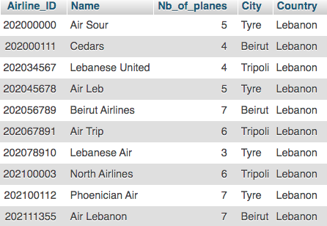

1. Airplane:

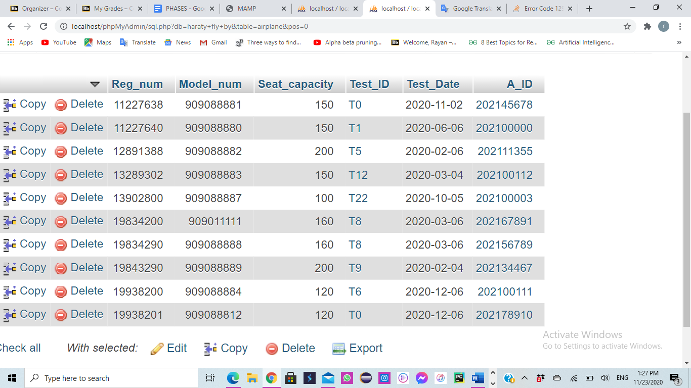

1. Flight Schedule:

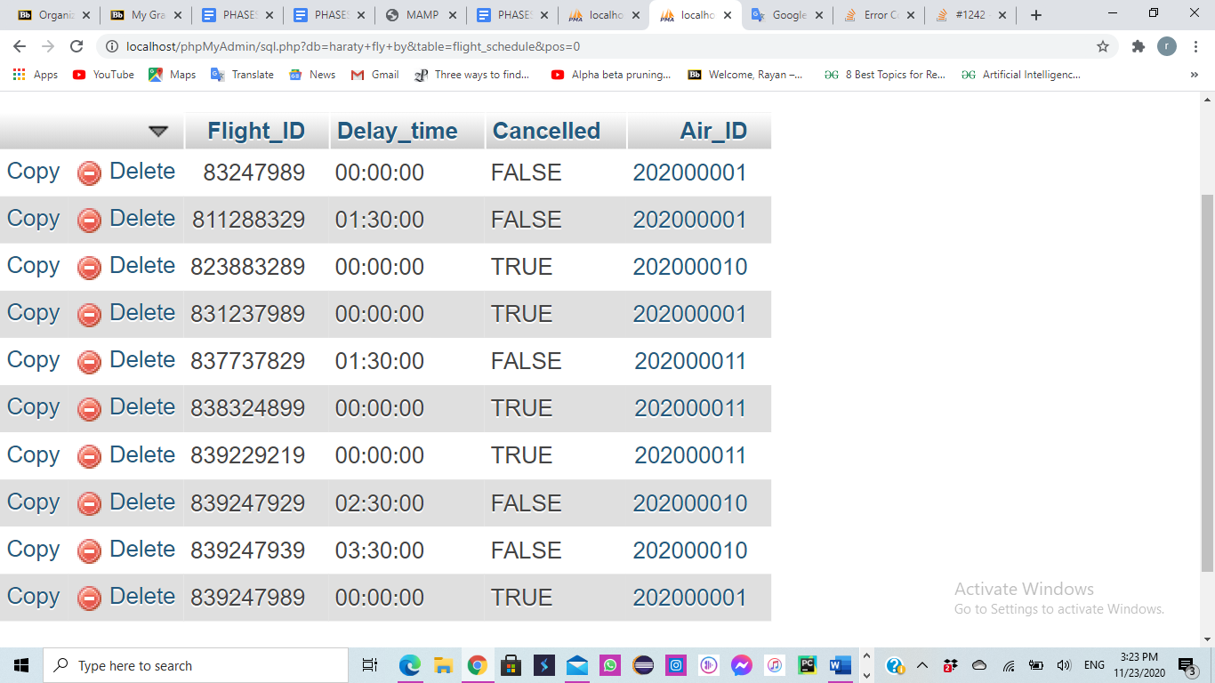

1. Hangar:

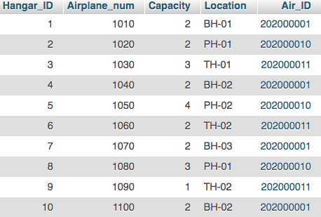

1. Airport:

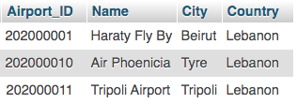

1. Airplane Test:

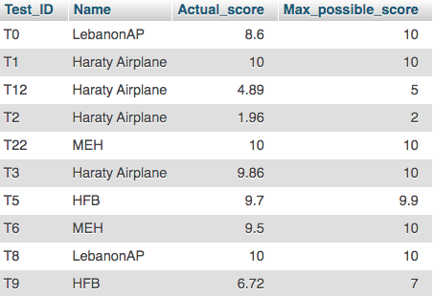

1. Flight:

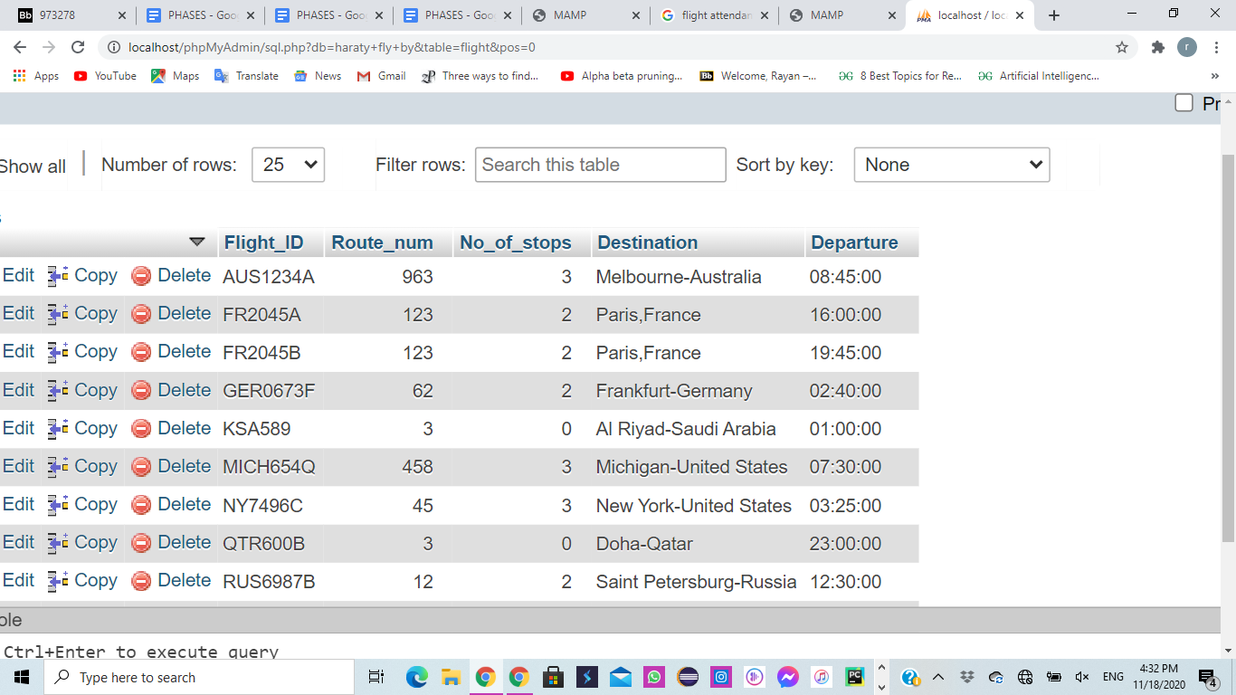

1. Employee:

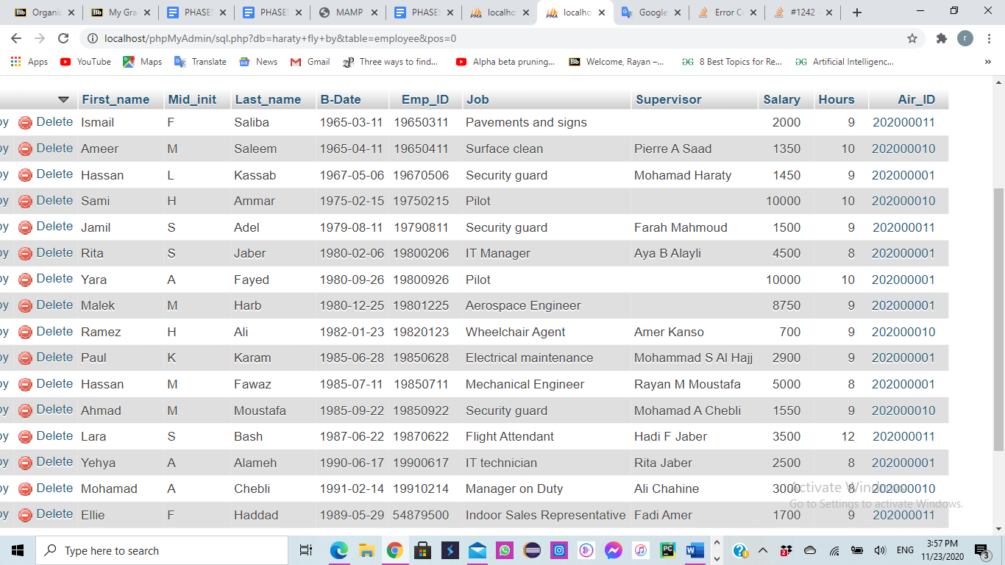

1. Maintenance:

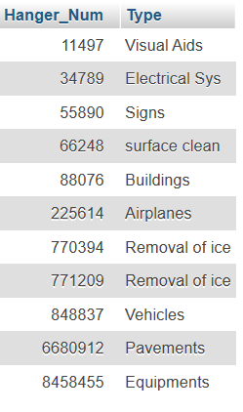

1. Airport Operations:

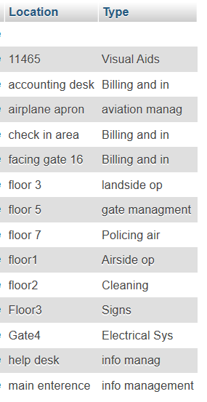

1. Gate:

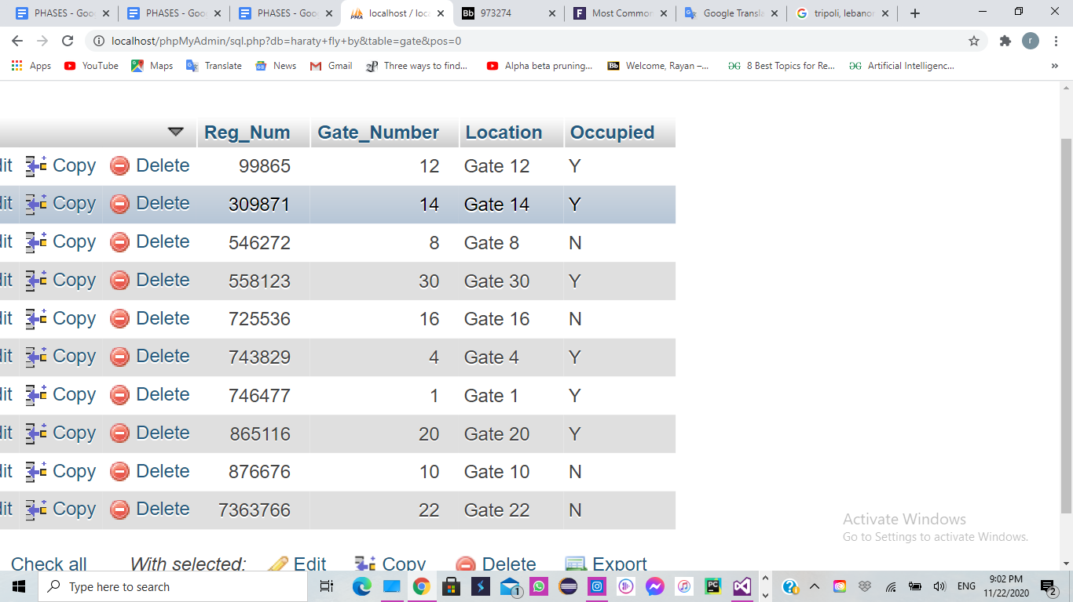

1. Lands:

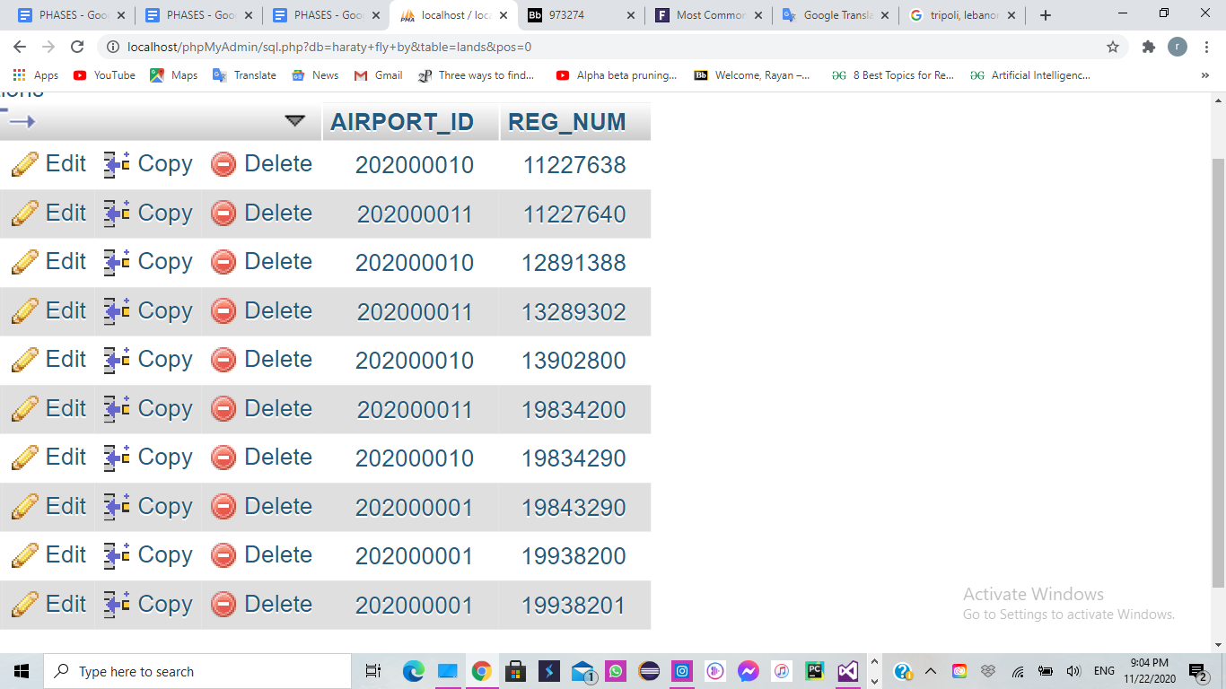

1. Provides:

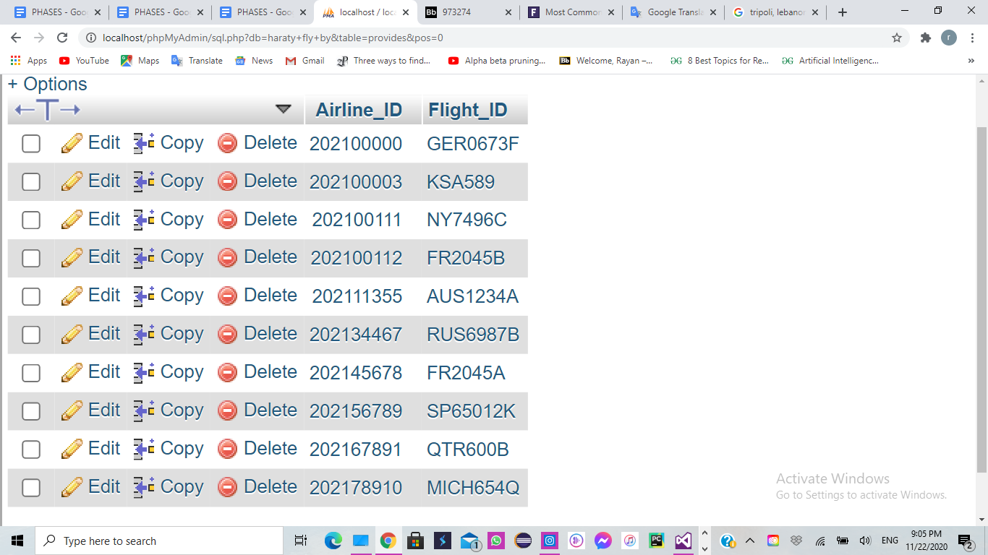

1. Location:

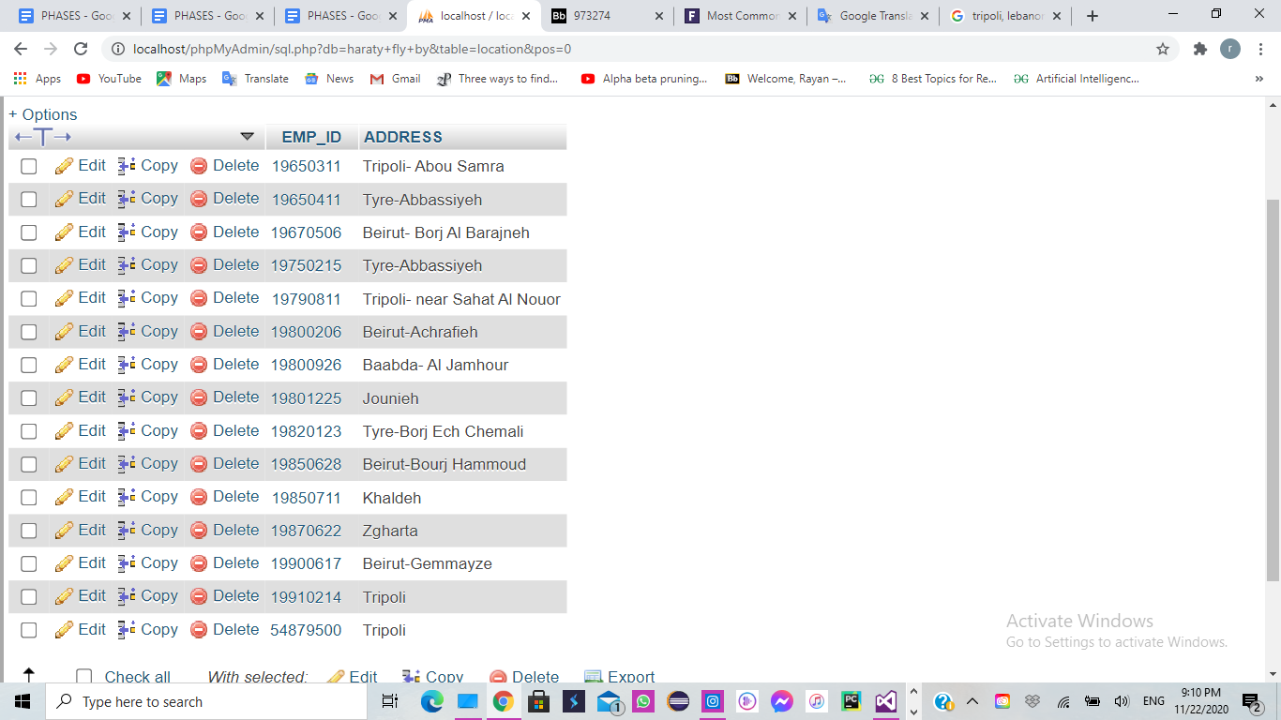

1. Security Equipment:

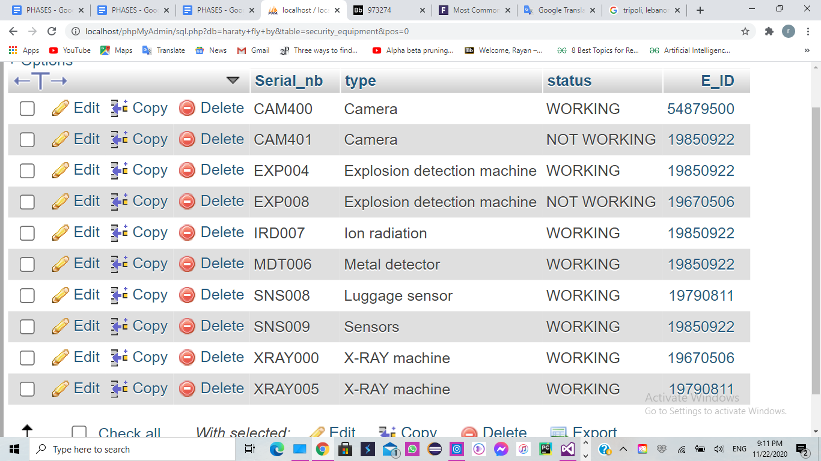

1. Serves:

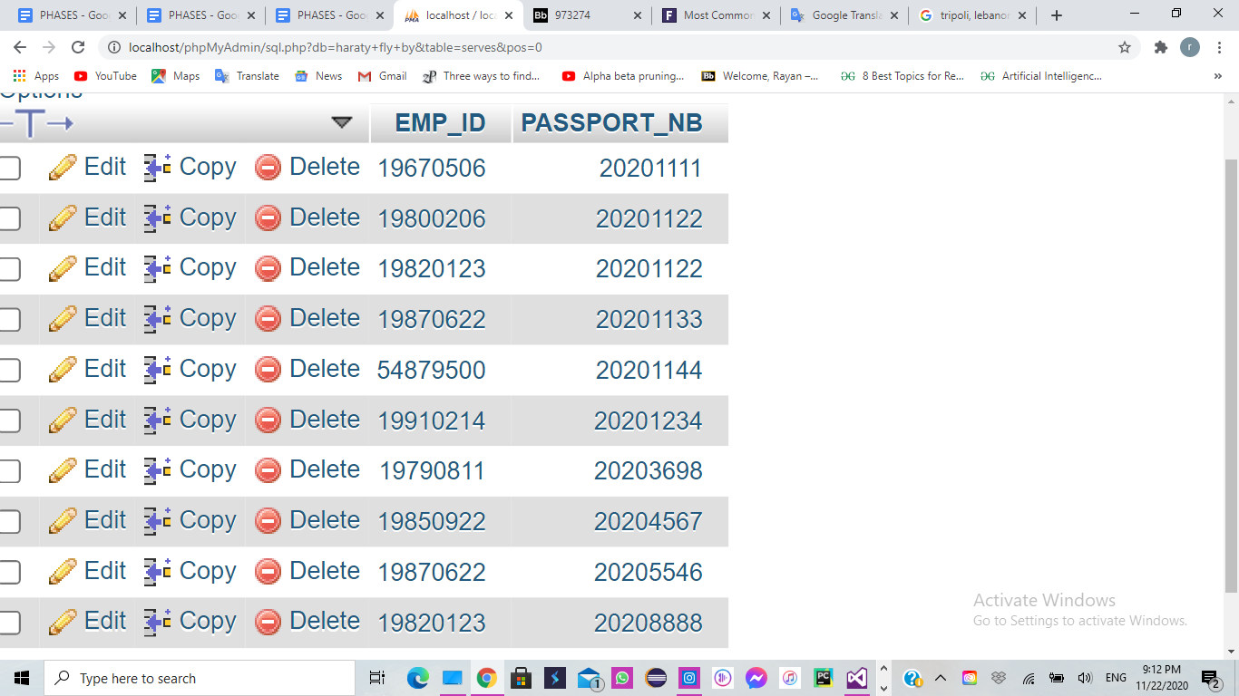

1. Ticket:

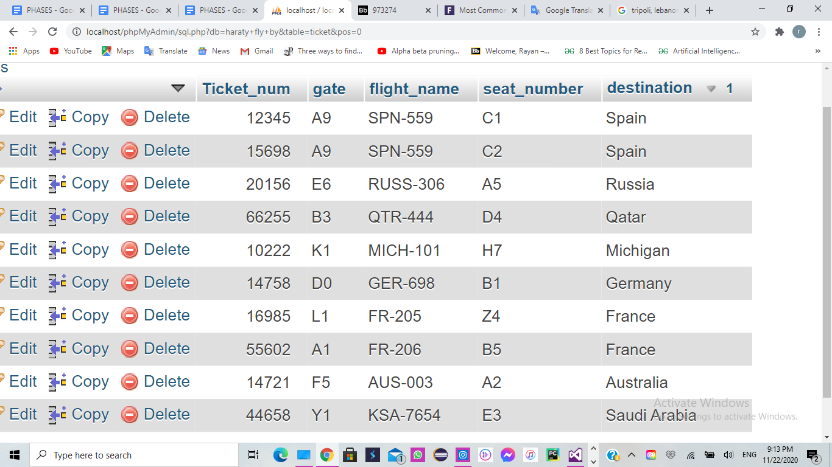

1. Time:

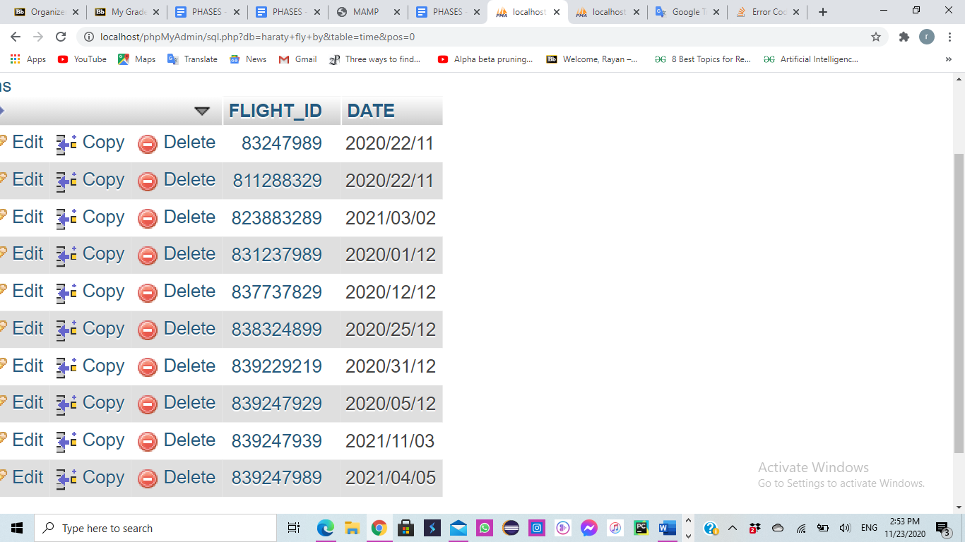

1. Uses:

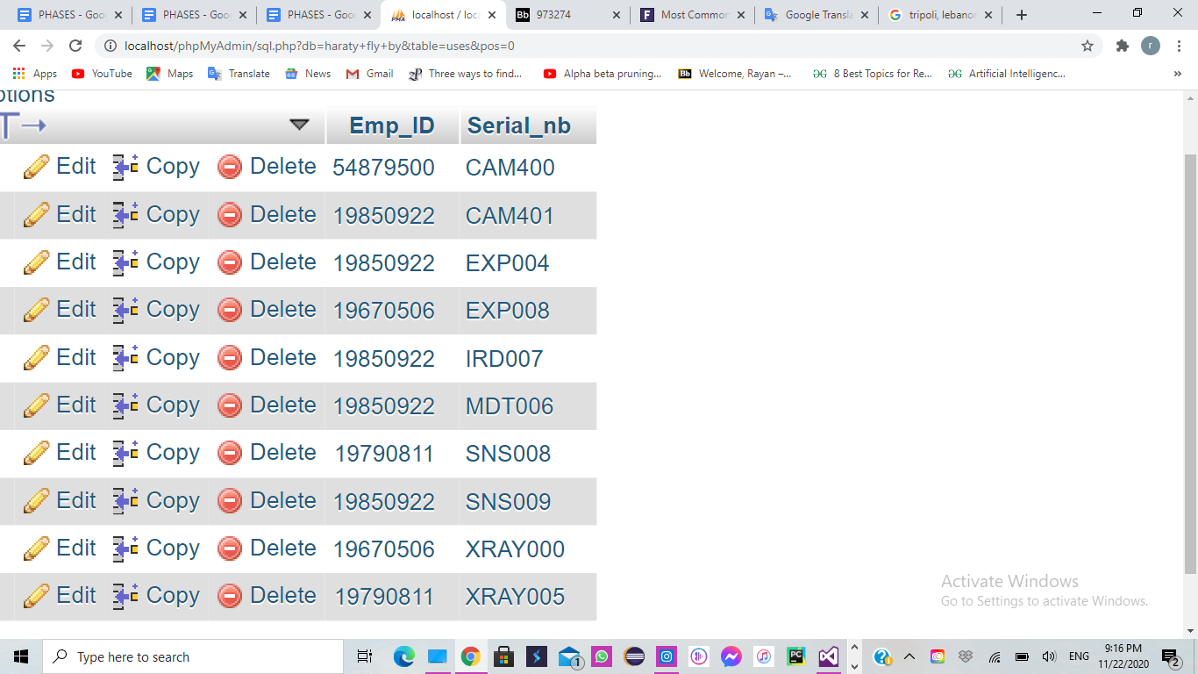

1. Works On:

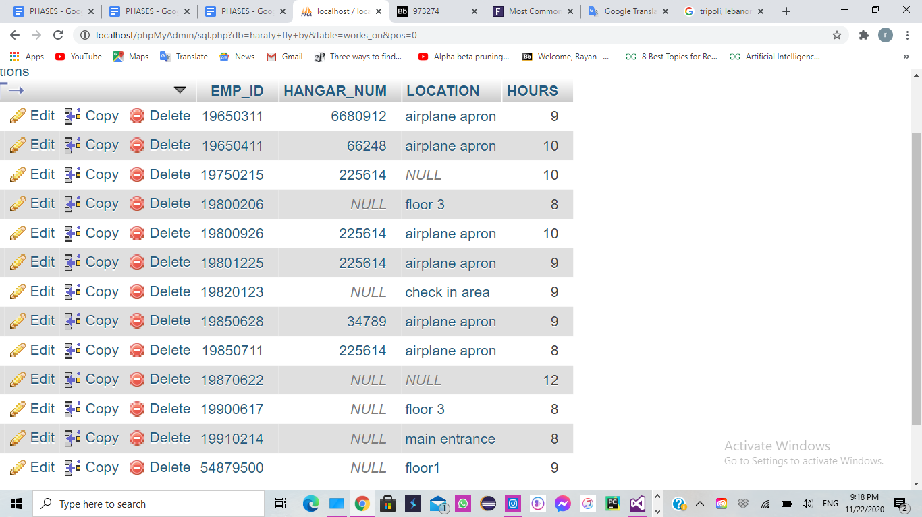

1. Passenger:

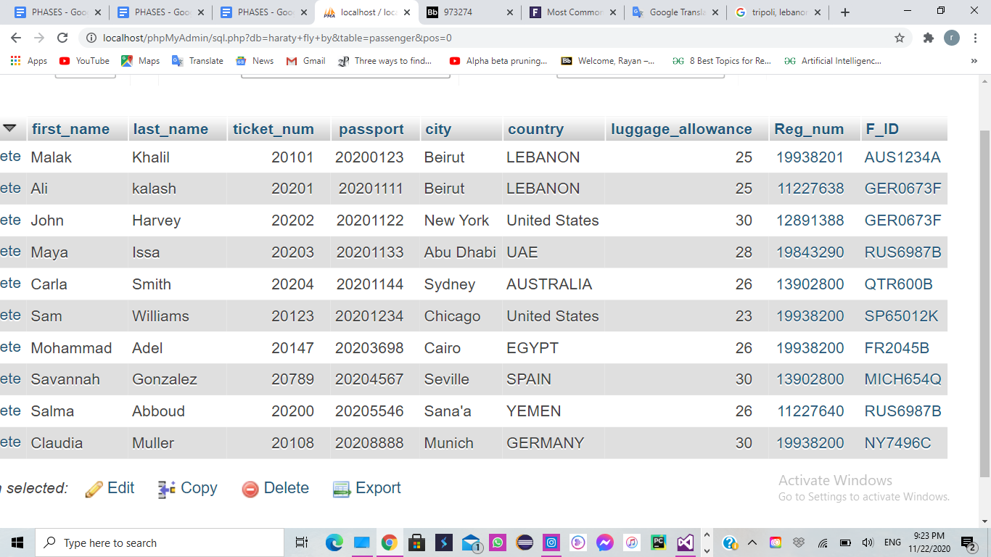

XIII. Queries:

1. An employee whose ID is ‘123987’ forgot his ID card at home, and the security guard wants to make sure that this employee actually works at this airport, so he searches the airport system for his full name knowing his ID number.

**Display the full name of the employee with ID=123987.**

**SQL Query:**

[SELECT](http://localhost/phpMyAdmin/url.php?url=https://dev.mysql.com/doc/refman/5.5/en/select.html) First_name,Mid_init,Last_name

FROM employee P

WHERE p.Emp_ID= 123987

**Output:**

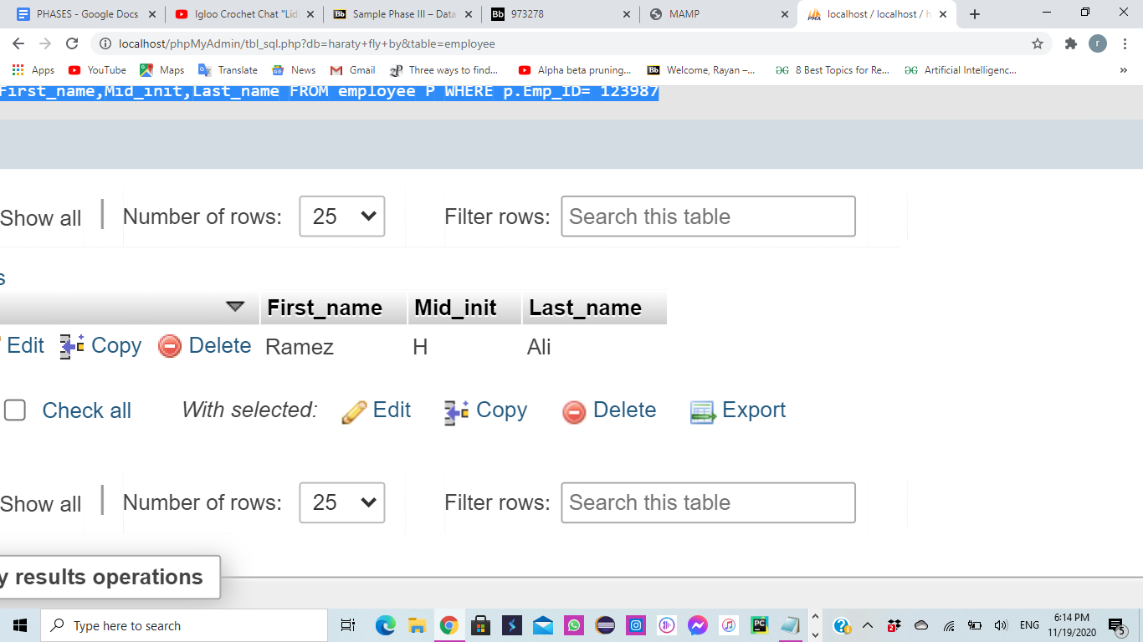

1. A pilot noticed that an airplane’s test is out of date but only knows the date of the last test. **Display the model number** **of the airplane with the test date ‘2020-2-4’.**

**SQL Query:**

[SELECT](http://localhost:8888/phpMyAdmin/url.php?url=https://dev.mysql.com/doc/refman/5.5/en/select.html) Model_num

FROM AIRPLANE A

WHERE A.Test_Date='2020-2-4'

**Output:**

Model_num

----------

909088889

1. The Federal Aviation Administration (FAA) is conducting a research and requested the lowest, highest and average among the scores of the airplane tests implemented on the airplanes owned in Lebanon.

**A: Compute and display the scores requested.**

**SQL Query:**

[SELECT](http://localhost:8888/phpMyAdmin/url.php?url=https://dev.mysql.com/doc/refman/5.5/en/select.html) [MIN](http://localhost:8888/phpMyAdmin/url.php?url=https://dev.mysql.com/doc/refman/5.5/en/group-by-functions.html#function_min)(Actual_score), [MAX](http://localhost:8888/phpMyAdmin/url.php?url=https://dev.mysql.com/doc/refman/5.5/en/group-by-functions.html#function_max)(Actual_score), [AVG](http://localhost:8888/phpMyAdmin/url.php?url=https://dev.mysql.com/doc/refman/5.5/en/group-by-functions.html#function_avg)(Actual_score) FROM AIRPLANE_TEST T

WHERE T.Actual_score [IS](http://localhost:8888/phpMyAdmin/url.php?url=https://dev.mysql.com/doc/refman/5.5/en/comparison-operators.html#operator_is) [NOT](http://localhost:8888/phpMyAdmin/url.php?url=https://dev.mysql.com/doc/refman/5.5/en/logical-operators.html#operator_not) NULL

**Output:**



**B: Display the airplane test table in descending order to clearly see what airplane needs to be replaced or maintenanced.**

**SQL Query:**

[SELECT](http://localhost:8888/phpMyAdmin/url.php?url=https://dev.mysql.com/doc/refman/5.5/en/select.html) *

FROM AIRPLANE_TEST T ORDER BY T.Actual_score DESC

**Output:**

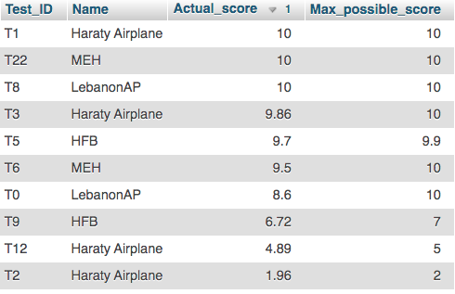

1. The government wants to know **all the information about employees** working at Beirut airport which is titled **“Haraty Fly By”**.
2. **Display information about the employees working at Haraty Fly By airport.**

**SQL Query:**

[**SELECT**](http://localhost/phpMyAdmin/url.php?url=https://dev.mysql.com/doc/refman/5.5/en/select.html) **\***

**FROM `EMPLOYEE`**

**WHERE Air_ID='202000001'**

**Output:**

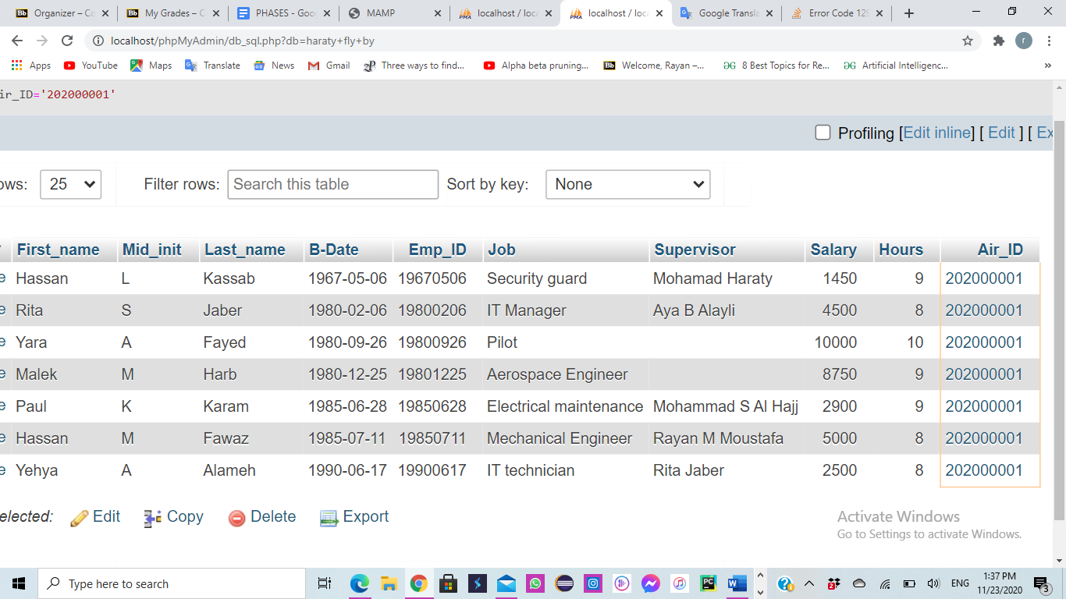

1. **Display their percentage**

**SQL Query:**

[SELECT](http://localhost/phpMyAdmin/url.php?url=https://dev.mysql.com/doc/refman/5.5/en/select.html)( [COUNT](http://localhost/phpMyAdmin/url.php?url=https://dev.mysql.com/doc/refman/5.5/en/group-by-functions.html#function_count)(*)*100/ ([Select](http://localhost/phpMyAdmin/url.php?url=https://dev.mysql.com/doc/refman/5.5/en/select.html) [COUNT](http://localhost/phpMyAdmin/url.php?url=https://dev.mysql.com/doc/refman/5.5/en/group-by-functions.html#function_count)(*) FROM EMPLOYEE)) AS PERCENTAGE

FROM EMPLOYEE E

WHERE E.Air_ID='202000001';

**Output:**

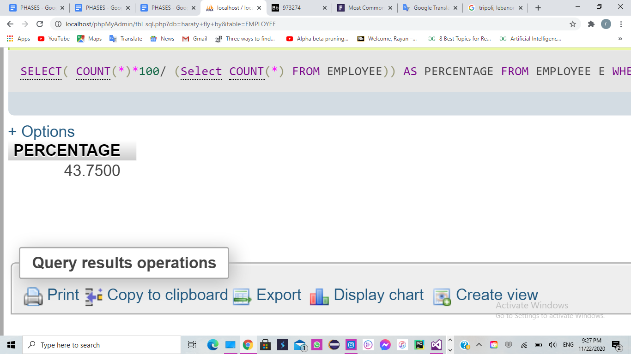

|  |  |
| --- | --- |
|  |  |
|  |  |

5. Every year the airport administration checks the salaries of its employees working on security equipment to add a bonus for the one who takes the least salary.

1. **Display the IDs of all the employees working on security equipment**

**SQL Query:**

[**SELECT**](http://localhost/phpMyAdmin/url.php?url=https://dev.mysql.com/doc/refman/5.5/en/select.html) **DISTINCT E_ID**

**FROM security_equipment**

**Output:**

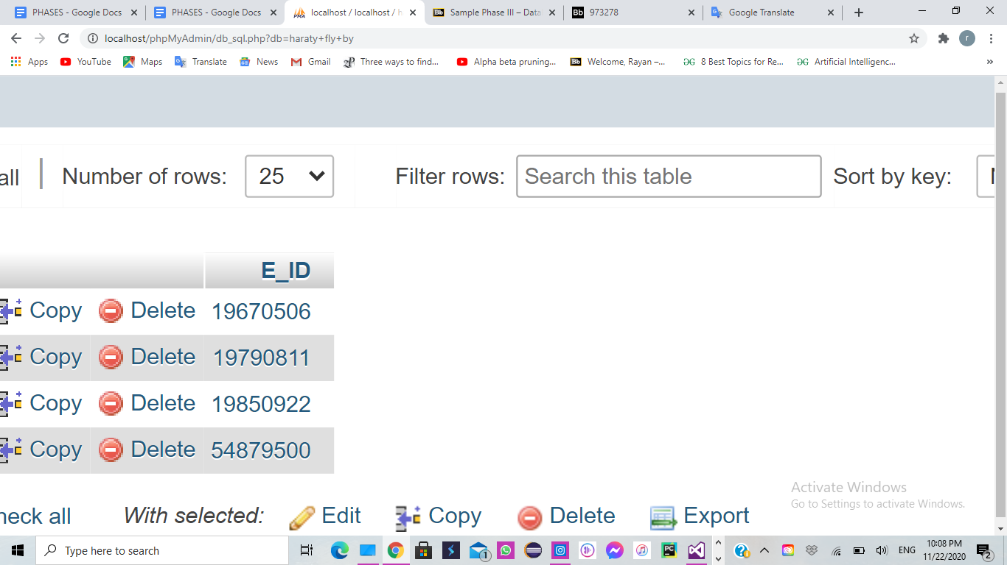

1. **Compute the salaries and the IDs of the employees working on security equipment that are ‘WORKING’**

**SQL Query:**

[**SELECT**](http://localhost/phpMyAdmin/url.php?url=https://dev.mysql.com/doc/refman/5.5/en/select.html) **E.salary,E.Emp_ID**

**FROM employee E**

**WHERE E.Emp_ID** [**IN**](http://localhost/phpMyAdmin/url.php?url=https://dev.mysql.com/doc/refman/5.5/en/comparison-operators.html#function_in) **(**[**SELECT**](http://localhost/phpMyAdmin/url.php?url=https://dev.mysql.com/doc/refman/5.5/en/select.html) **S.E_ID**

**FROM security_equipment S**

**WHERE S.status='WORKING');**

**Output:**

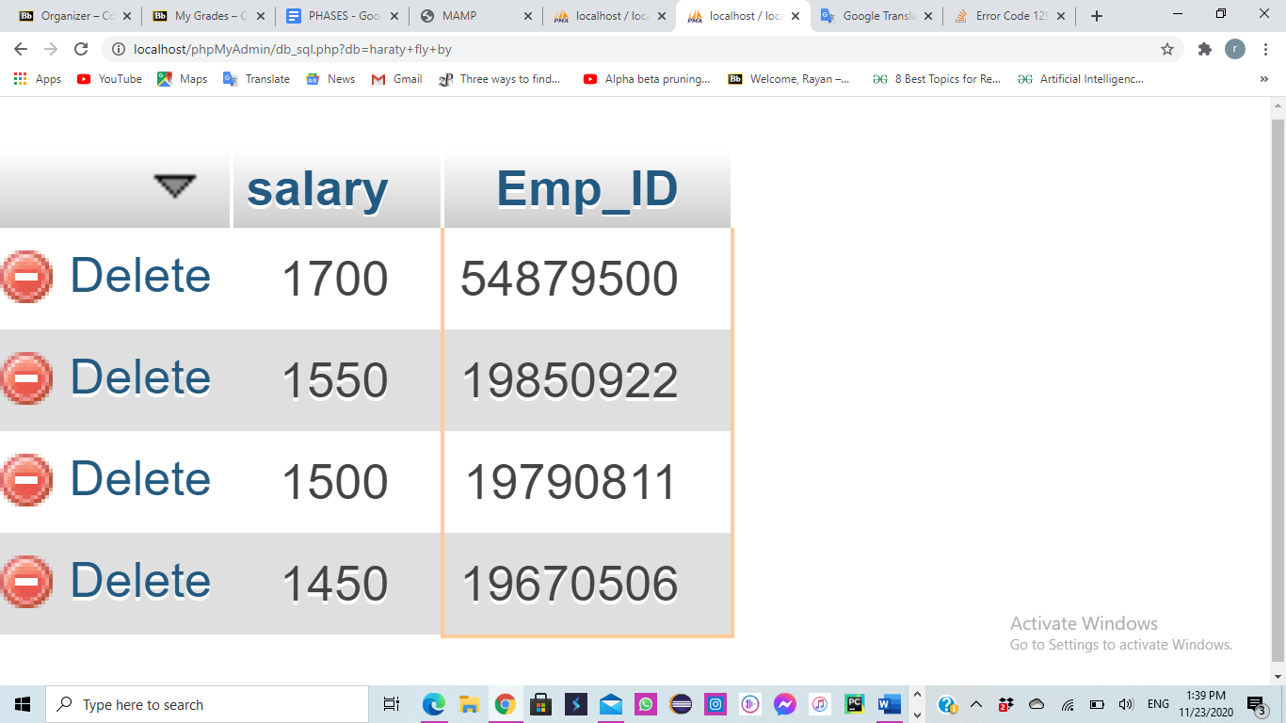

1. **Compute the minimum salary of them all**

**SQL Query:**

[**SELECT**](http://localhost/phpMyAdmin/url.php?url=https://dev.mysql.com/doc/refman/5.5/en/select.html)[**MIN**](http://localhost/phpMyAdmin/url.php?url=https://dev.mysql.com/doc/refman/5.5/en/group-by-functions.html#function_min)**(E.salary)**

**FROM employee E**

**WHERE E.Emp_ID** [**IN**](http://localhost/phpMyAdmin/url.php?url=https://dev.mysql.com/doc/refman/5.5/en/comparison-operators.html#function_in) **(**

[**SELECT**](http://localhost/phpMyAdmin/url.php?url=https://dev.mysql.com/doc/refman/5.5/en/select.html) **S.E_ID**

**FROM security_equipment S**

**WHERE S.status='WORKING');**

**Output:**

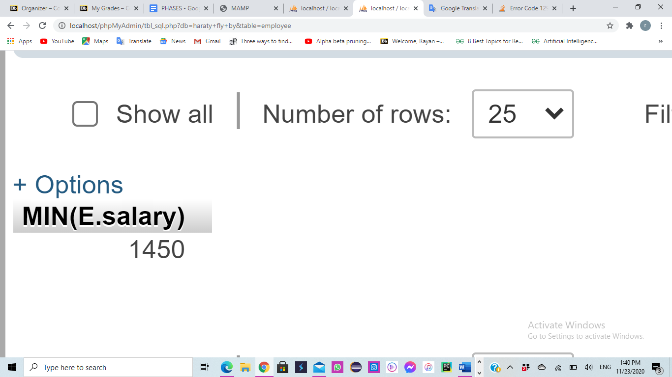

6. A passenger needs help with his bills but he doesn't know where to go exactly, so he checks the airport map on his phone to know where the billing and invoicing desk is.

**Display location of airport operation where type= ‘Billing and invoicing’**

**SQL Query:**

[**SELECT**](http://localhost/phpMyAdmin/url.php?url=https://dev.mysql.com/doc/refman/5.5/en/select.html) **B.Location**

**FROM airport_ops B**

**WHERE type='Billing and invoicing'**

**Output:**

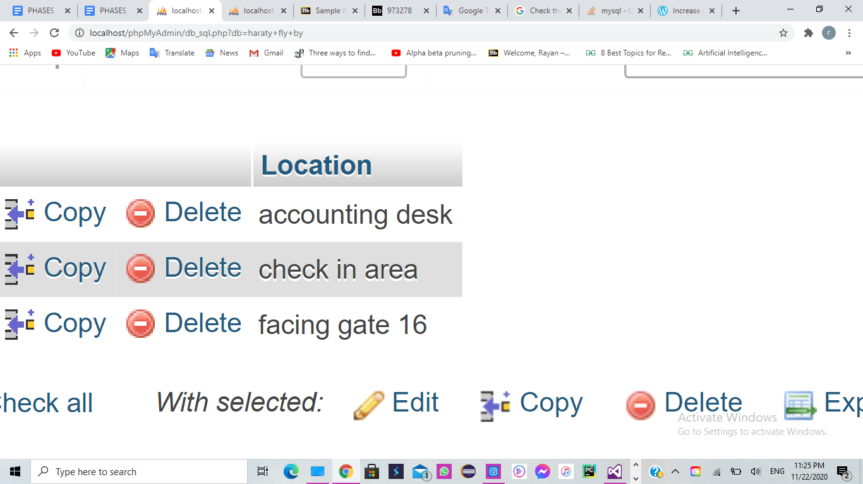

7. Knowing the registration number on his ticket, a passenger wants to know the departure time of his flight to Australia.

**SQL Query:**

[**SELECT**](http://localhost/phpMyAdmin/url.php?url=https://dev.mysql.com/doc/refman/5.5/en/select.html) **departure**

**FROM flight**

**WHERE FLIGHT_ID= (**[**SELECT**](http://localhost/phpMyAdmin/url.php?url=https://dev.mysql.com/doc/refman/5.5/en/select.html) **F_ID FROM passenger WHERE REG_NUM = '19938201');**

**Output:**

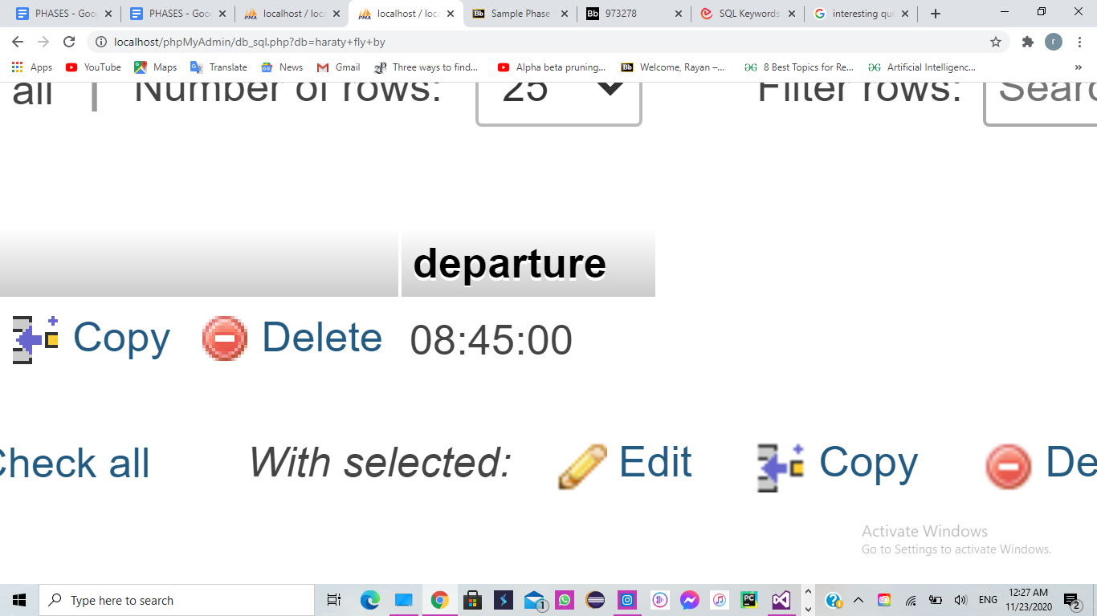

8. Retrieve the registration numbers of the airplanes who were not tested before taking off.

**SQL Query:**

[**SELECT**](http://localhost/phpMyAdmin/url.php?url=https://dev.mysql.com/doc/refman/5.5/en/select.html) **A.reg_num**

**FROM airplane A**

**WHERE** [**NOT**](http://localhost/phpMyAdmin/url.php?url=https://dev.mysql.com/doc/refman/5.5/en/logical-operators.html#operator_not) **EXISTS (** [**SELECT**](http://localhost/phpMyAdmin/url.php?url=https://dev.mysql.com/doc/refman/5.5/en/select.html) **\* FROM airplane_test T WHERE A.Test_ID=T.Test_ID)**

**Output:**

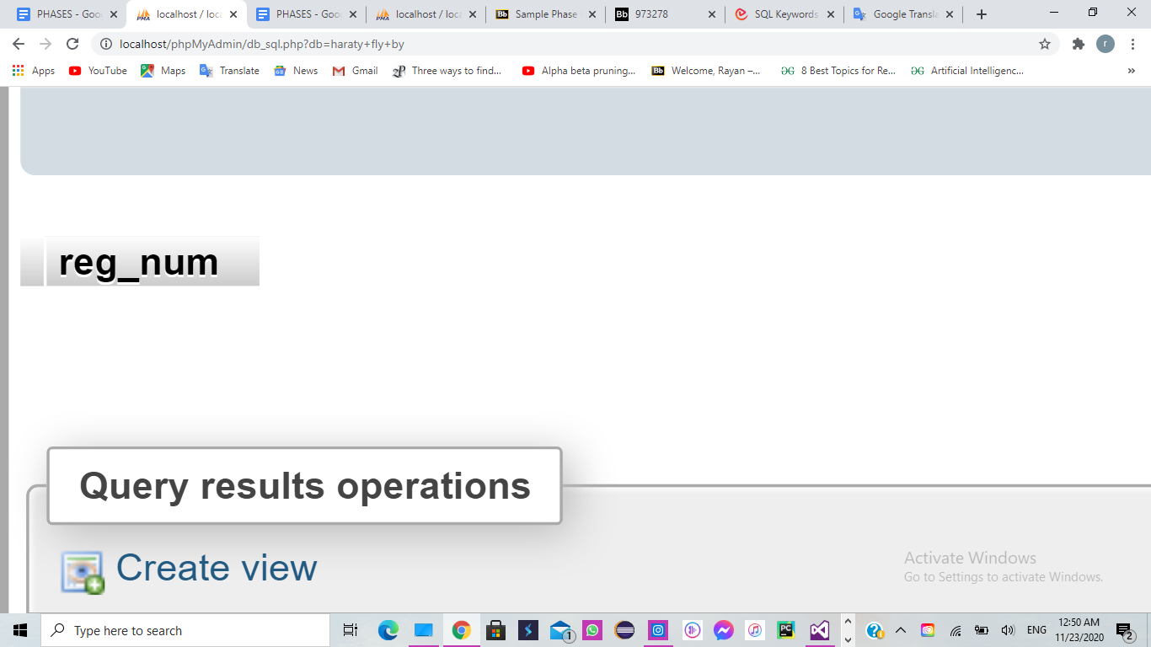

Results show no airplanes were not tested.

9. On 11/22/2020 an airplane, approximately 20 minutes away from the Beirut Airport, needs to make an emergency landing because the left engine failed.

1. Display the **airport ID** and the **number of seats** on the plane so the emergency services can prepare medical attention.

**SQL Query:**

[Select](http://localhost/phpMyAdmin/url.php?url=https://dev.mysql.com/doc/refman/5.5/en/select.html) Airport_ID,seat_capacity

From Airport A,airplane B

Where A.Name='Haraty fly by' [AND](http://localhost/phpMyAdmin/url.php?url=https://dev.mysql.com/doc/refman/5.5/en/logical-operators.html#operator_and) B.reg_num='12891388'

**Output:**

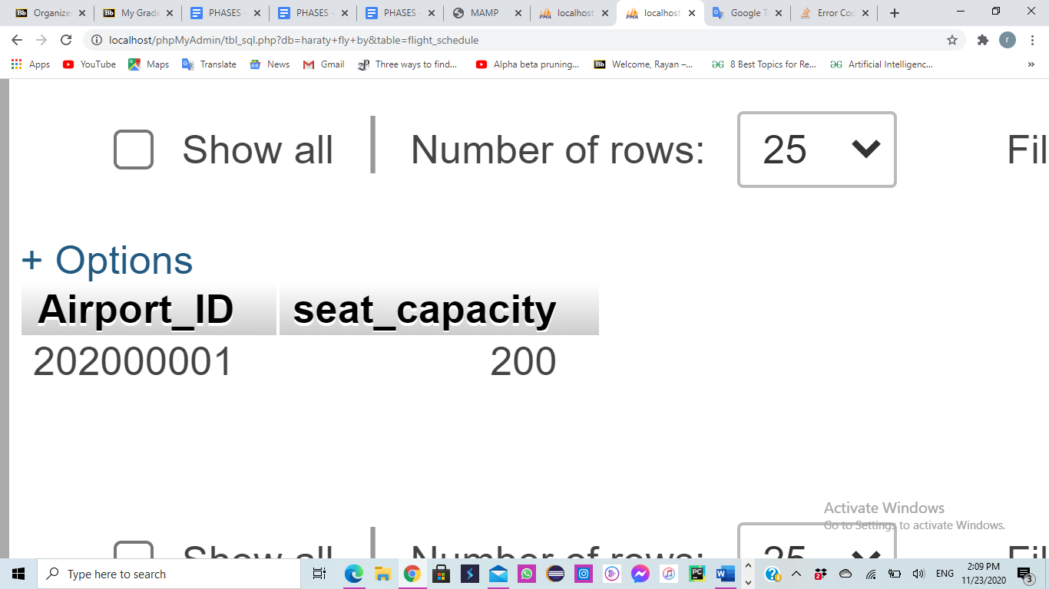

1. **Retrieve all flights occurring at that day and** **cancel them** to ensure there is no collision between planes.

**SQL Query:**

[**Update**](http://localhost/phpMyAdmin/url.php?url=https://dev.mysql.com/doc/refman/5.5/en/update.html) **Flight_Schedule AS FS**

[**Set**](http://localhost/phpMyAdmin/url.php?url=https://dev.mysql.com/doc/refman/5.5/en/set.html) **Cancelled='TRUE'**

**Where flight_ID IN (**[**Select**](http://localhost/phpMyAdmin/url.php?url=https://dev.mysql.com/doc/refman/5.5/en/select.html) **flight_ID**

**From** [**time**](http://localhost/phpMyAdmin/url.php?url=https://dev.mysql.com/doc/refman/5.5/en/date-and-time-types.html)

**Where** [**date**](http://localhost/phpMyAdmin/url.php?url=https://dev.mysql.com/doc/refman/5.5/en/date-and-time-types.html)**='2020/22/11')** [**AND**](http://localhost/phpMyAdmin/url.php?url=https://dev.mysql.com/doc/refman/5.5/en/logical-operators.html#operator_and) **FS.Air_ID='202000001'**

**Output:**

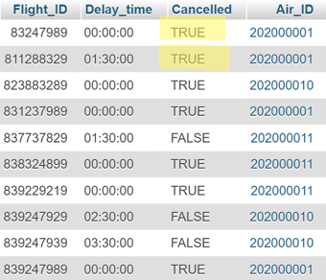

1. **Reroute** the airplanes scheduled to land in Beirut at that day to land in Phoenicia airport (Tyre).

**SQL Query:**

[Update](http://localhost/phpMyAdmin/url.php?url=https://dev.mysql.com/doc/refman/5.5/en/update.html) LANDS

[Set](http://localhost/phpMyAdmin/url.php?url=https://dev.mysql.com/doc/refman/5.5/en/set.html) Airport_ID='202000010'

Where Airport_ID [IN](http://localhost/phpMyAdmin/url.php?url=https://dev.mysql.com/doc/refman/5.5/en/comparison-operators.html#function_in) ([SELECT](http://localhost/phpMyAdmin/url.php?url=https://dev.mysql.com/doc/refman/5.5/en/select.html) AIR_ID

FROM flight_schedule F

WHERE F.flight_ID [IN](http://localhost/phpMyAdmin/url.php?url=https://dev.mysql.com/doc/refman/5.5/en/comparison-operators.html#function_in) ([Select](http://localhost/phpMyAdmin/url.php?url=https://dev.mysql.com/doc/refman/5.5/en/select.html) flight_ID

From [time](http://localhost/phpMyAdmin/url.php?url=https://dev.mysql.com/doc/refman/5.5/en/date-and-time-types.html) T

Where T.[date](http://localhost/phpMyAdmin/url.php?url=https://dev.mysql.com/doc/refman/5.5/en/date-and-time-types.html)='2020/22/11') )

**Output:**

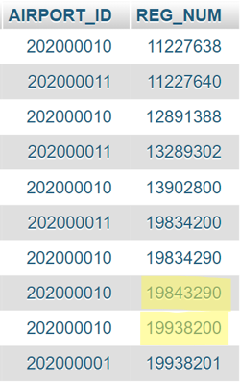

10. Nearing the end of the year, the manager wants to give the engineers a raise. The mechanical engineers receive a 10% raise and the aerospace engineers receive a 4% raise. **Compute and Display the raises.**

**SQL Query:**

[Update](http://localhost/phpMyAdmin/url.php?url=https://dev.mysql.com/doc/refman/5.5/en/update.html) Employee AS E

[Set](http://localhost/phpMyAdmin/url.php?url=https://dev.mysql.com/doc/refman/5.5/en/set.html) E.Salary=E.Salary+(E.Salary*0.1)

Where E.Job='Mechanical Engineer'

[Update](http://localhost/phpMyAdmin/url.php?url=https://dev.mysql.com/doc/refman/5.5/en/update.html) Employee AS E

[Set](http://localhost/phpMyAdmin/url.php?url=https://dev.mysql.com/doc/refman/5.5/en/set.html) E.Salary=E.Salary+(E.Salary*0.04)

Where E.Job='Aerospace Engineer'

**Output:**

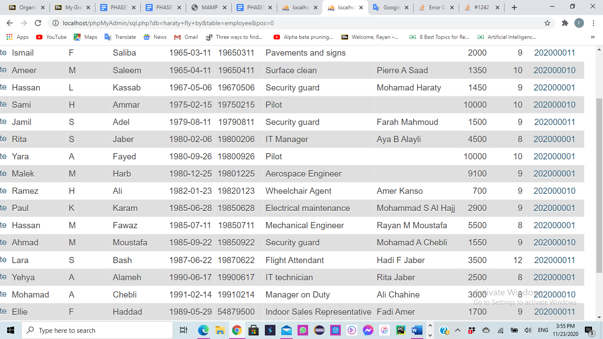



**XII. Normalization Up to The BCNF Normal Form:**

After creating our database in SQL, we aim to improve it by normalizing it following the four normal forms. We will begin with each relation normalizing them up to the Boyce-Codd Normal Form.

Our goal is to try to solve the problems of insertion, deletion, and update anomalies. This normalization will minimize data redundancy and protect referential integrity.

First Normal Form:

This normal form disallows composite attributes, multivalued attributes, and nested relations. It can only have single atomic values for each attribute.

Second Normal Form:

A relational schema R is considered to be in second normal form (2NF) if every non-prime attribute of the relation is fully functional dependent on the primary key (PK).

* **Non-Prime attributes** are attributes that are not members of any candidate keys.
* **Functional dependency:** Occurs when a set of attributes in X determines a set of attributes Y, if X determines a unique value for Y.
* **Full functional dependency:** Is a functional dependency (FD) X->Y where if any attribute of X is removed causes the FD to be unsustainable.

Third Normal Form:

A relational schema is in third normal form (3NF) if it is in 2NF and no non-prime attribute is transitively dependent on the primary key. This means that there is no other non key attribute we would need to change in a relation if we changed a non key attribute. This form reduces duplicate data and ensures referential integrity.

**Transitive dependency:** A FD X->Z that is derived from X-Y and Y->Z.

Boycee-Codd Normal Form:

Boycee-Codd Normal Form is satisfied if whenever FD X->Y is true, then X is a superkey of the relation. Another condition for this normal form to hold is that the relation must be in 3NF.

1. AIRPORT

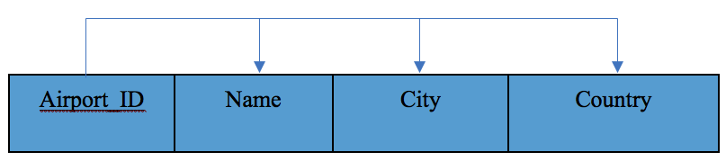

**1.** The **AIRPORT** relation schema is in 1NF because it does not contain any multivalued attributes or any composite attributes. All attributes are single and atomic.

**2.** The **AIRPORT** relation schema is in 2NF because every non prime attribute A is fully functionally dependent on the primary key **“Airport_ID”** and is also in 1NF.

**3.** The **AIRPORT** relation schema is in 3NF because there is no transitive dependency of a non-key attribute on the primary key **“Airport_ID”** in addition to being in 2NF.

**4.** The **AIRPORT** relation schema is in Boyce-Codd Normal Form (BCNF) because it is in 3NF and because in the FD X->Y, X is a super key of the relation R and there is no prime attribute A in R.

1. HANGAR

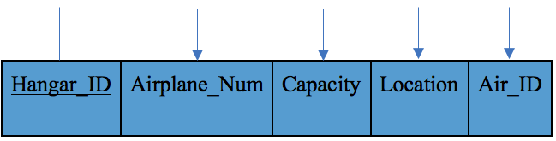

**1.** The **HANGAR** relation schema is in 1NF because it does not contain any multivalued attributes or any composite attributes. All attributes are single and atomic.

**2.** The **HANGAR** relation schema is in 2NF because every non prime attribute A is fully functionally dependent on the primary key **“Hangar_ID”** and is also in 1NF.

**3.** The **HANGAR** relation schema is in 3NF because there is no transitive dependency of a non-key attribute on the primary key **“Hangar_ID”** in addition to being in 2NF.

**4.** The **HANGAR** relation schema is in Boyce-Codd Normal Form (BCNF) because it is in 3NF and because in the FD X->Y, X is a super key of the relation R and there is no prime attribute A in R.

1. FLIGHT SCHEDULE:

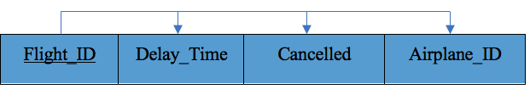

**1.** The **FLIGHT SCHEDULE** relation schema is in 1NF because it does not contain any multivalued attributes or any composite attributes. All attributes are single and atomic.

**2.** The **FLIGHT SCHEDULE** relation schema is in 2NF because every non prime attribute A is fully functionally dependent on the primary key **“Flight_ID”** and is also in 1NF.

**3.** The **FLIGHT SCHEDULE** relation schema is in 3NF because there is no transitive dependency of a non-key attribute on the primary key **“Flight_ID”** in addition to being in 2NF.

**4.** The **FLIGHT SCHEDULE** relation schema is in Boyce-Codd Normal Form (BCNF) because it is in 3NF and because in the FD X->Y, X is a super key of the relation R and there is no prime attribute A in R.

1. AIRLINE:

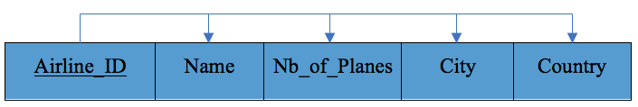

**1.** The **AIRLINE** relation schema is in 1NF because it does not contain any multivalued attributes or any composite attributes. All attributes are single and atomic.

**2.** The **AIRLINE** relation schema is in 2NF because every non prime attribute A is fully functionally dependent on the primary key **“Airline_ID”** and is also in 1NF.

**3.** The **AIRLINE** relation schema is in 3NF because there is no transitive dependency of a non-key attribute on the primary key **“Airline_ID”** in addition to being in 2NF.

**4.** The **AIRLINE** relation schema is in Boyce-Codd Normal Form (BCNF) because it is in 3NF and because in the FD X->Y, X is a super key of the relation R and there is no prime attribute A in R.

1. AIRPLANE:

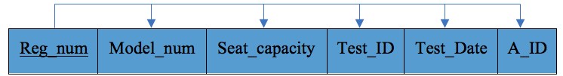

**1.** The **AIRPLANE** relation schema is in 1NF because it does not contain any multivalued attributes or any composite attributes. All attributes are single and atomic.

**2.** The **AIRPLANE** relation schema is in 2NF because every non prime attribute A is fully functionally dependent on the primary key **“Reg_num”** and **“Model_num”** is also in 1NF.

**3.** The **AIRPLANE** relation schema is in 3NF because there is no transitive dependency of a non-key attribute on the primary key **“Reg_num”**and **“Model_num”** in addition to being in 2NF.

**4.** The **AIRPLANE** relation schema is in Boyce-Codd Normal Form (BCNF) because it is in 3NF and because in the FD X->Y, X is a super key of the relation R and there is no prime attribute A in R.

1. AIRPLANE_EXAM:

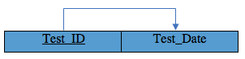

**1.** The  **AIRPLANE EXAM** relational schema is in 1NF because it does not contain any multivalued attributes or any composite attributes. All attributes are single and atomic.

**2. AIRPLANE EXAM** was created as a new relation in order to satisfy the 2NF. Now the two relations are in 2NF since non prime attribute A is fully functionally dependent on the primary key **“Test_ID”**.

**3.** The **AIRPLANE EXAM** relation schema is in 3NF because there is no transitive dependency of a non-key attribute on the primary key  **“Test_ID”** in addition to being in 2NF.

**4.** The **AIRPLANE EXAM** relation schema is in Boyce-Codd Normal Form (BCNF) because it is in 3NF and because in the FD X->Y, X is a super key of the relation R and there is no prime attribute A in R

1. AIRPLANE TEST:

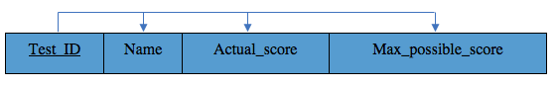

**1.** The **AIRPLANE TEST** relation schema is in 1NF because it does not contain any multivalued attributes or any composite attributes. All attributes are single and atomic.

**2.** The **AIRPLANE TEST** relation schema is in 2NF because every non prime attribute A is fully functionally dependent on the primary key **“Test_ID”** and is also in 1NF.

**3.** The **AIRPLANE TEST** relation schema is in 3NF because there is no transitive dependency of a non-key attribute on the primary key **“Test_ID”** in addition to being in 2NF.

**4.** The **AIRPLANE TEST** relation schema is in Boyce-Codd Normal Form (BCNF) because it is in 3NF and because in the FD X->Y, X is a super key of the relation R and there is no prime attribute A in R.

1. FLIGHT:

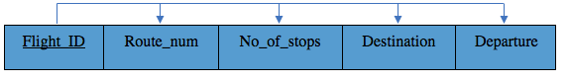

**1.** The **FLIGHT** relation schema is in 1NF because it does not contain any multivalued attributes or any composite attributes. All attributes are single and atomic.

**2.** The **FLIGHT** relation schema is in 2NF because every non prime attribute A is fully functionally dependent on the primary key **“Flight_ID”** and is also in 1NF.

**3.** The **FLIGHT** relation schema is in 3NF because there is no transitive dependency of a non-key attribute on the primary key **“Flight_ID”** in addition to being in 2NF.

**4.** The **FLIGHT** relation schema is in Boyce-Codd Normal Form (BCNF) because it is in 3NF and because in the FD X->Y, X is a super key of the relation R and there is no prime attribute A in R.

1. EMPLOYEE:

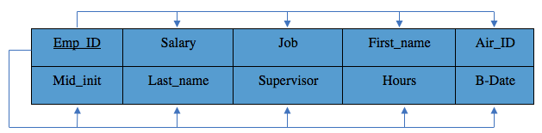

**1.** The **EMPLOYEE** relation schema is in 1NF because it does not contain any multivalued attributes or any composite attributes. All attributes are single and atomic.

**2.** The **EMPLOYEE** relation schema is in 2NF because every non prime attribute A is fully functionally dependent on the primary key **“Emp_ID”** and is also in 1NF.

**3.** The **EMPLOYEE** relation schema is in 3NF because there is no transitive dependency of a non-key attribute on the primary key **“Emp_ID”** in addition to being in 2NF.

**4.** The **FLIGHT** relation schema is in Boyce-Codd Normal Form (BCNF) because it is in 3NF and because in the FD X->Y, X is a super key of the relation R and there is no prime attribute A in R.

1. PASSENGER:

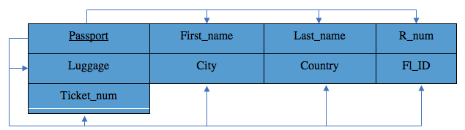

**1.** The **PASSENGER** relation schema is in 1NF because it does not contain any multivalued attributes or any composite attributes. All attributes are single and atomic.

**2.** The **PASSENGER** relation schema is in 2NF because every non prime attribute A is fully functionally dependent on the primary key **“Passport”** and is also in 1NF.

**3.** The **PASSENGER** relation schema is in 3NF because there is no transitive dependency of a non-key attribute on the primary key **“Passport”** in addition to being in 2NF.

**4.** The **PASSENGER** relation schema is in Boyce-Codd Normal Form (BCNF) because it is in 3NF and because in the FD X->Y, X is a super key of the relation R and there is no prime attribute A in R.

1. TICKET:

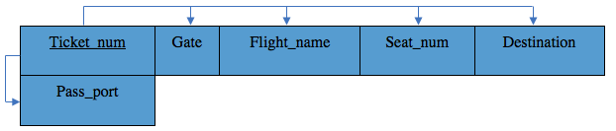

**1.** The **TICKET** relation schema is in 1NF because it does not contain any multivalued attributes or any composite attributes. All attributes are single and atomic.

**2.** The **TICKET** relation schema is in 2NF because every non prime attribute A is fully functionally dependent on the primary key **“Ticket_num”** and is also in 1NF.

**3.** The **TICKET** relation schema is in 3NF because there is no transitive dependency of a non-key attribute on the primary key **“Ticket_num”** in addition to being in 2NF.

**4.** The **TICKET** relation schema is in Boyce-Codd Normal Form (BCNF) because it is in 3NF and because in the FD X->Y, X is a super key of the relation R and there is no prime attribute A in R.

1. SECURITY EQUIPMENT:

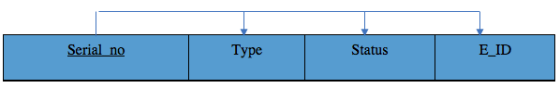

**1.** The **SECURITY EQUIPMENT** relation schema is in 1NF because it does not contain any multivalued attributes or any composite attributes. All attributes are single and atomic.

**2.** The **SECURITY EQUIPMENT**  relation schema is in 2NF because every non prime attribute A is fully functionally dependent on the primary key **“Serial_nb”** and is also in 1NF.

**3.** The **SECURITY EQUIPMENT** relation schema is in 3NF because there is no transitive dependency of a non-key attribute on the primary key **“Serial_nb”** in addition to being in 2NF.

**4.** The **SECURITY EQUIPMENT** relation schema is in Boyce-Codd Normal Form (BCNF) because it is in 3NF and because in the FD X->Y, X is a super key of the relation R and there is no prime attribute A in R.

1. MAINTENANCE:

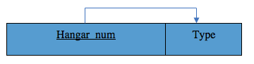

**1.** The **MAINTENANCE** relation schema is in 1NF because it does not contain any multivalued attributes or any composite attributes. All attributes are single and atomic.

**2.** The **MAINTENANCE** relation schema is in 2NF because every non prime attribute A is fully functionally dependent on the primary key **“Hanger_Num”** and is also in 1NF.

**3.** The **MAINTENANCE** relation schema is in 3NF because there is no transitive dependency of a non-key attribute on the primary key **“Hanger_Num”** in addition to being in 2NF.

**4.** The **MAINTENANCE** relation schema is in Boyce-Codd Normal Form (BCNF) because it is in 3NF and because in the FD X->Y, X is a super key of the relation R and there is no prime attribute A in R.

1. AIRPORT OPS:

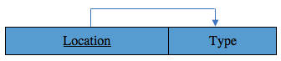

**1.** The **AIRPORT OPS** relation schema is in 1NF because it does not contain any multivalued attributes or any composite attributes. All attributes are single and atomic.

**2.** The **AIRPORT OPS** relation schema is in 2NF because every non prime attribute A is fully functionally dependent on the primary key **“Location”** and is also in 1NF.

**3.** The **AIRPORT OPS** relation schema is in 3NF because there is no transitive dependency of a non-key attribute on the primary key **“Location”** in addition to being in 2NF.

**4.** The **AIRPORT OPS** relation schema is in Boyce-Codd Normal Form (BCNF) because it is in 3NF and because in the FD X->Y, X is a super key of the relation R and there is no prime attribute A in R.

1. GATE:

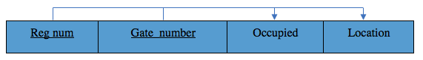

**1.** The **GATE** relation schema is in 1NF because it does not contain any multivalued attributes or any composite attributes. All attributes are single and atomic.

**2.** The **GATE** relation schema is in 2NF because every non prime attribute A is fully functionally dependent on the primary key **“Reg_Num” and “Gate_Number”** is also in 1NF.

**3.** The **GATE** relation schema is in 3NF because there is no transitive dependency of a non-key attribute on the primary key **“Reg_Num” and “Gate_Number”** in addition to being in 2NF.

**4.** The **GATE** relation schema is in Boyce-Codd Normal Form (BCNF) because it is in 3NF and because in the FD X->Y, X is a super key of the relation R and there is no prime attribute A in R.

Relation Schemas without non-prime attributes:

1. PROVIDES

|  |  |
| --- | --- |
| Flight_ID | Airline_ID |

1. LANDS

|  |  |
| --- | --- |
| Airport_ID | Reg_num |

1. USES

|  |  |
| --- | --- |
| Emp_ID | Serial_no |

1. SERVES

|  |  |
| --- | --- |
| Emp_ID | Passport |

1. TIME

|  |  |
| --- | --- |
| Date | Flight_ID |

1. LOCATION

|  |  |
| --- | --- |
| Emp_ID | Address |

XIII-Conclusion

A database is essential for the organization of a complex system like an airport. In the airport we have airplanes that need to be constantly tested every 6-month period to ensure the safety of passengers and their belongings. These airplanes are owned by airlines that provide the flight schedules every day to make sure the passenger boards the airplane for which they scheduled a flight and purchased a ticket. There are many employees making sure all these operations run smoothly. They take care of maintenance and operations in the airport, they use security equipment to protect the airport, and serve the passenger. A failure in the organization of these entities may cause a loss of money and even lives. Therefore a database management system is needed, to monitor everything happening in the airport runs smoothly.

XIV- Phase I Report Checklist

Font Type: Times New Roman.

Team of three: No.

Plain English: Yes.

Group named: Yes.

Group leader: Yes.

Real-life database application: Yes.

Challenging and interesting database application: Yes.

Font Size: 11

Spaced: Yes.

Typed: Yes.

At least 10 essential pages: Yes.

At least 10 entities: Yes.

At least 1 multivalued attribute: Yes.

At least 1 composite relation: Yes.

At least 1 multivalued relationship: Yes.

At least 1 weak entity: Yes.

ER Model built: Yes.

SQL: Yes

Normalization: Yes

Deadline respected: Yes.